Microsoft Access 2007

Introduction

Access is a database management system that you can use independently, or you can use it as part of the Office Suite. A database is just a file, very similar to the word processing files and spreadsheets you've worked with before. But there are a few differences. A database is used to store data – a single collection or several sub-collections. A database can hold all kinds of data--and there's no specific size limit. The size of the database file is only limited by memory and hard disk space. As for what it contains, databases contain fields and records. A record is like an entry in an address book, and the fields are the individual bits of data: name, address, and phone number. Here are two sample databases:
Sample: Customer Table
Customer ID | Name | Address | City | State | Zip
Number | Text | Text | Text | Text | Text
1001 | Mr. Patrick Church | 123 Seaside Street | Ruth | MI | 48470
1002 | Ms. Bailey Thayer | 2121 Otsego Lake Drive | Gaylord | MI | 49735
1003 | Mr. Todd Wysong | 442 Oldsmobile Court | Parisville | MI | 48474

Sample: Accounts Table
Customer ID | Account Number | Account Type | Deposit Date | Balance
Number | Number | Text | Date | Number
1001 | 8888 | Checking | 11/04/2008 | 4500.00
1002 | 9991 | Savings | 11/08/2008 | 6400.00
1003 | 1234 | Checking | 11/15/2008 | 1600.00
1003 | 4321 | Savings | 11/22/2008 | 2500.00

Compare:

- The Customer table has six columns (or fields): Customer ID, Name, Address, City, State and Zip and three rows (or records) of data.
- The Accounts table has five columns (or fields): Customer ID, Account Number, Account Type, Date Opened and Balance and four rows (or records) of data.

FYI:
- Files created with Access 07 are .accdb files (previous versions of Access are .mdb files).
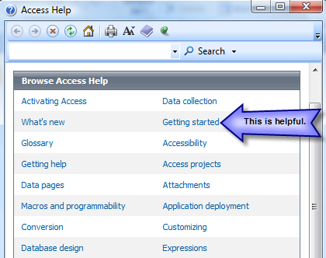
- Access is not forward compatible, meaning that older versions of Access cannot recognize newer file formats without converting them to the older file format. Access 2007 can open database files created in earlier versions; however, Access 2007 can only provide the same level of functionality as the original Access program.
- For help, click the Access Help question mark icon above the rightmost end of the ribbon. The Access Help window appears and allows you to search online and offline articles and topics.

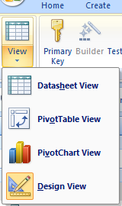
Datasheet and Design Views
- Datasheet view allows you to enter and see your data presented in a spreadsheet-type format.
  - Entering the data in an existing table in datasheet view is easy; just use the keyboard tab key or arrows to move around in your table.
- Design view allows you to create a new table by entering fields, data types, and so on.
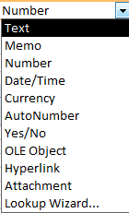
- Setting up a table in design view allows you to format the data type as:

Let’s Get Started!
Part I— Open Access and create a blank database.
- Before you click on the “Create” button, be sure you change the name from database1.accdb to NUTRITION FIRST LAST NAME. Also, change the location that the database file will be saved from the C: drive to your network folder. (Be sure to create a new folder for all of your database files. Call it Access.) Then click on the Create button.
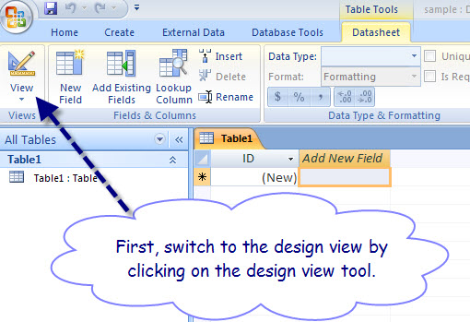
- Next, switch to design view. When you are prompted to save your new table, save it as “FAST FOOD XXX” (replace XXX with your last name)

- Now, create a Table in Design View listing the fields and data type.
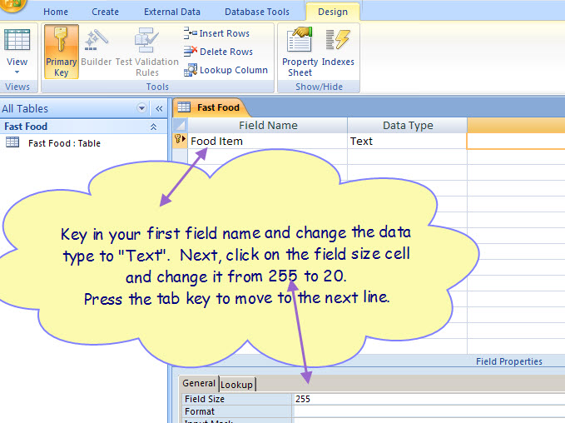
35

- Continue adding the remaining field names using this illustration as a guide. Note: Change the field size of the first two text fields from the default of 255 to 35. 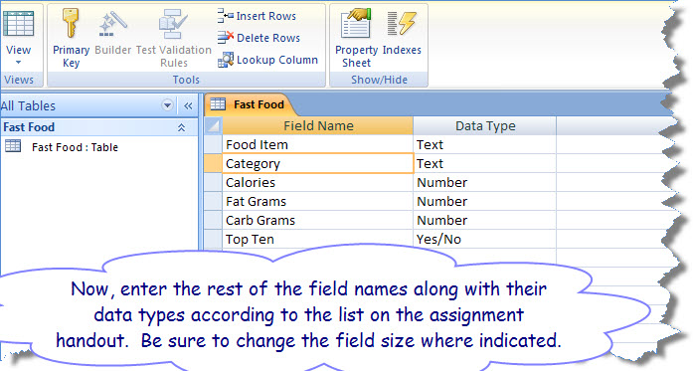

- You do not need a primary key for this database. To remove the primary key, move your cursor to the Food Item field name, and then click on the Primary Key icon that is located on the ribbon.
- After you have the six field names, their data types ,and field sizes entered, please close the table calling it FAST FOOD last name
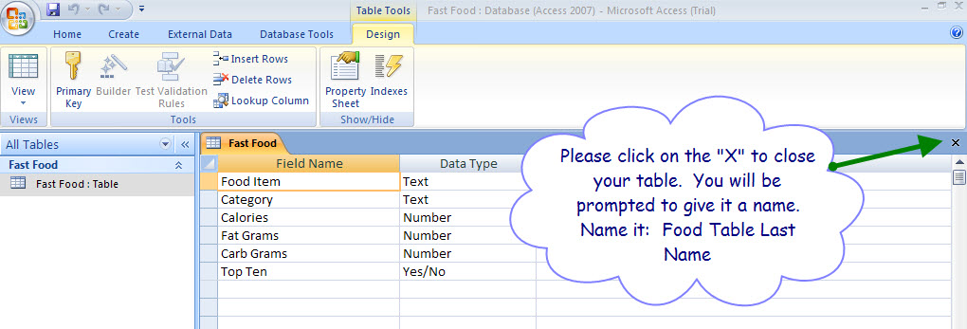

- FYI: What you just did was set up the “structure” of your database. Now add the ten records that are shown in the following illustration:
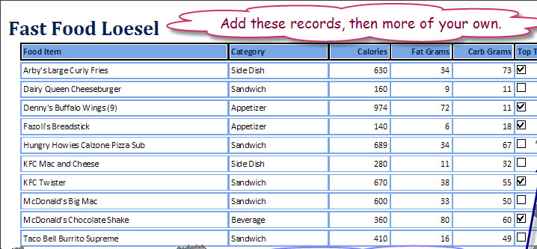

When you are done, proofread carefully. Change the page setup to landscape orientation. Print one copy of the Food Table XXX database table. Before printing, run spell check and make sure all text and column titles are viewable in Print Preview. Your table must print on 1 page. Sort your table items from A-Z by Restaurant.
Part II – It’s time to learn how a query works. A query is a database object that you create to answer questions, view, modify, or delete data, or to analyze data in a database. You can set criteria to display certain data. A saved query can be run anytime, and it will include any new data that you may have added to your database. Let’s say you need to quickly determine which of your favorite food items have the highest calorie count. Creating and running a query makes this task simple. To create a simple query:
- Create a query in design view by clicking on the Query Design Tool on your ribbon.
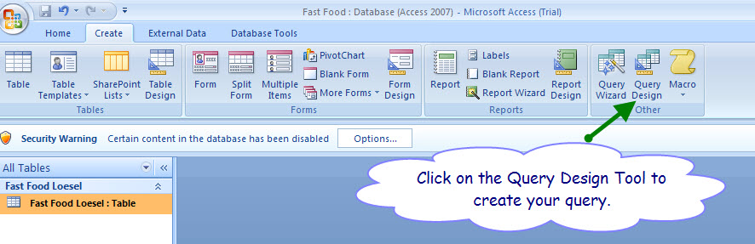

- The Show Table dialog box will appear first. With the Fast Food Table highlighted, click on the “Add” button. Then click on the “Close” button. 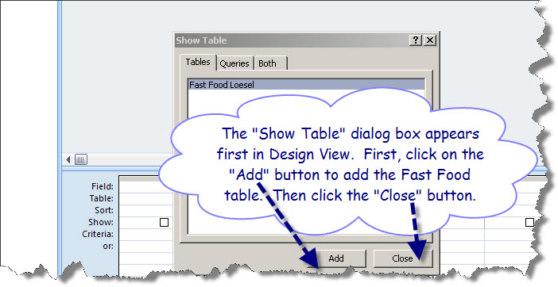
- Add four fields of the Fast Food Table to your query search: Food Item, Category, Calories, and Top Ten. 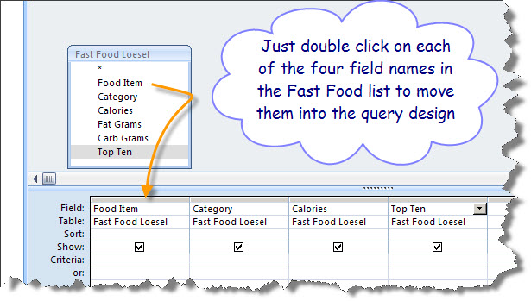
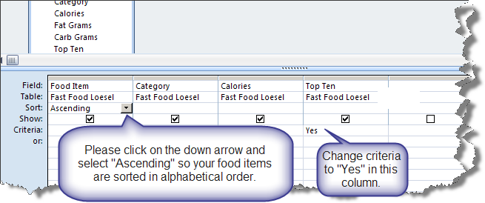
- Sort the Category field in ascending order so it will be easy to see which foods are the highest in calories. Change the Criteria in the Top Ten field to “Yes” so only food items that are your favorites are included when you run the query.
- Run the query. Then print the query.
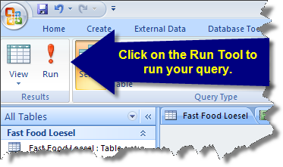

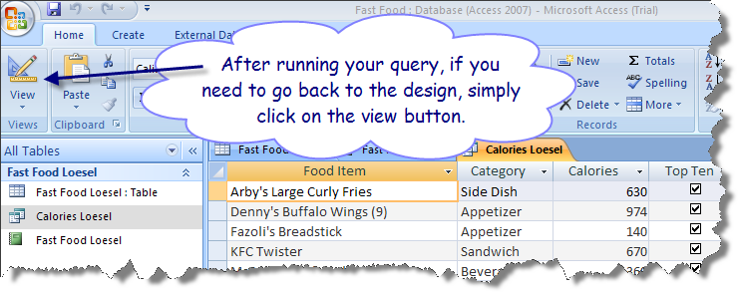

- Close the Query. Save the query as Calories XXX. (Replace XXX with your last name.)
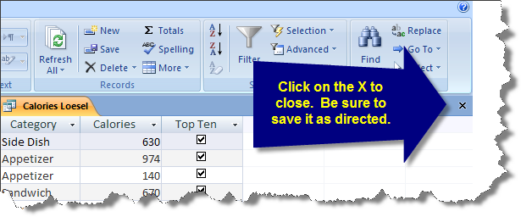

PART III —Your next challenge is to print a list of low calorie foods.
- Create another query that shows each of the food items available that are less than 300 calories. 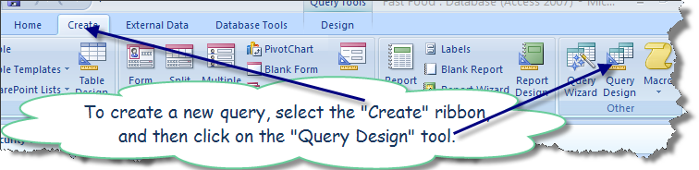
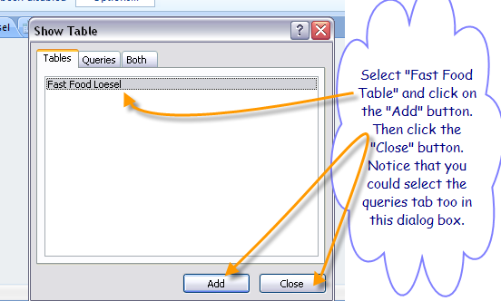
- Use the Fast Food Table.

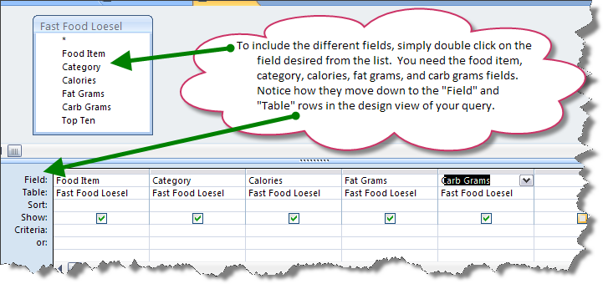
- Next, include the food item, category, calories, fat grams, and grams fields.

- Change the Criteria in the Calories field to <300 so only food items that are less than 300 calories are included. Run the query.
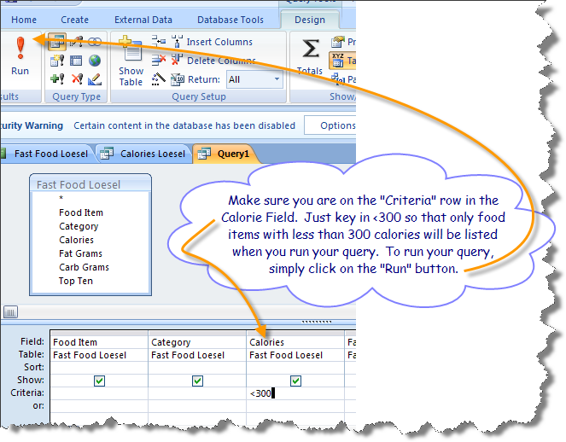

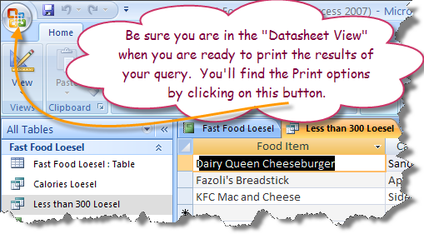
- Print the results of your query. Then, close the query. (Do you remember which X to click on?) Save this query as Less than 300 XXX. (Replace XXX with your last name.)

PART IV — You need to print a report that shows all of the information in a professional looking document. Reports are database objects that use the data in your tables and queries to create a presentation-quality printout. Like queries, once you create a report, you can open and print it later and it will include any new or updated information.
- Use the Report Wizard to create a report using the Fast Food Table.
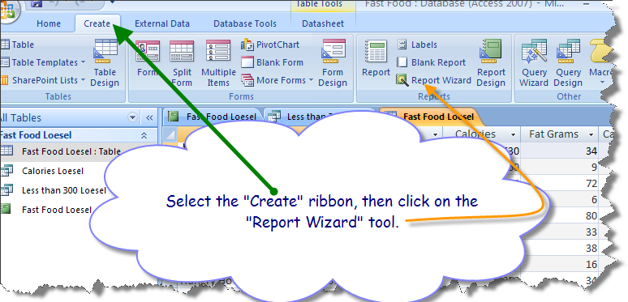

- Include all fields. 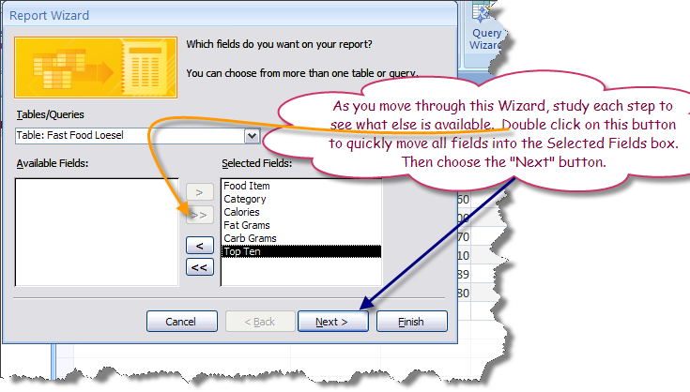
- Group by the Category field. 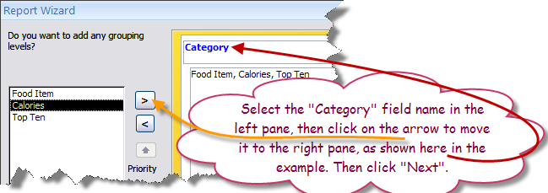
- Sort the Food Item field in ascending order. 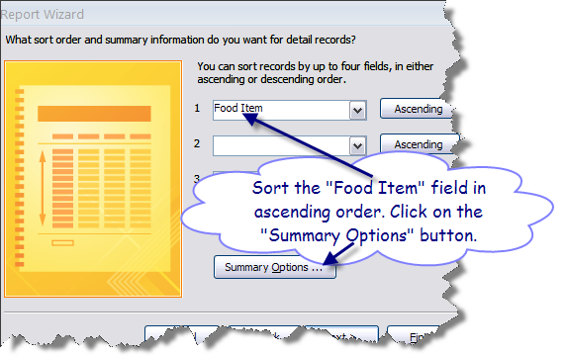
- In the same dialog box, click on the Summary Options button and click on Sum for the Calories field. Show Detail and Summary. 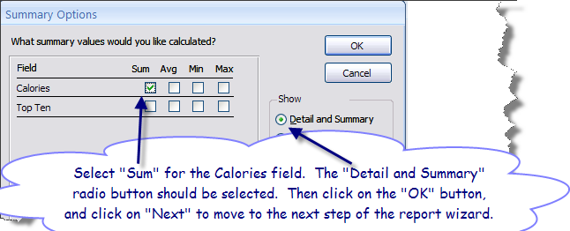
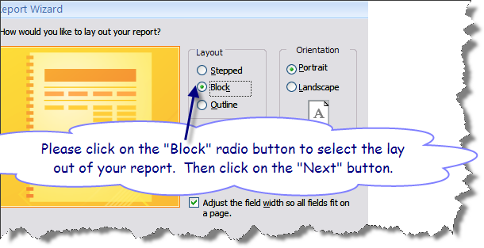
- Select the Block layout in portrait orientation. Choose the compact style.

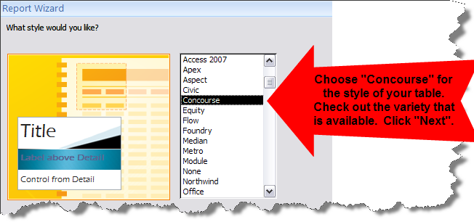
- There are so many styles for you to choose from. Select “Concourse” and then click on the “Next” button.

- Title the report “Fast Food XXX.” (Replace XXX with your last name.)
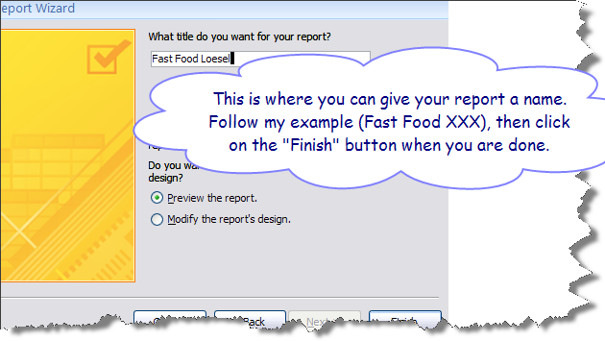
- What appears on your screen is a preview of your report so you can check out the appearance of your report. In “Layout” view, make any necessary changes to better align the data on your report. You can also make changes in the “Design” view. Make some changes and then switch to the “Print Preview” view to evaluate your progress. 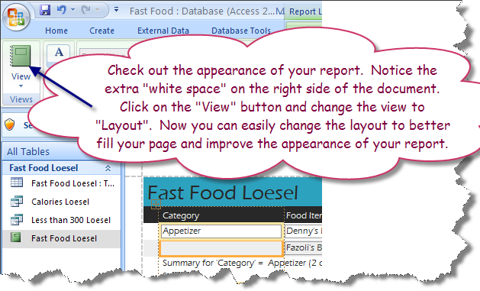
- If necessary, change the size of columns if they are not wide enough. Simply click on the “handles” and stretch a column or push it over to make it smaller to eliminate unnecessary space. Be sure that all of your information shows in each column. Just switch between views to check your progress. You will find that it is easy to make changes to make sure your report looks professional.
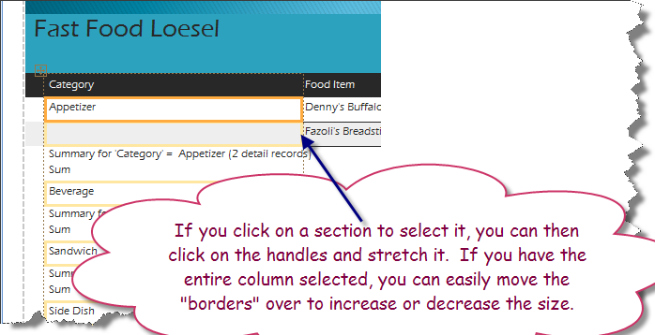

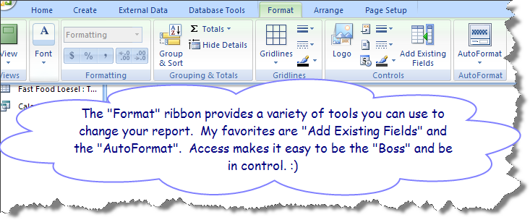
- There are a number of ways to improve the appearance of your report after the Report Wizard is finished. The “Format” ribbon is an option when you are in the “Layout” view.
- When you have finished improving the format, please print your report. Just switch to the “Print Preview” view, and then click on “Print Preview” to open the ribbon. You can change from portrait to landscape orientation, and you can also change the margins.
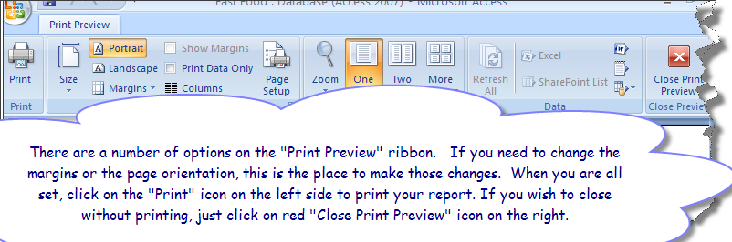

BONUS CHALLENGE POINTS — With your report open, click on the Word button and export your report as a RTF file. MS Word will automatically open up. Add your name, date, and filename in a header, include a graphic, and do something to improve the appearance of your report. When saving the file in Word, be sure to change the document type to a Word document. Print a copy of this new report after you have made the changes.

Part V — Finally, add ten more of your favorite fast food items gleaned from ChowBaby.com to your FAST FOOD XXX table. When you are adding your food items, it may be difficult to decide on a category. Don’t sweat it; just choose the one that seems to be the best fit. Here are five that may work: appetizer, side dish, main dish, beverage, dessert. One thing you must do is try to get several items for each category.
Then print your new fast food table, the two queries, and your report showing the new fast food items.

