Microsoft Access 2000

Practical 8

In this practical, you will learn how to create parameter queries. You will also learn how to create queries using the Structured Query Language (SQL), which is a language used in querying, updating, and managing relational databases. You should first read the information given in this practical and then complete the activities listed throughout this practical.

We start this practical by presenting an overview of the types of queries provided by Microsoft Access.

Microsoft Access Queries

As well as select queries, you can also create many other types of useful queries using Microsoft Access. Table P8-1 presents a summary of the types of queries provided by Access.

Query Type | Description
Select Query | Asks a question or defines a set of criteria about the data in one or more tables.
Parameter Query | Displays one or more predefined dialog boxes that prompts the user for the parameter value (criteria).
Find Matched Query | Finds duplicate records in a single table.
Find Unmatched Query | Finds distinct records in related tables.
Crosstab Query | Allows large amounts of data to be summarized and presented in a compact spreadsheet format with row and column headings.
Autolookup Query | Automatically fills in certain field values for a new record.
Action Query  (including delete, append, update and make-table queries) | Makes changes to many records in just one operation. Such changes include the ability to delete, append, or make changes to records in a table and also to create a new table.
SQL Query  (including union, pass-through, data-definition, subquery SQL) | Union SQL query combines matching fields from two or more tables. Pass-through SQL query sends commands to an SQL database. Data-definition SQL query creates, changes or deletes tables.

Table P8-1: Summary of Microsoft Access Query Types.

Creating Parameter Queries
If you frequently run the same select query but you change the criteria each time you run it, you can save time by creating a parameter query. When you run a parameter query, you do not have to open the Query window and make changes to the QBE grid; instead, Microsoft Access prompts you for criteria in the Enter Parameter Value dialog box.

If you design a parameter query that prompts you for more than one criterion, Microsoft Access displays successive dialog boxes for each criterion. Note that you can enter values into the Enter Parameter Value dialog box, but you cannot enter expressions.
To create a parameter query

1. Create a query without using a Wizard, and add the tables you want.

2. Drag the fields for the query to the QBE grid.

3. In the Criteria cell under each field you want to use as a parameter, enter a prompt enclosed in square brackets. Microsoft Access displays this prompt when the query is run. The text of the prompt must be different from the field name, though it can include the field name. An example QBE grid for a parameter query is shown in Figure P8-1.

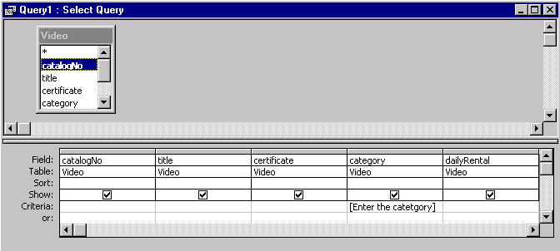

Figure P8-1: Creating a parameter query for the Video table.

4. Run the query by clicking the View button or Run button button on the toolbar. Microsoft Access displays the Enter Parameter Value dialog box, as shown in Figure P8-2.

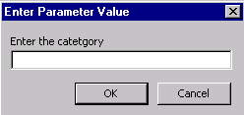

Figure P8-2: The Enter Parameter Value dialog box for the parameter query created in Figure P8-1.

5 . Enter a value, and then choose OK.

Microsoft Access retrieves the data and displays the dynaset. Or, if you have specified more than one parameter, Microsoft Access prompts you for the other parameters and then displays the dynaset.

Prompting for Several Parameters

You can also create queries that prompt you for several parameter values. You can specify parameters in each of several fields, or multiple parameters in a single field. For example, to display the details of videos with a daily rental rate between certain maximum and minimum rate, we create a query that prompts you with two successive dialog boxes. The QBE grid for this query is shown in Figure P8-3.

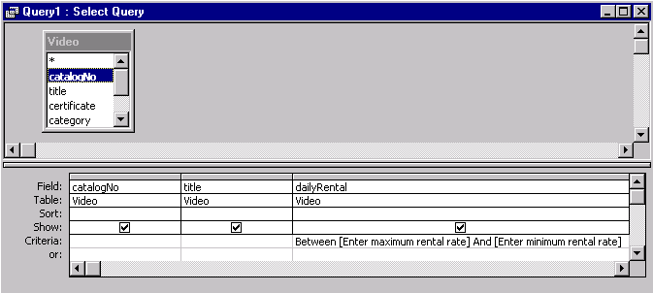

Figure P8-3: Creating a parameter query for the Video table using multiple parameters in the dailyRental field.

When the query is run, Microsoft prompts you with successive dialog boxes. By entering the maximum and minimum rental rates into each dialog box, you specify the range of rental rates you want.

Activity P8-1

Create and save the following parameter queries:

- To display the details of videos in a given category (as shown in Figure P8-1).
- To display the details of one or more members given the last name.
- To display the details of a member given the member’s number.
- To display the details of one or more members given the first name and last name.
- To display the member number, full name, and address of members who had rented out a video, between certain dates.
- To display the details of videos with a daily rental rate between certain maximum and minimum limits (as shown in Figure P8-3).

Create any other useful single or multi-parameter queries.

Using SQL in Microsoft Access

Structured Query Language (SQL) is a language often used in querying, updating, and managing relational databases. Each query created in Microsoft Access has an associated SQL statement that defines the actions of that query. You can use SQL statements to:

View and modify queries you created using the QBE grid
For every query you create using the QBE grid in Design view, you can view and make changes to its SQL statement.

Set properties
You can use SQL statements when setting form and report properties, such as Record Source and Row Source.

Create SQL-specific queries
For some types of queries, you must use SQL statements. Union queries, pass-through queries, and data-definition queries cannot be designed using the QBE grid.

Create subqueries
To create a subquery, you use the QBE grid, but you enter an SQL SELECT statement for criteria.

Using SQL to View and Modify Queries

When you create a query with the QBE grid, Microsoft Access constructs the equivalent SQL statement behind the scenes. You can view or modify the SQL statement, rather than use the QBE grid. After you make changes to the SQL statement, the changes are reflected in the QBE grid.

To view or modify an SQL statement

- Create a query, or open an existing query in Design view.

2. From the View menu, choose SQL View.

Microsoft Access displays the query in SQL view. This view is of the SQL statement that is equivalent to what you created in Design view. The SQL statement for the query created in Figure P8-1 is shown Figure P8-4.

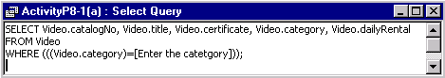

Figure P8-4: SQL View of parameter query created in Figure P8-1.

3. If you want to make changes, enter the changes into the SQL statement.

4. To return to the QBE grid select from the View menu, choose Design View.

The QBE grid reflects the changes you made.

Activity P8-2

Examine each of the queries you created for Activity P8-1 in SQL view. If you have saved any queries created in earlier practicals, also examine these queries in SQL view.

Now re-examine the queries for Activity P8-1(a) to (f) using the QBE grid. Convert your parameter queries into standard select queries by carrying out the following modifications (shown underlined) to these queries using the QBE grid and note the changes reflected in the corresponding SQL statement. Also, run the queries to ensure that they retrieve the correct information.

- To display the details of videos in category “Comedy” or “Children”.
- To display the details of one or more members with “Smith” as the last name.
- To display the details of member number “4”.
- To display the details of one or more members with last name “Smith” and first name “Lorna”.
- To display the member number, full name, and address of members who have rented out video number “1”.
- To display the details of videos with a daily rental rate that is less than 4.00.

Creating Tables with Access SQL

You can create tables in your database using the Access SQL.

- CREATE TABLE table_name (field_name data_type [(field size)][, field_name data_type...]) creates a new table with the fields specified by a comma-separated list. (For field names with spaces enclose entries with in square brackets). The field_size entry is only optional for Text fields.

- CONSTRAINTS index_name {PRIMARY KEY (field_name)|UNIQUE (field_name)| |FOREIGN KEY (field_name) REFERENCES foreign table [(foreign_field)]} creates an index on the field name that follows the expression. You can specify the index as a PRIMARYKEY or as an UNIQUE index. You can also establish a relationship between the field and the field of a foreign table with the REFERENCES foreign_table [foreign_field] entry.

- ALTER TABLE allows you to add new fields (ADD COLUMN field_name...) or delete existing fields (DROP COLUMN field_name...).

- DROP INDEX index_name ON table_name deletes the index from a table specified by table_name.

- DROP TABLE table_name deletes a table from the database.

Note that, the Access SQL statement must terminated with a semi-colon (;).

The Access SQL statements to create tables called Branch and Staff are shown in Figures P8-5 and P8-6, respectively.

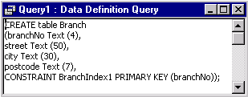

Figure P8-5: Creating the Branch table using Access SQL.

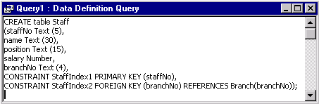

Figure P8-6: Creating the Staff table using Access SQL.

Activity P8-3

Open your StayHome database and create the Branch and Staff tables using Access SQL (as shown in Figures P8-5 and P8-6). Use the CONSTRAINT clause of the CREATE TABLE statement to create primary keys for the tables and to establish the relationship between these tables.

Writing Select Queries in SQL

When you create a select query using QBE, Access translates the QBE query into an Access SQL statement. Every select query begins with the SELECT statement. The syntax for the basic SQL SELECT statement is shown overleaf.

SELECT [ALL|DISTINCT|DISTINCTROW] select_list
FROM table_names
[WHERE search_criteria]
[ORDER BY column_criteria [ASC|DESC]]

The following list describes the purpose of the elements in the basic select statement.

- SELECT is the basic command that specifies the query. The select_list parameter determines the fields (columns) that are to be included in the results table of the query. When you design an Access QBE query, the select_list parameter is determined by the fields you add to the Field row in the Query grid. Only those fields with the Show box ticked are included in the select_list. Multiple fields are separated by commas. The optional ALL, DISTINCT and DISTINCTROW qualifiers determine how rows are handled. ALL specifies that all rows are to be included, DISTINCT and DISTINCTROW have a similar function in eliminating duplicate rows.

- FROM table_name specifies the name or names of the table(s) that form the target of the query. The table_names parameter is created in Access QBE by the entries from the Show Table dialog box. Commas are used to separate multiple tables.

- WHERE search_criteria determines which records from the select list are displayed The search_criteria parameter is an expression with a text (string) operator such as LIKE for text fields or a numeric operator such as >= for numeric values. The WHERE clause is optional and if absent all rows are retrieved.

- ORDER BY column_criteria specifies the sorting order of the records in the results table. ORDER BY is optional.

An example of a simple SQL statement to query the Video table and the resulting datasheet are shown in Figures P8-7 and P8-8, respectively.

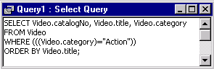

Figure P8-7: Creating a Select query on the Video table using Access SQL.

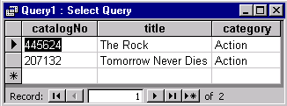

Figure P8-8: The datasheet created on running the Select query shown in Figure P8-7.

Activity P8-4

Using Access SQL, create simple select queries on the tables of your StayHome database. For example, create and save the following queries on the Video table.

- List the catalogNo, title and category of the Video table, ordered by video title (as shown in Figures P8-7 and P8-8).
- List title, certificate, category and dailyRental of the Video table for videos in the “Childrens” category with a rental rate less than £4.00.
- List all videos with a certification of “PG” or “18”in the Video table.

Using the SQL Aggregate Functions

If you want to use the aggregate functions to determine totals, averages or statistical data for groups of records with a common attribute value, you add the GROUP BY clause. You can further limit the result of the GROUP BY clause with the optional HAVING qualifier.

SELECT [ALL|DISTINCT|DISTINCTROW]
aggregate_function (field_name) AS alias [, select_list]
FROM tables_names
[WHERE search_criteria]
[GROUP BY group_criteria]
[HAVING aggregate_criteria]
[ORDER BY column_criteria]

The select_list includes the aggregate function with a field_name as its argument.

- AS alias assigns a caption to the column.

- GROUP BY group_criteria establishes the column on which the grouping is based.

- HAVING aggregate_criteria is one or more criteria applied to the column that contains the aggregate function. The aggregate_criteria of the HAVING is applied after the grouping is complete. WHERE search_criteria operates before the grouping occurs.

An example of a SQL statement using the aggregate functions (COUNT and SUM), and the GROUP BY and HAVING clauses to query the Videos table and the resulting table are shown in Figures P8-9 and P8-10, respectively.

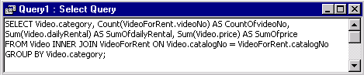

Figure P8-9: Creating an Aggregate query on the Video table using Access SQL.

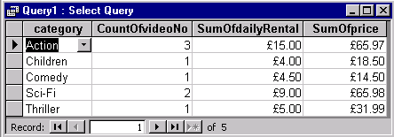

Figure P8-10: The datasheet created on running the Aggregate query shown in Figure P8-9.

Activity P8-5

Using the Access SQL, create select queries on the tables of your StayHome database. For example, create and save the following queries on the Video table.

- For each video category, list the total number of videos, the total daily rental rate and total price of videos (as shown in Figures P8-9 and P8-10).
- List the total number of videos with a certification of “PG” or “18”.
- List the maximum and minimum daily rental rate for videos in each category.

Creating Joins with SQL

Joining two or more tables with Access QBE uses the JOIN_ON clause that specifies the tables to be joined and the relationship between the fields on which the join is based.

SELECT [ALL|DISTINCT|DISTINCTROW]
FROM tables_names
{INNER|LEFT|RIGHT} table_name JOIN join_table ON join_criteria
[{INNER|LEFT|RIGHT} table_name JOIN join_table ON join_criteria
[WHERE search_criteria]
[ORDER BY column_criteria]

- table_name JOIN join_table specifies the name of the table that is joined with other tables listed in table_names. Each of the tables participating in a join must be included in the table_names list.

One of the three types of joins, INNER, LEFT or RIGHT must precede the join statement. INNER specifies an equi-join: LEFT specifies a left outer join and RIGHT specifies a right outer join.

- ON join_criteria specifies the two fields to be joined and the relationship between the two joined fields. The join_criteria expression contains an equal sign (=) comparison operator and returns a true or false value. If the value of the expression is True, the record in the joined table is included in the query result.

An example of an INNER JOIN (natural join) between the Member and RentalAgreement tables using Access SQL and the resulting datasheet are shown in Figures P8-11 and P8-12, respectively.

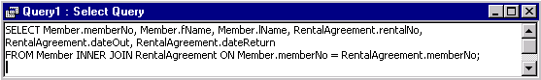

Figure P8-11: Creating an INNER JOIN between the Member and RentalAgreement tables.

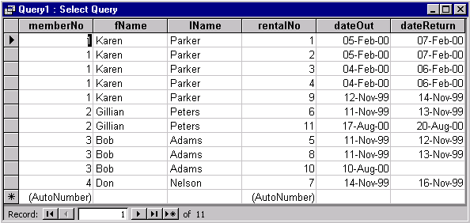

Figure P8-12: The datasheet created on running the Inner Join query shown in Figure P8-11.

Activity P8-6

- Using Access SQL, create an INNER (natural) join between the Member and RentalAgreement tables to display only the memberNo, fName, lName, rentalNo, dateOut and dateReturn fields (as shown in Figures P8-11 and P8-12).

Investigate the effect of changing the join type between the Member and RentalAgreement tables to a LEFT (outer) join and then to a RIGHT (outer) join.

- Create an INNER (natural) join between the VideoForRent, RentalAgreement and Member tables to display only the catalogNo, videoNo, dateOut, dateReturn, memberNo, fName and lName fields.

Creating Subqueries

A subquery is an SQL SELECT statement inside another select query. You can create a subquery that defines a field, or you can use a subquery to define criteria for a field.

In many cases, SQL statements that include subqueries can be formulated either as a join or as one query based on another. For example, say you wanted to find all videos with a daily rental rate the same as the rental rate of a video called “Independence Day”. You can create one query that finds the daily rental rate of “Independence Day”. Then you can create another query based on the first query. The second query finds all videos with the same rental rate as that found in the first query. Or you can create a subquery that performs everything in one operation.

You can write a SELECT query that uses another SELECT query to supply the criteria for the WHERE clause. The general syntax of a sub-query is as follows.

SELECT field_list
FROM tables_list
[WHERE [table.name.]field_name
IN SELECT select statement
[GROUP BY group_criteria]
[HAVING aggregate_criteria]
[ORDER BY column_criteria]

An example of a subquery and the resulting datasheet is shown in Figures P8-13 and P8-14.

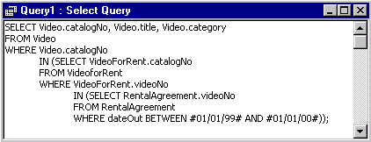

Figure P8-13: An example of a Subquery (nested query) on the Video, VideoForRent and RentalAgreement tables.

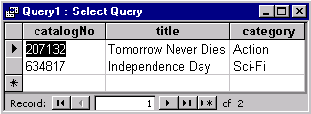

Figure P8-14: The datasheet created on running the Subquery shown in Figure P8-12.

For more information on the syntax for subqueries and useful examples of subqueries, search Help for "SQL: subqueries."

Activity P8-7

Using the Access SQL, create select subqueries on the tables of your StayHome database. For example, create and save the following queries.

- List the catalogNo, title and category fields of the Video table for those videos that were rented out between the 1st January 99 and the 1st January 00 (as shown in Figures P8-13 and P8-14).
- List the details of the videos with a certification of “PG” or “18” that were rented out to member number “3”.
- List the videoNo, dateOut and dateReturn fields of the RentalAgreement table for videos with a certification “U”.

Activity P8-8

Return to Table P8-1 of this practical and examine the range of queries provided by Microsoft Access. Ensure that you understand the purpose of each type of query and attempt to create and run some of the queries not covered in detail in this practical

