6 FORMS

Forms provide a user-friendly interface for data entry, which avoids the use of the Datasheet View format. A form contains no data of its own, but provides a window for viewing the table or query. Exhibit 6.1 is a sample form from the Northwind database that can be used for input into the Products table of the Northwind database. You may view other sample forms in the Northwind database that accompanies the Access program.

How to create a form

To create a form object:

- Select Forms/New/Design View.

- From the list box select the table for which you will provide input data. Now select the Courses table from the scroll down window box.

- Click OK.

The Design View gray grid should open, and a small box called a field list containing the fields of the Courses table should open for use:

- Maximize the Design View Window and stretch the gray grid to cover the entire screen.

- Click and drag the desired field values from the field list to the gray grid. For our first form, select all fields in the table and place them on your grid. (To select more than one field, hold the control key down while making your selection).

  - While in the field list for the Courses table, click on the desired field or fields.
  - Drag and drop each field onto the gray grid.
  - Adjust all fields for viewing. Make sure your text box is large enough to view its content.
    - On your gray grid there should appear a combo box, containing a white text box combined with a gray label box.
    - The white text box is used to for data input. The gray label box contains the title or caption of the text box for the reader will view.
    - See for yourself… view the form in Form View….

- View your form in Form View.
  - Notice that the text box contains the content of a single record from the Courses table. This record is the first of twelve records that were previously entered in the Courses table.
  - You can view all existing records in the Courses form by advancing the record number at the bottom of the form.
  - Now look at the form in Datasheet View. These are the same records you viewed in Form View.

- Select Design View again and make the following alterations to the label caption:
  - Stretch the labels on the form grid to make these labels more visually attractive.
  - Click inside the label box and highlight the contents:
    - Change the captions to all CAPITAL LETTERS.
    - Change the font color to red.
    - Change the font type to bold.
  - Provide the following modifications to the form:
    - Align the label boxes and text boxes as follows:
    - Align all labels so they are left justified and all letters of each label’s caption are visible in Form View.
    - Align all text boxes so they are right-justified and all contents of the text box are visible in Form View.

- Save the form as frmCoursesXX, where XX represents your initials.

Now lets create a graphics logo for your form. In Design View:

  - Open the toolbox icon from the menu bar.

  - Select the unbound object icon from the open toolbox.

  - Select the “Microsoft Clip Gallery”.

  - Choose any clipart from among the “Academic” ClipArts. Insert it in your form.

  - Resize the inserted clipart. If you have trouble resizing, right-click and choose

All properties/Size mode/Stretch. This will fit the object in the window you have created.

  - View the Form again in Form View. Continue to modify the form until your are satisfied with its appearance.

  - Save the form frmCoursesXX again.

To create a label for your form and place it under the clipart image:

  - Select the toolbox icon.

  - Select the label icon and drag it onto the gray grid beneath the clipart image.

  - Resize the label and insert the caption below in your label:
Student Enrollment Form
Created by Your Name

- Highlight the handle on the label box and right-click.
- From the Formatting Menu (top of form), make any necessary changes in the font size and color.
- Also from the Formatting Menu, select a background color for your form.
- View the form in Form View.

- Save the form frmCoursesXX again. Your form should be similar to the one presented in Exhibit 6.2.
Protect the contents of the form

It is important to “lock” the contents of your form to protect the user’s ability to change the information in a field. This is done through the modification of properties for specific objects of the form in Design View for frmCoursesXX as follows:

Open the form in Form View.

- Select the textbox for the field "DeptCode" and right-click.

- Every object on the form has Properties that control the behavior of that object.

- Select the Properties option for DeptCode and click it open.

With the ALL menu tab selected, scroll down to the “Locked” property and choose the “Yes “ option.

- This will protect the value in this textbox until the Locked property is overridden.

- Select Form View. View the results.

- After viewing the form with a locked DeptCode property, unlock the locked property and set the locked property to "No". View the form in Form View. What differences do you detect?

- Save the changes to frmCoursesXX.

Exhibit 6.1 Northwind Database Sample Form

Exhibit 6.2 Create a Form from CoursesXX Table
.

7 SUBFORMS

A columnar main form with a tabular subform is a useful way to represent information from tables with a one-to-many relationship. The main form of this combo form shows each unique record (unique, based on the primary key). Because the subform is linked to the main form, it lists the many sub records for the single record in the main form. Exhibit 7.1 illustrates a form/subform object for the Products table in the Northwind database.

How to create the form/subform combination in Design Wizard

A. Create a columnar main form.

B. Create a tabular subform.

C. Combine the form and subform.

D. Link the form and subform.

Creating the main form

Recall the one-to-many relationship:

1 M
Has

Course

Sections

We will create a form from the Courses table where every (one) course is unique. Then we will create a subform containing many sections for each course. Let’s begin with the main form.

- Use the Form Wizard to create a columnar form based on the Courses table.
  - Click on “Create form using form wizard”.
  - Select the table Courses as the source table for your new form. Follow the Wizard instructions as seen in Exhibit 7.2
  - Select >> to transfer all fields at once, or > to transfer one field at a time.
  - Open the form in Design View.
  - Rearrange the labels and text boxes in Design View as illustrated below.

Department Code: Credit:

Course:

Title: Activity:

- Save the form as frmCoursesMainXX again.

Creating the subform

- Using the wizard to create the subform:
  - Select Form Wizard “Create form using form wizard”.
  - Choose a table or query as the source for the new form (Sections).
  - Complete the Form Wizard.
  - Save the form as sfrmSectionsXX. (Exhibit 7.3).

Combining both forms

- In order to attach the subform to this main form we need to have both open on the screen at the same time.

- Open the main form frmCoursesMainXX in Design View. Select Windows/Cascade from the menu bar. FrmCoursesMainXX should open but appear smaller on the screen.

- Open the database window and select the Forms object. Select Windows/Cascade from the menu bar. The database window should also appear smaller on the screen.

- Drag the frmCoursesMainXX toward the top of your screen, and drag the open database window toward the bottom of your screen.

- Now let's combine the form and subform:

  - From the open database window, click on the sfrmSectionsXX form and drag it to the bottom of the frmCoursesMainXX form.
  - Are they attached? Good!

- Save frmCoursesMainXX.

- View frmCoursesMainXX with the attached sfrmSectionsXX in Form View. It should resemble the one pictured in Exhibit 7.4.

- Return to Design View, of the newly combined form, and resize the subform portion until you are satisfied with its appearance. The two should fit together like a puzzle.

Now that the two forms are combined, you can enter data about multiple sections (subform) for each single Course (form).

Exhibit 7.1 Northwind Database
Sample Form with Subform

Exhibit 7.2 Main Form frmCoursesMainXX
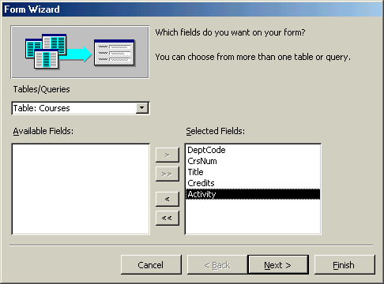
1. Select a table named Courses

2. Select Columnar layout
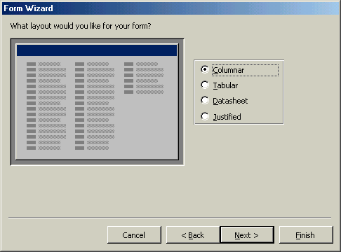

3. Select a style

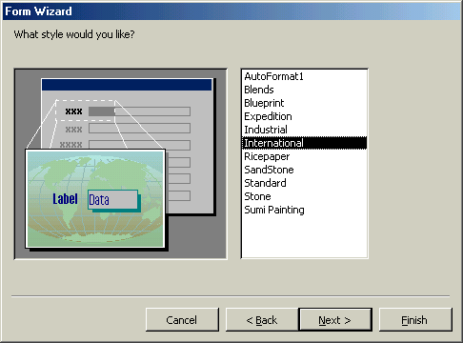
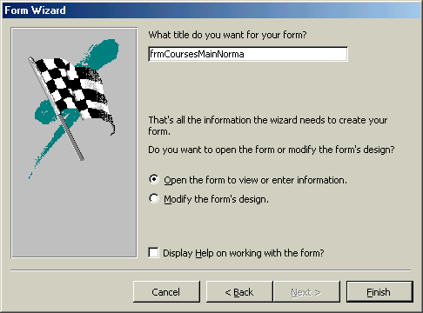
- Name of Form is frmCoursesMainXX

Exhibit 7.3 Creating Subform sfmSectionsXX

Exhibit 7.4 Form With an Attached Subform

Exhibit 7.5 Design View
Attached Form frmCoursesMainXX and Subform sfrmSectionsXX

Drag the subform on the grid to resize it. with its form.
In Design View, drag the control boxes to resize them.

Exhibit 7.6 Form View
Attached Form frmCoursesMainXX and Subform sfrmSectionsXX
Enter data in form and subform
at the same time.

Tutorial Assignment C Due Date _______________

Creating Forms and Subforms

A wizard (design wizard, query wizard, form wizard) is an easy to use creative tool that allows Access to automate the creation of an Access object. Let’s use the Form Wizard to create a new form.

In the forms menu:

- Select the Form Wizard.

- Choose a table or query that will be the source of data for your form.

- Select those fields you wish to include in your form.

- Complete the wizard.

- The form should contain existing data. Enter additional data in the form.

- Save the form as MyFormXX.

Cut and paste the following forms to a Word document. Submit all forms in the following views.

1. Submit form MyFormXX
- Design View
- Form View
- Data View

- Submit form CoursesXX
- Design View
- Form View
- Data View

- Submit frmCoursesMainXX
- Design View
- Form View
- Data View

Include your name, assignment number, and section number. Include also a description of the form. Submit the assignment by the due date.

