
MICROSOFT ACCESS 2003 TUTORIAL

MICROSOFT ACCESS 2003
Microsoft Access is powerful software designed for PC. It allows you to create and
manage databases. A database is an organized body of related information that is
arranged for ease and speed of search and retrieval. Some of the examples of
databases are: Jerome Library online catalogue, telephone directories, address books,
cookbooks, tour books, etc.
Most BGSU offices and departments work with Access as their database application.
The examples in this tutorial present common features of databases used on campus.
Microsoft Access is equipped with a few options that help you to enter, organize, and
edit data in an easy and intuitive way. You can also effectively perform such tasks as
storing, filtering, and retrieving data, as well as asking questions about the data and
receiving instant answers. In Access, you can create professional reports and save your
data in HTML format for viewing in a browser.
Microsoft Access 2003
2

PLANNING YOUR DATABASE
Creating and working with databases in Microsoft Access requires thorough planning. If
you plan your database in advance, it will save you a lot of time and effort later. Follow
these guidelines before you start creating your database:

Determine the purpose of your database (this will help you decide what
information to include, and how to organize your fields)
Include only related information (this will make your database more meaningful
and easier to work with)
Review existing files that can provide information necessary for your database
(e.g. archives, paper files, electronic files, etc.)
Plan fields in your table ahead of time (list all the fields you need to include in
your table before starting in Access)
Break up fields into smallest meaningful values (e.g. Name into LastName,
FirstName)
Enter data (type in your information)
Finalize design (convert your database into a Form or a Report)
Microsoft Access 2003
3
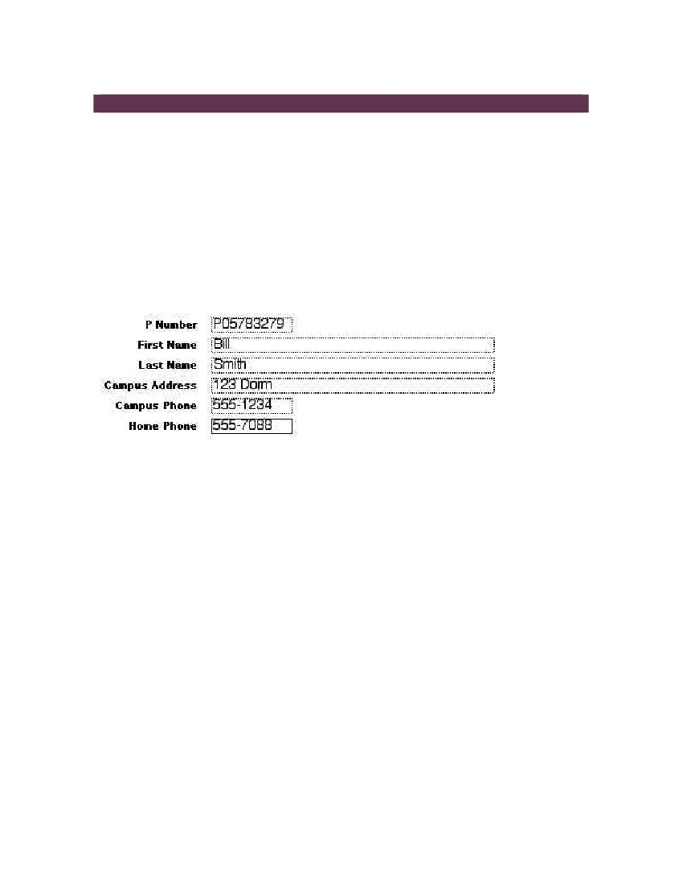
UNDERSTANDING PARTS OF A DATABASE
RECORDS AND FIELDS
Before creating and working with a database, it is important to understand what a
database is and what it is made of.
A database is a collection of related data organized in tables. Tables consist of records
and fields. A record is a row in the table that contains information such as name,
address, phone number, etc. A field is a column that contains categories of information.
For example, each field in the Records table (Figure 1) contains the same type of
information about a person. First Name, Last Name, Address are fields. Each record in
the table (Figure 1) contains all the information about a person. P05783279, Bill Smith,
123 Dorm, 555-1234, 555-7088 is a record.
Figure 1. Record in a database
DATABASE WINDOW
When you open an Access file, whether existing or new, you will see the Database
window. The Database window is the command center of your database; here you can
create and use any object, such as Tables, Queries, Forms, Reports, Pages, Macros,
and Modules (Figure 2). Database objects are the basic components that make up a
database. For the purposes of this tutorial, we will discuss only four objects: Tables,
Queries, Forms, and Reports.
Tables – used to enter, store, organize, and view data. For example, one table could
store a list of students and their IDs, while another table could store the equipment that
the students checked out.
Queries – used to extract data from a database. Queries ask a question of data stored
in a table. For example, a query could display only students who checked out still
cameras.
Forms – used to enter, edit, or view data stored in a table or a query.
Microsoft Access 2003
4
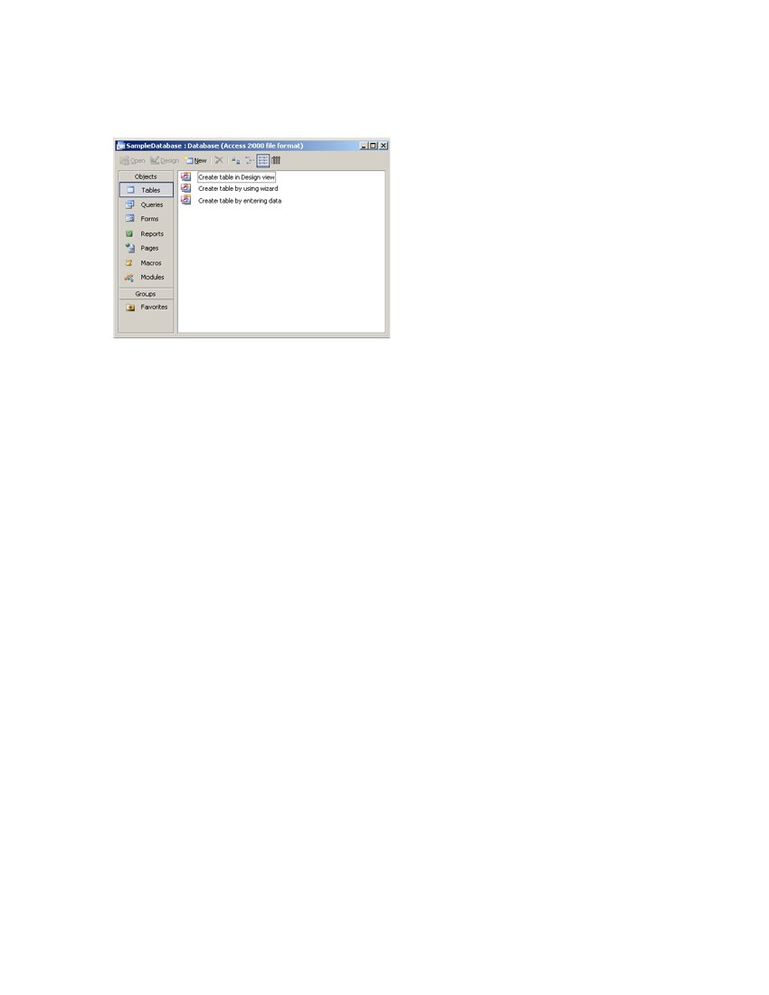
Reports – used to display and print selected information from a table in a visually
appealing customized way.
Figure 2. Database window
Microsoft Access 2003
5
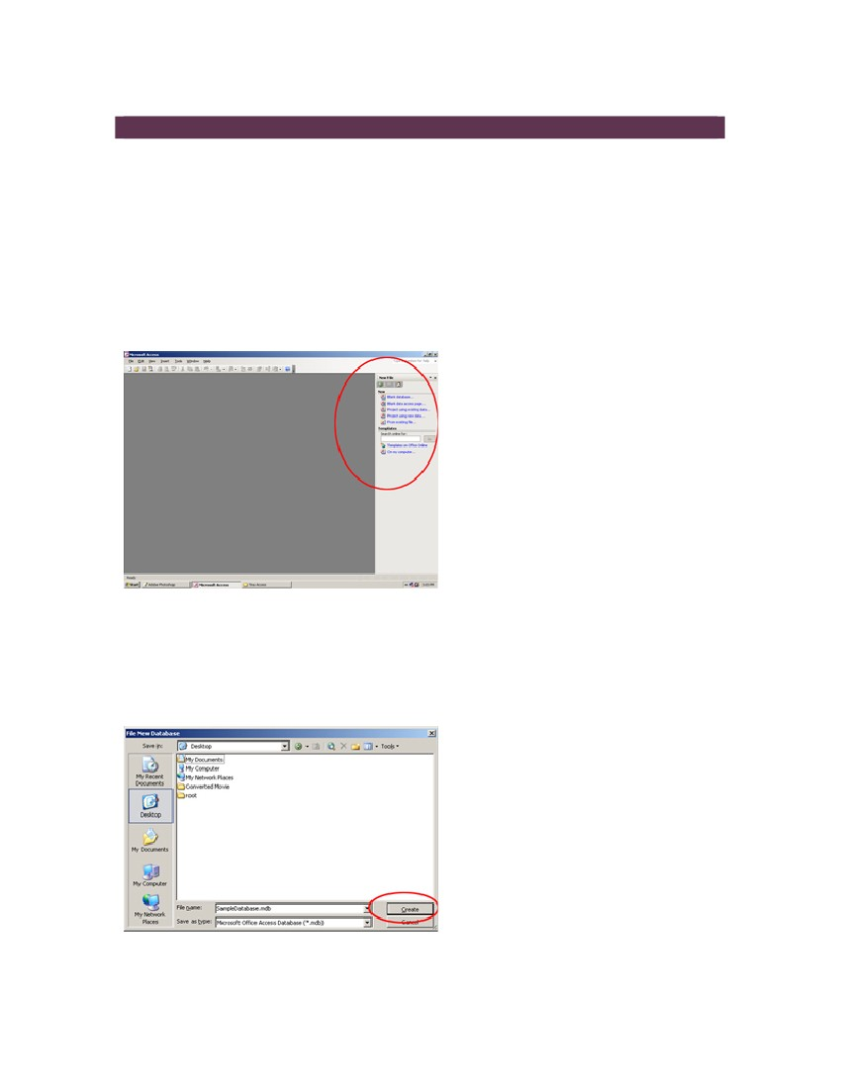
CREATING A DATABASE AND ENTERING DATA
NEW FILE
Once you have a thorough plan, you can start creating your database in Microsoft
Access. To create a new database in Access, follow these steps:
1. Go to Start > Programs > Microsoft Office > Microsoft Access 2003. You will see
the gray screen with Access menu on top.
2. Click File in the menu, choose New. The New File pane will open on the right-
hand side of the screen (Figure 1).
Figure 1. New File pane
3. In the New File pane, select Blank Database option. This will open the File New
Database dialog box.
4. In the File New Database dialog box, type in a name for your database, navigate
to the folder where you wish to save your file, and click Create (Figure 2).
Figure 2. File New Database dialog box
Microsoft Access 2003
6
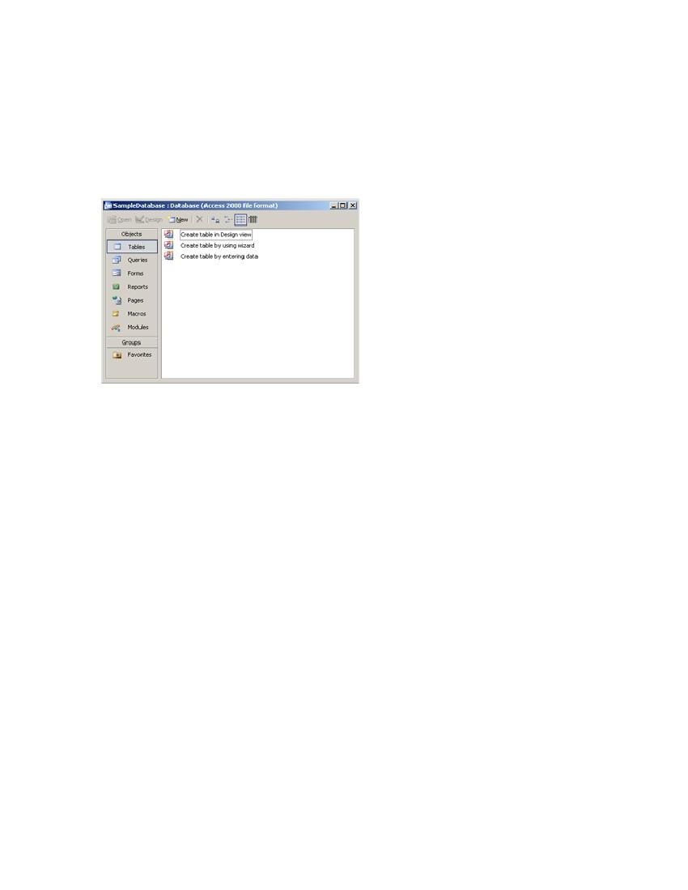
CREATING A TABLE
After saving your database file you will be able to see the Database window. In the
Database window you will see three options for creating tables: Create table in Design
view, Create table by using wizard, and Create table by entering data (Figure 3).
Figure 3. Database window
If you choose the Create table in Design view option, you can name your fields, assign
data type for each field, and format your fields.
Choosing the Create table by using wizard option allows you to create a table by
following instructions in the Table Wizard dialog boxes.
If you decide to use the Create table by entering data option, you can enter data first,
and then do all the formatting.
TABLE WIZARD
Table Wizard is the easiest way to create a table. To create a table in the Table Wizard,
follow these steps:
1. Select Tables from the Objects bar.
2. Double-click the Create table by using wizard option. You will see the Table
Wizard dialog box (Figure 4).
Microsoft Access 2003
7
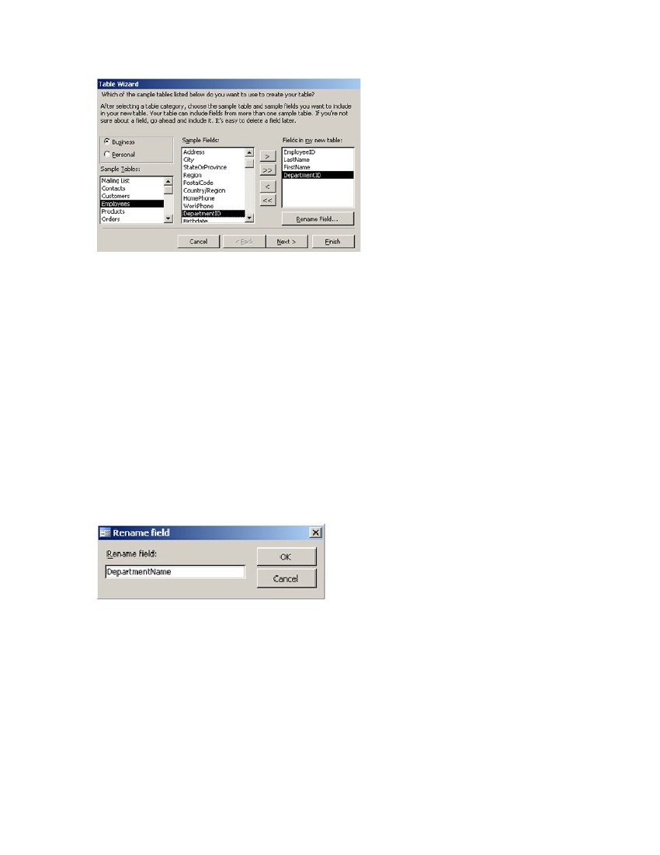
Figure 4. Table Wizard
3. In the Table Wizard dialog box (Figure 4), select your table category, Business
or Personal, by clicking one of the radio buttons.
4. Choose the purpose of your database under Sample Tables (Figure 4) by
clicking on one of the items in the list. You will see that Sample Fields change
for each sample table.
5. Choose content fields for your database from the list under Sample Fields
(Figure 4). To do this, double-click the desired filed. You will see it appear in the
Fields in my new table list box (Figure 4).
NOTE: You can also use the single arrow to move the field into the Fields in my new
table list. Click the double arrow if you wish to move the entire list.
If you need to have customized names for your fields, select the field in the Fields in my
new table list and click Rename. Type in a new name in the dialog box and click OK
(Figure 5).
Figure 5. Rename field dialog box
6. Once you have selected all the fields for your table, click Next.
7. The next step will ask you to name your table and set a Primary Key. Type in
the name for your table (do not use spaces or special characters). Then, choose
No, I’ll set the primary key (Figure 6). Click Next.
Microsoft Access 2003
8
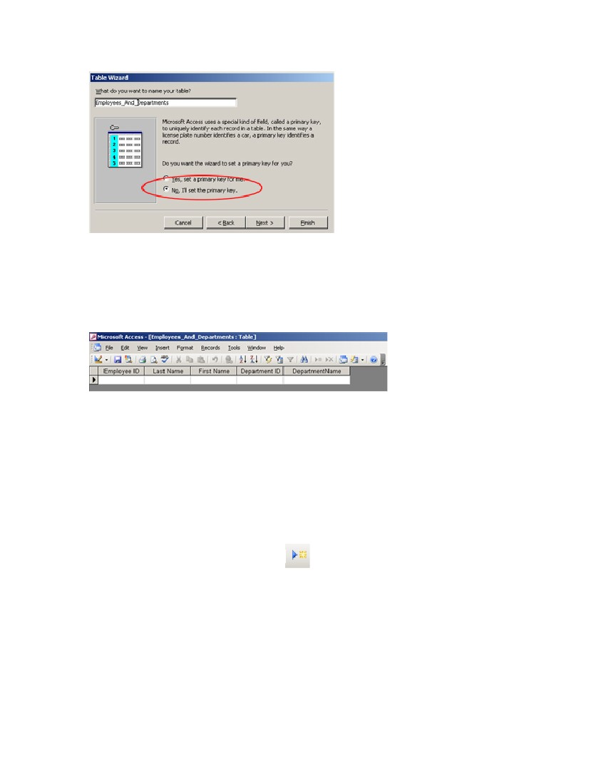
Figure 6. Set Primary Key
8. In the next dialog box, choose Numbers I enter when I add new records. Click
Next.
9. In the next dialog box, select Enter data directly into the table. Click Finish.
You will see your table in a new window (Figure 7).
Figure 7. Sample table
ENTERING DATA
Start entering your data into the table by typing in the cells. To delete typing mistakes,
use the BACKSPACE key. To delete changes in the current field, hit the ESC key.
NOTE: Only the latest changes will be deleted.
To move between cells or between records, use arrow keys or the Tab key.
To add a new record, click New Record
NOTE: You cannot add records if your cursor is on the blank record.
To edit data in a field, click in that field and type in the new data.
To replace the entire value in the field, move the pointer to the left corner of the field until
it changes into the plus sign, and click. Type in new data. Microsoft Access saves your
data when you move to another record.
Microsoft Access 2003 9
in the toolbar.
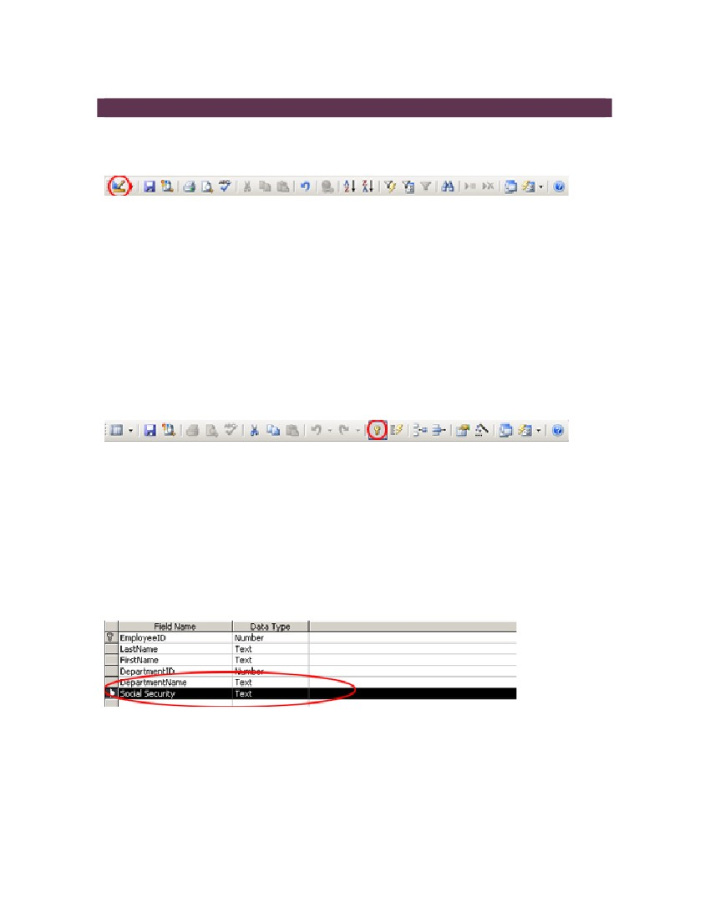
FORMATTING A TABLE
Once you have created a table you can format it in Design View. Click on the Design
View button in the toolbar (Figure 1) to see the formatting options.
Figure 1. Design View button
SETTING PRIMARY KEY
The first step you should take while formatting your table is setting a Primary Key. The
Primary Key, which is assigned to one of the fields, is a unique identifier of each record
in a table. To set the Primary Key, do the following:
1. Select the field you want to be the Primary Key for your table. This is usually a
number, for example a student ID, a product serial number, etc.
Figure 2. Primary Key button
INSERTING COLUMNS
If you need to insert a column into your table, i.e. if you need to add a field, you can do it
from Design View.
1. Click the Design View button (Figure 2); in the table grid you will see extra fields.
2. Type in a title in a blank field (Figure 3).
Figure 3. New field in Design View
3. Click on the Data Sheet View button. You will see a dialog box asking you to
save the changes. Click OK.
4. Scroll all the way to the right to see the new column in your table.
Microsoft Access 2003 10
2. Click the Primary Key button in the toolbar (Figure 2). This is now the unique
identifier of the record.
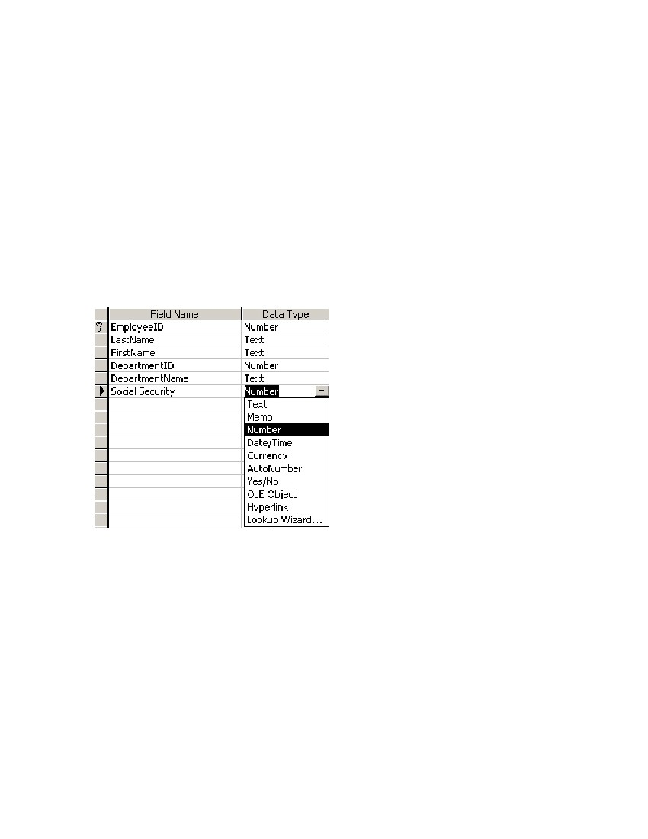
NOTE: You don’t need to insert rows; Access does that automatically when you enter
data.
FORMATTING DATA TYPE
In Design View you can also define the data type for each of the fields. For example, if
you have a field that contains dollar values, you can define the data type for this field as
Currency. The field will display the dollar sign and two decimal points.
To format the data type in Design View, follow these steps:
1. Click in the cell next to the field you wish to format the data type for in Data Type
column.
2. Choose the desired type from the dropdown menu (Figure 4).
Figure 4. Formatting Data Type
3. Click on the Data Sheet View button. You will see a dialog box asking you to
save the changes. Click OK.
4. Type in the data in the field; you will see how the formatting is applied.
Microsoft Access 2003 11

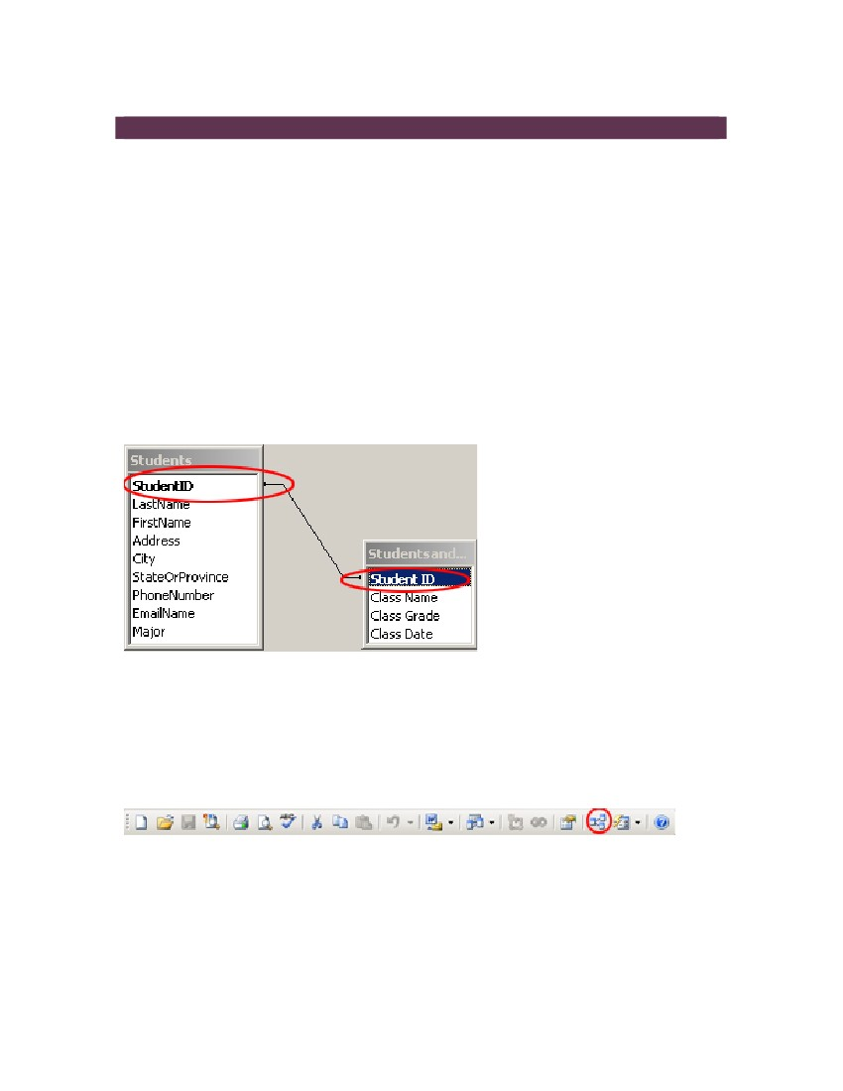
RELATING TABLES
USING RELATED TABLES
Any database contains several tables that have related information and are connected
through one Primary Key. Related tables are used for queries, forms, and reports.
When you start planning your database, plan for several tables and a field that will
connect them. This field, for example student ID, should be set as the Primary Key in
both tables.
SETTING RELATIONSHIPS
To relate two tables, make sure the Primary Key is set for the same fields in both tables
(Figure 1).
Figure 1. Student ID set as Primary Key
Follow these steps to set a relationship between two tables:
1. In the Database window, click Tables from the Objects bar.
2. Click Relationships button in the toolbar (Figure 2). You will see the primary
table.
Figure 2. Relationship button
3. Click the Show Table button in the toolbar to view the other table (Figure 3).
Microsoft Access 2003 12

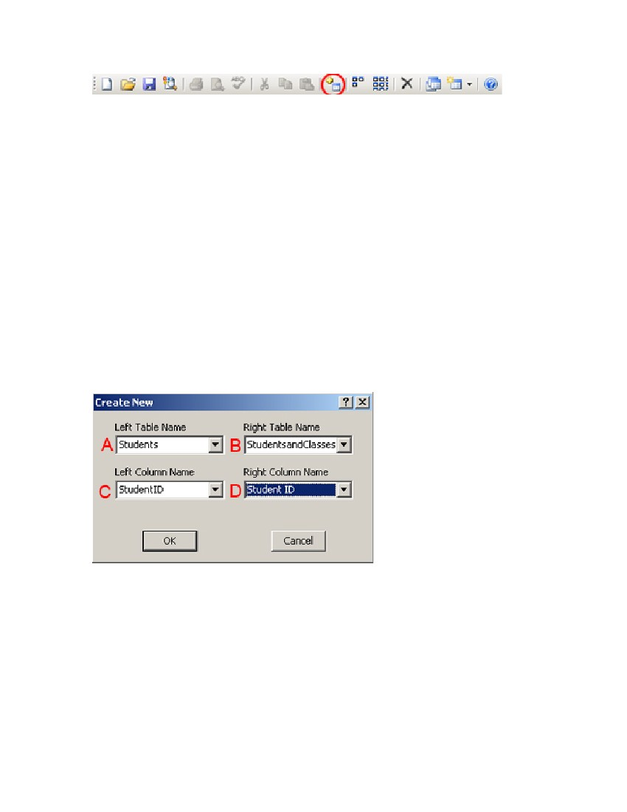
Figure 3. Show Table button
4. Select the second table from the list and click Add.
5. Close the dialog box. Now you can see both of your tables.
6. Go to Relationships in the main menu. Select Edit Relationships.
7. In Edit Relationships dialog box click Create New.
8. Select Left Table Name from the dropdown menu. This will be the name of your
first primary table (Figure 4A).
9. Select Right Table Name from the dropdown menu. This will be the name of
your second table (Figure 4B).
10. Select Left Column Name from the dropdown menu. This will be the name of
the primary key in the first table (Figure 4C).
11. Select Right Column Name from the dropdown menu. This will be the name of
the foreign key form the second table (Figure 4D). Both Left Column Name and
Right Column Name should be the same.
Figure 4. Create Relationships dialog box
12. Click OK. Then click Create. You will see a black line connecting the primary key
and the foreign key in both tables – this is the relationship between these two
tables.
NOTE: If both of your tables were created in Table Wizard and they have at least one
identical field, the relationship between the tables is automatically set.
For more information, please check the official Microsoft website at
http://office.microsoft.com/en-us/assistance/CH062526461033.aspx
Microsoft Access 2003 13

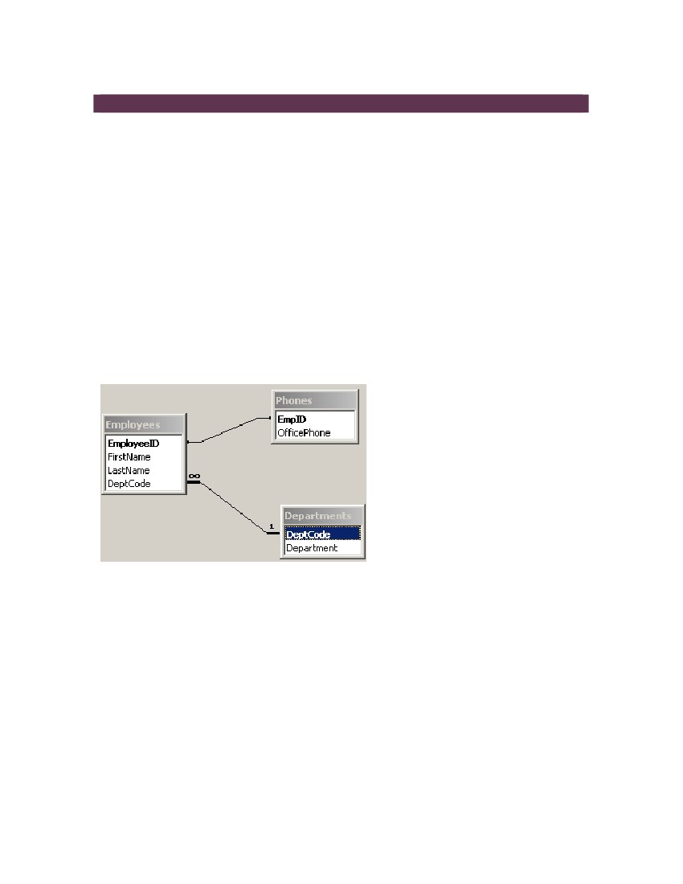
CREATING QUERIES
USING QUERIES
Queries are used to extract information from the database based on criteria that you
define. In queries you can pull data from several related tables to get an answer to a
specific question. For example, you need to know each employee’s name, their
department, and their phone numbers. You have several tables in your database:
1. An Employee table: Employee ID, Employee First and Last name, and
Department Code;
2. A Department table: Department Name and Department Code;
3. A Phone table: Employee ID and Phone Number.
You can pull out the fields that you need to answer this question and put them in a new
table – a query (Figures 1 and 2).
Figure 1. Relationships between tables

Microsoft Access 2003 14

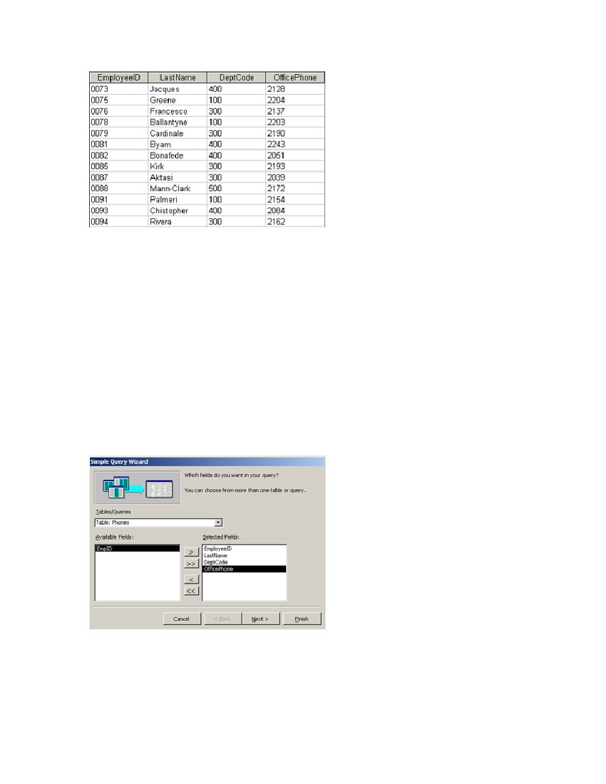
Figure 2. Sample query
CREATING QUERIES BY USING WIZARD
1. In the Database window select Queries from the Objects bar.
2. Double-click Create query by using wizard.
3. In the Simple Query Wizard dialog box, select one of your tables from the
Tables/Queries dropdown menu (Figure 3).
4. Double-click or use single arrows to choose fields for the query (Figure 4).
Figure 4. Simple Query Wizard
5. Repeat steps 3 and 4 to add fields from other tables.
Microsoft Access 2003 15

The easiest way to create a query is by using Query Wizard. Before starting, make sure
all the tables in your database are related. To create a new query, follow this process:

6. Once you have all the necessary fields, click Next.
7. In the next dialog box choose Detail (shows every field of every record) and click
Next.
8. Type in a name for your query in the dialog box (don’t use spaces or special
characters), select Open the query to view information, and click Finish. You will
see the datasheet with the answer to your question, i.e. employee’s last names
and phone numbers along with employee IDs and department codes.
NOTE: You can format your query in Design View. Click here to learn how to format
tables in Access.
For more information, please check the official Microsoft website at
http://office.microsoft.com/en-us/assistance/CH062526491033.aspx

Microsoft Access 2003 16

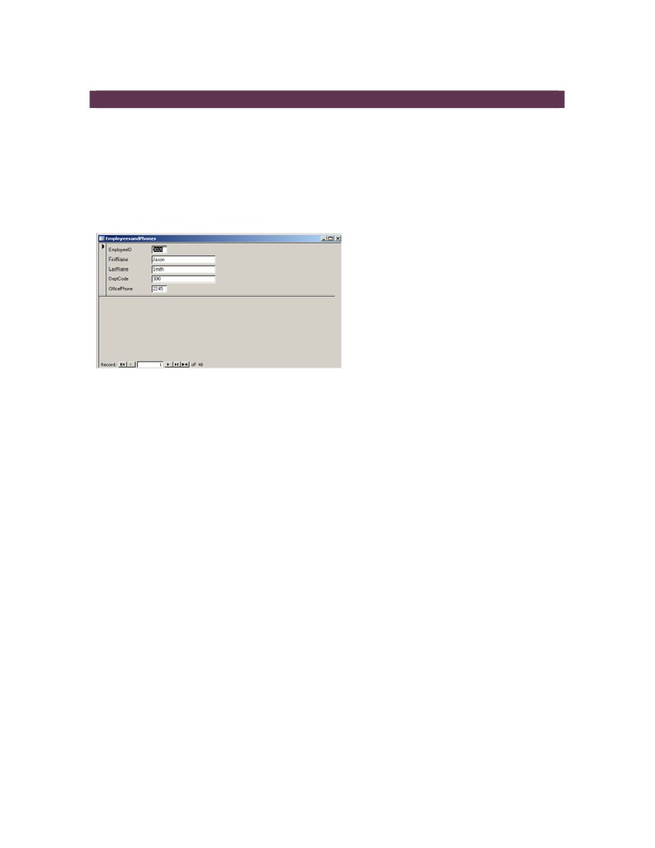
CONVERTING TO A FORM
USING FORMS
Forms are an easy way to enter, edit, and view data (Figure 1). Any table or query can
be converted into a form. Forms can include fill-in-the-blank fields, check boxes, lists of
options‚ etc. Forms can also contain buttons that allow the user to perform other actions,
for example to print reports or labels.
Figure 1. Sample form
CREATING FORMS
Just like with tables and queries, the easiest way to create a form is by using Form
Wizard. To create a form, follow the steps below:
1. Click the Forms icon in the Objects bar. You will see two options in the Database
window:Create form in Design view and Create form by using wizard.
2. Double-click Create form by using wizard. The Form Wizard dialog box will
open.
3. In the Form Wizard dialog box, select your table from the Tables/Queries
dropdown menu (Figure 2).
4. Double-click or use single arrows to choose fields from the Available Fields list
(Figure 2).
Microsoft Access 2003 17

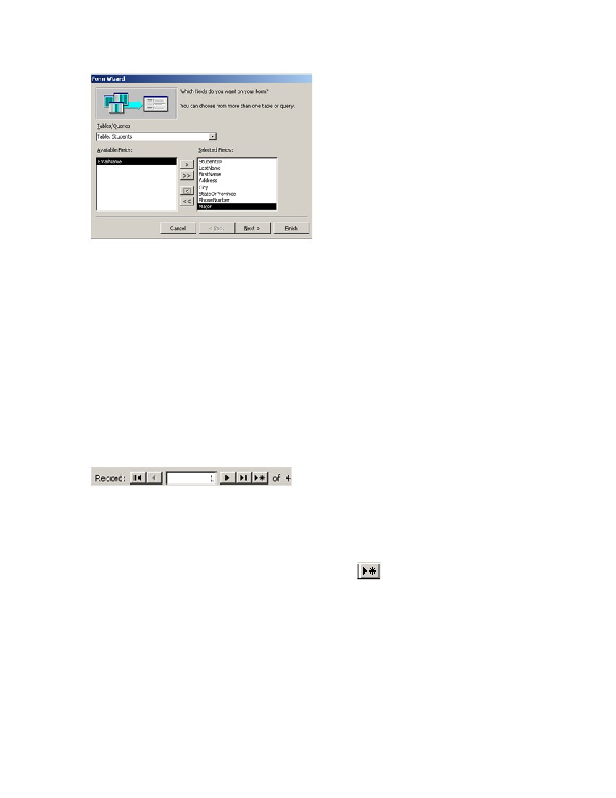
Figure 2. Form Wizard
5. Once you have all the necessary fields, click Next.
6. Choose a design for your form by clicking one of the radio buttons. You can
preview the design as you click the buttons. The most popular designs are
Columnar, Tabular, and Justified.
7. Click Next.
8. Choose a style for your form by clicking one of the styles from the list.
9. Type in a name for your form in the dialog box and click Finish. You will see your
form with one record on display.
NOTE: To see the other records, use the Navigation bar at the bottom of the window
(Figure 3).
Figure 3. Navigation bar
Once you have created your form, you can enter data or format the form to suit your
needs.
To add a new record, click on the New Record button
in the Navigation bar.
To use formatting options, click the Design View button from the Database toolbar.
Here you can add controls, such as Text Box, Label, List Box, Check Box, Option
Button, etc. and format other options.
For more detailed information, please visit the official Microsoft website
http://office.microsoft.com/en-us/assistance/CH062526471033.aspx

Microsoft Access 2003 18

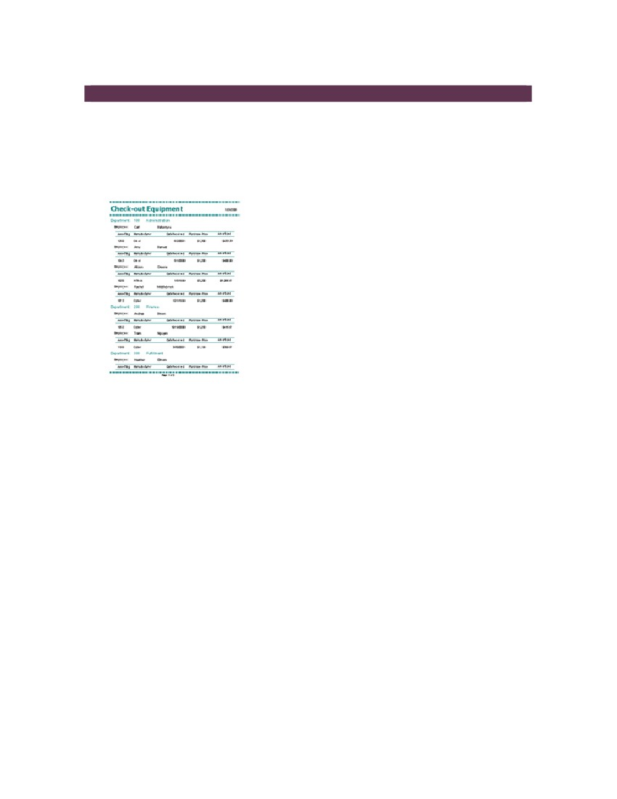
CONVERTING TO A REPORT
USING REPORTS
Reports allow you to view and present data from your database in a printed form.
Access offers several styles and formats for reports, so you can create a customized
document to suit your needs (Figure 1).
Figure 1. Sample report
CREATING REPORTS
Again, you are going to learn how to create a report by using Report Wizard. To create
a report, follow the steps below:
1. Click the Reports icon in the Objects bar. You will see two options in the
Database window:Create report in Design view and Create report by using
wizard.
2. Double-click Create report by using wizard. The Report Wizard dialog box will
open.
3. In the Report Wizard dialog box, select your table from the Tables/Queries
dropdown menu (Figure 2).
4. Double-click or use single arrows to choose fields from the Available Fields list
(Figure 2).
Microsoft Access 2003 19

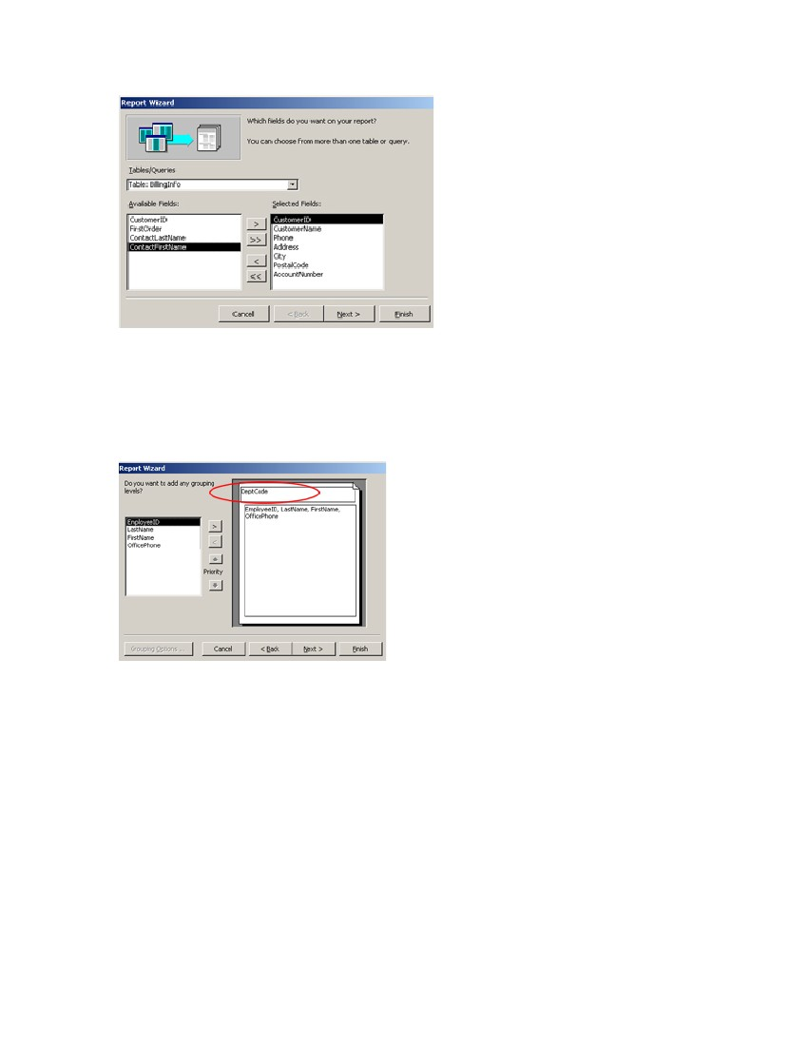
Figure 2. Report Wizard
5. Once you have all the necessary fields, click Next.
6. In the next step you can add grouping to your report by selecting one of the
fields. For example, in our sample report the data is grouped by department code
(Figure 3). Once you are finished with the grouping click Next.
Figure 3. Report Wizard: Grouping
7. Choose a sorting order for the data in your report. Select fields from the
dropdown boxes and assign either Ascending or Descending sorting order by
clicking the appropriate buttons (Figure 4).

Microsoft Access 2003 20

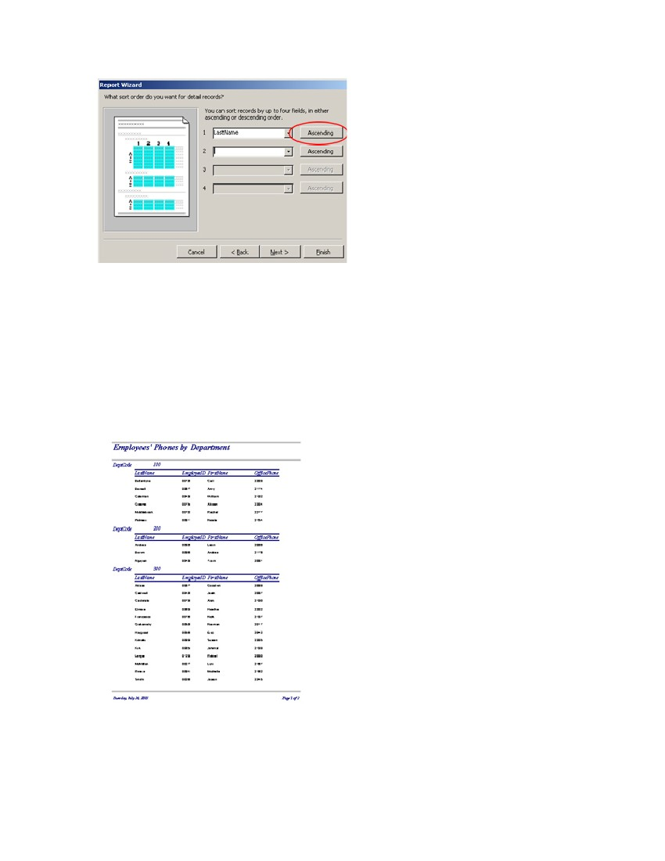
Figure 4. Report Wizard: Sorting
8. Click Next.
9. Choose a layout and orientation for your report by clicking the radio buttons.
Click Next.
10. Choose a style for your report by clicking on a title form the list. Click Next.
11. Type in a name for your report in the dialog box (don’t use spaces or special
characters) and click Finish. You will see the print layout of your report (Figure
5).
Figure 5. Finished report

Microsoft Access 2003 21

You can format your report in Design View. To use formatting options, click the Design
View button from the Database toolbar. Here you can add controls, such as Text Box,
Label, List Box, Check Box, Option Button, etc. and format other options.
For more detailed information, please visit the official Microsoft website
http://office.microsoft.com/en-us/assistance/CH062526481033.aspx

Microsoft Access 2003 22

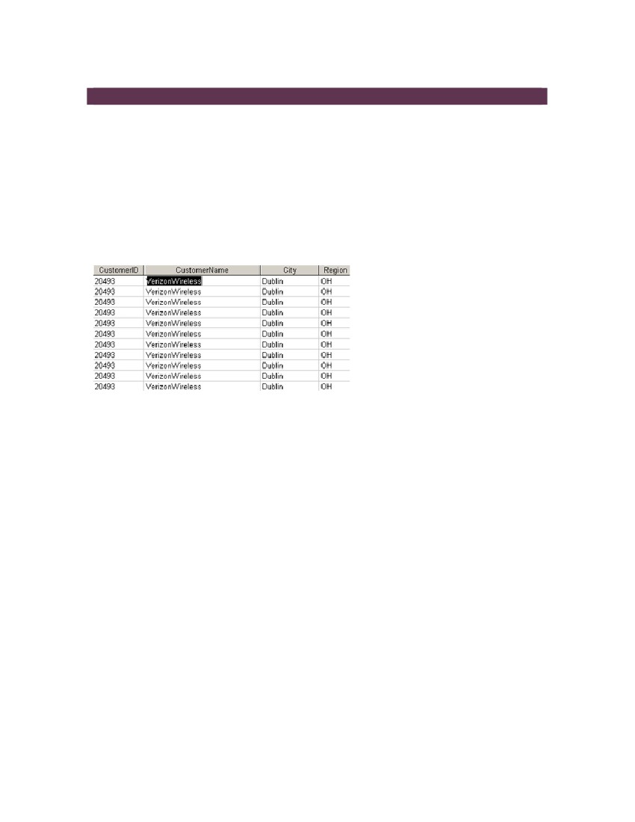
FILTERING
FILTER COMMAND
Filter is an Access command that allows you to view only specific records in a table, a
query, or a form. Those records must match one or more criteria that you specify. For
example, you have a query with CustomerID, CustomerName, Address, Phone,
AccountNumber, OrderID, OrderDate, ItemNumber, and Quantity fields, and you wish to
see only the products ordered by a specific customer, for instance Verizon Wireless. If
you apply Filter By Selection command and choose this customer name as a criterion,
you will be able to view only those records that match this criterion (Figure 1).
Figure 1. Sample filter
SAVING AND RE-APPLYING FILTERS
Filters can be saved and re-applied. However, the way saving and re-applying works
depends on the object they are created in.
If you created your filters in a table or a form, Microsoft Access saves these filters when
you save your table or form. You can reapply the filters when you need them the next
time you open this table or form.
If you created your filters in a query, Access saves these filters, but it does not add the
filter criteria to the query design grid when you save your query. You can reapply the
filters after you run the query the next time you open it.
If you created a report based on an open table or query that is filtered, the filter is saved
and automatically applied to the report each time that you open it. If you created a report
based on a closed table or query, the filter settings that are saved with the table or query
are also saved with the new report but not automatically applied when you open the
report.

Microsoft Access 2003 23

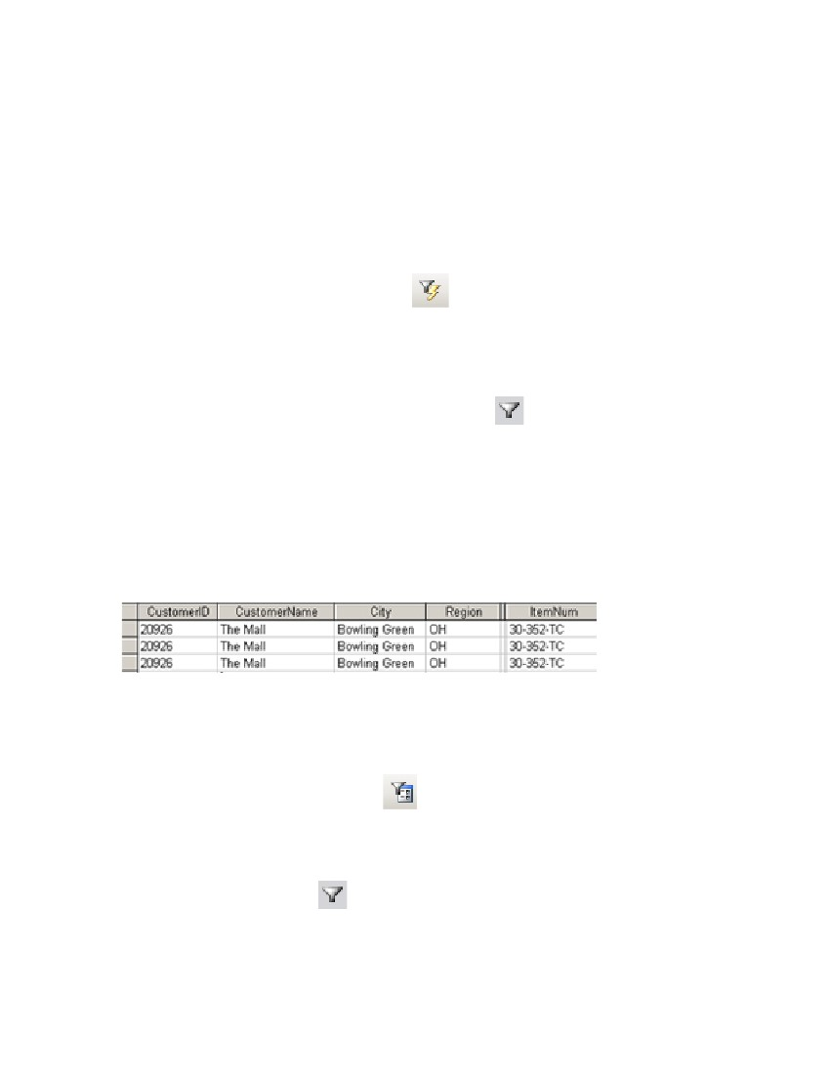
FILTER BY SELECTION
If you need to view records that contain text (such as “Verizon Wireless”) in the field, you
have to use the Filter By Selection command. To apply Filter By Selection, follow
these steps:
1. Open a table, a query, or a form.
2. Click in the field you want to view records with.
3. Click the Filter By Selection buttonin the toolbar. You will see a
datasheet with records containing the field that you clicked in Step 2.
4. Save the filtered data using the guidelines in the Saving and Reapplying Filters
section.
NOTE: To remove filter, click the Remove Filter button.
FILTER BY FORM
If you need to filter records based on values in more than one field, you have to use the
Filter By Form command. Figure 4 shows the filtered query with the following criteria
selected: The Mall for CustomerName, Bowling Green for City, OH for Region, and 30-
352-TC for ItemNumber, this is what will be displayed after the filter is applied (Figure
2).
Figure 2. Sample filter by form
To apply Filter By Form, follow these steps:
1. Open a table, a query, or a form.
2. Click the Filter By Form buttonin the toolbar. You will see a blank
datasheet with the fields from your table.
3. Type in or select from the dropdown menu one or more criteria for your filter.
4. Click the Apply Filterbutton in the toolbar. You will only see the records
that match all the specified values (Figure 2).
Microsoft Access 2003 24

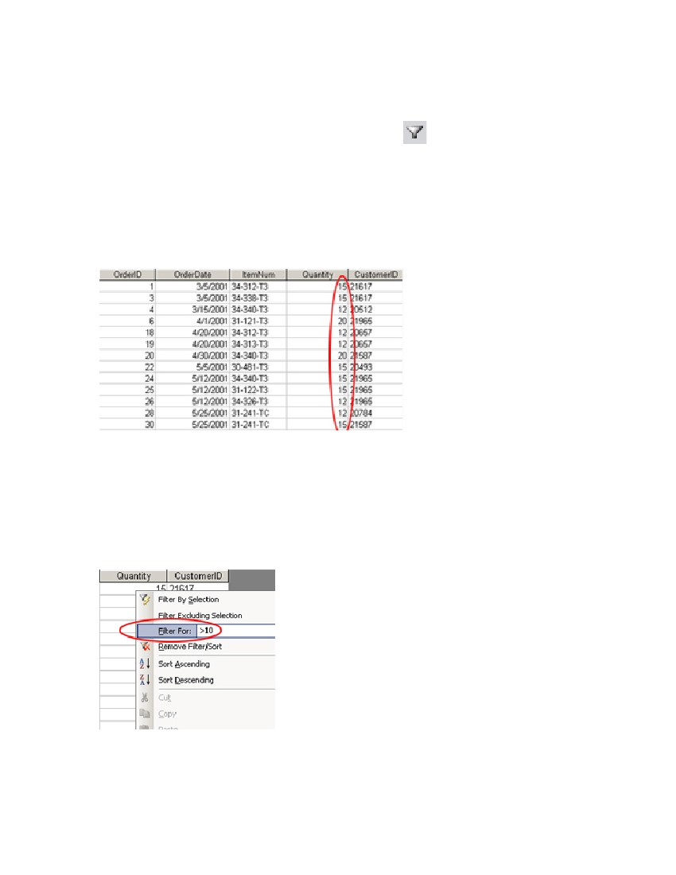
5. Save the filtered data using the guidelines in the Saving and Reapplying Filters
section.
NOTE: To remove filter, click the Remove Filter button.
FILTER FOR INPUT
If you need to filter records that exactly match a criterion, you have to use the Filter For
Input command. Figure 3 shows the filtered table with Quantity greater than 10
selected as a criterion.
Figure 3. Sample Filter For Input
To apply Filter For Input, follow these steps:
1. Open a table, a query, or a form.
2. Right-click in the field you want to apply your criterion to.
3. In the context menu find Filter For and type in your criterion, e.g. >10 (Figure 4).
Figure 4. Filter For context menu
Microsoft Access 2003 25

NOTE: Use arithmetic operators to specify your criterion.
4. Click ENTER. You will see the datasheet with the records that match the
specified criterion, i.e. you will see the records that show Quantities larger than
10.
5. Save the filtered data using the guidelines in Saving and Reapplying Filters
section.
NOTE: To remove filter, click the Remove Filter button.

Microsoft Access 2003 26

RESOURCES
Please visit these links for more helpful tips, detailed instructions, and advanced features
of Microsoft Access 2003:
http://office.microsoft.com/en-us/assistance/default.aspx offers comprehensive
assistance with Access projects for beginners as well as advanced users;
http://www.atomiclearning.com/windows presents movie-based tutorials:
http://www.atomiclearning.com/access_2003_intro,
http://www.atomiclearning.com/access_2003_interm, or
http://www.atomiclearning.com/access_2003_adv;
http://www.techtutorials.info/appaccess.html has a list of web sites offering various
Access tutorials;
http://allenbrowne.com/tips.html shares a few tips on his site.
KEY TERMS
Database
A collection of related data organized in tables.
Database window
The command center of a database; here any object, such as Tables, Queries, Forms,
Reports, Pages, Macros, and Modules can be created and used.
Field
A column that contains categories of information.
Filter
An Access command that allows you to view only specific records in a table, a query, or
a form. Those records must match one or more criteria that you specify.
Forms
Used to enter, edit, or view data stored in a table or a query.
Primary Key
A unique identifier of a table, usually a number, such as a student ID, a product asset
tag, etc.
Queries
Used to extract data from a database. Queries ask a question of data stored in a table.
For example, a query could display only students who checked out still cameras.
Microsoft Access 2003 27

Record
A row in the table that contains information such as name, address, phone number, etc.
Reports
Used to display and print selected information from a table in a visually appealing
customized
way.
Tables
Used to enter, store, organize, and view data. For example, one table could store a list
of students and their IDs, while another table could store the equipment that the students
checked out.
Microsoft Access 2003 28

