Masaryk University
Faculty of Science

Department of Chemistry



Photoinduced Hydrogen Atom Transfer: Application and Theoretical Aspects

Diploma Thesis

Brno 2009 Tomáš Šolomek

...Those sciences are vain and full of errors which
are not born from experiment, the mother of certainty...

-- LEONARDO DA VINCI, 1452-1519

Acknowledgement
I would like to thank prof. Petr Klán Ph.D. for a thorough guidance during my work on the thesis, for his patience and the freedom to participate in so many interesting research projects which he gave me. I would like to thank prof. Thomas Bally Ph.D. who taught me much during my great time at the University of Fribourg and who supervised and approved the part of the thesis concerning the nitrobenzyl moiety. I thank prof. Christian Bochet Ph.D. for proposal of this project. I would also like to thank all the organic photochemistry group members, especially Jaromír Literák, for help and fruitfull discussions. I thank my parents and Hanka for supporting me on the studies. Finally, I would like to thank the Rector’s Programme to Support Masaryk University Students‘ Creative Work for financial support.

Table of Contents
Table of Contents 3
Introductory Notes 3
Literature Part 5
2.1. Introduction 5
2.2. Setting Up the Scene 5
2.2.1. Making the Connection Arguments 6
2.3. Photochemistry of Ketones in Context of Hydrogen Atom Abstraction 7
2.3.1. γ-Hydrogen Atom Abstraction and 1,4-Biradicals 8
2.3.2. More Remote Hydrogen Atom Abstractions 19
2.4. The Nitroaromatic Chromophore 19
2.4.1. Solvent-Mediated Photoredox Reactions 20
2.4.2. Intramolecular Hydrogen Atom Abstractions 21
Experimental Section 24
3.1. Instrumentation 24
3.2. Quantum Chemical Calculations 24
3.3. Preparation of Compounds 25
Part I: Discussion on the Photochemistry of Dimethylphenacyl Epoxides 37
4.1. Preparation of Model Compounds 37
4.2. Photochemistry of Model Compounds 38
4.3. Mechanistic and Computational Studies 42
4.4. The Strategy of Indanocine Synthesis Using a Photochemical Key Step 51
4.5 Conclusion I 57
Part II: A Contribution to the o-Nitrobenzyl Photochemistry 59
5.1. Introduction 59
5.2. Comments on the Methods Used 60
5.3. Structure of Triplet o-Nitrotoluene 63
5.4. Differences of Aci-nitro Intermediate and its Triplet State 66
5.5. The Impact of the Benzylic Substitution on the Geometries 67
5.6. Thermodynamic and Kinetic Parameters and Their Correlations 70
5.7. Conclusion II 77
List of Abbreviations 78
References 79

Introductory Notes

The present work concerns with the photoinduced hydrogen atom transfer reactions. This process has been used for the synthesis of indan-1-one derivatives via photochemical enolization and epoxide ring opening with subsequent cyclization of the substituted 1-(o-methylphenyl)-2,3-epoxypropan-1-one moiety. Mechanistic studies and quantum chemical calculations are provided to explain the scope of this reaction. The approach used is discussed in regard to the synthesis of biologically interesting compounds like Pterosines and Indanocine.
The triplet state hydrogen atom transfer reaction of the substituted o-nitrobenzyl moiety has been explored by quantum chemical calculations to reveal the triplet state reactivity of this kind of chromophore. Valuable information of the geometry, thermodynamic and kinetic parameters are presented and are believed to stimulate further experimental and theoretical research in the photoremovable protecting groups development.

Chapter 2 describes intramolecular hydrogen atom transfer described in the literature part putting great emphasis on the photoinduced fashion of this process in aromatic ketones and the o-nitrobenzyl chromophore.

Chapter 3 describes theoretical and experimental procedures used in this work. All synthetic products have been characterized by ¹H and ¹³C or 2D NMR spectroscopy and mass spectroscopy where necessary.

Finally, the next two chapters summarize and discuss the experimental and theoretical observations.

Literature Part

2.1. Introduction
Hydrogen transfer is the reaction of fundamental importance in all branches of chemistry. Recall neutralization reaction as the most basic experiment or acid-base catalysis concept in organic chemistry. These examples can be denoted as proton transfer. However, depending upon the degree of charge transfer they are often referred to as hydrogen atom transfer (HAT). It plays a central role in various oxidation reactions like combustion of fuels¹, atmospheric chemistry², synthetic chemistry, biochemistry or chemical biology.^{3,4} Understanding the mechanisms in the most simple cases allows us to propose new kinetic models which can be used to predict the behaviour of even more complex systems. Nowadays, this approach is crucial in developing new types of fuels or combustion technologies due to the world’s rapidly changing energy requirements. Rapid climate change threat became more open to public, thus further accelerating the atmospheric chemistry research. Photoinduced hydrogen atom transfer is often used in chemistry of photoremovable protecting groups.⁵⁻¹³ It is worth to mention photoactivatable molecules, also called caged compounds, which upon irradiation irreversibly release a species possessing desirable physical, chemical, or biological qualities.^{3,4} All these examples often include hydrogen atom transfer as a key step.
The next few chapters will concern with the intramolecular HAT, primarily focusing on the photoinduced intramolecular hydrogen atom abstraction in aromatic ketones. Substituted nitroaromatic compounds will be considered too.

2.2. Setting Up the Scene
There is a wide variety of hydrogen atom transfer reactions. However, the most important ones share a major feature which is when the oxygen abstracts hydrogen. Let us note that one can encounter several of them in different fields of chemistry (Scheme 2.1): (1) the famous Barton reaction¹⁴, (2) the Norrish type II cleavage¹⁵, (3) the McLafferty rearrangement¹⁶, (4) related alcohol or ether radical cation reactions¹⁷ and (5) retro-ene reaction of carbonyl compounds.¹⁸
Although all the reactions mentioned above are essentially the same fundamental type of process, significant differences can be found for their activation energies which are related to their open-, closed-shell (the very last example) or charged open-shell character.¹⁹ There are also structural similarities in cyclic transition states for the first four. Based upon ab initio calculations of Houk et al.¹⁹, three distinct groups can be made according to the character of the oxygen atom. We will very briefly discuss the ‘open-shell’ group consisting of the ground state alkoxy radicals and the triplet aromatic ketones putting great emphasis on the latter. Finally, similarities of the nitrobenzyl moiety photochemistry will be discussed.

Scheme 2.1.

2.2.1. Making the Connection Arguments
It is surprising at first glance that one can explain some reaction features for excited state compounds simply by looking at relatively well studied ground state alkoxy radicals. In order to understand these features in HAT in such two different species, several arguments need to be introduced. Firstly, it has long been known the triplet formaldehyde is sp³ hybridized at carbon.²⁰ Additionally, the C–O bond length in triplet aldehydes has been shown to be 0.10 Å longer than that in their ground states.²¹ The triplet ketones behave the same way. This can be supported by comparing the dipole moments of benzophenone and formaldehyde triplets²² which are of equal value (1.7 D) characteristic for a C–O single bond suggesting that ketones undergo similar geometrical changes upon excitation.²⁰ All these features suppose that triplet ketones could possibly demonstrate the behaviour of alkoxy radicals.
The experimental activation energies for the Barton reaction and the Norish type II process fall within 5–10 kcal mol^{–1}.^{14,15} A higher barriers of 14.9 kcal mol^{–1} and 14.0 kcal mol^{–1} were found at MP2/6-31G*//HF/3-21G level of theory for the intramolecular hydrogen atom abstraction via a six-membered transition state for the Barton and the Norrish type II reactions, respectively.¹⁹ Both reactions appeared to be almost thermoneutral computationally. This kind of HAT regioselectivity is observed in general. 1,5- and 1,6-H-atom transfers are significantly lower in energy than those for shorter ‘migrations’ by 7–25 kcal mol^{–1}.¹ However, the reason for the 1,5-H-atom preference in these two reactions slightly differs. The chair-like, six-membered transition state is suggested to reflect the strain-free character of cyclohexane which has been shown by quantum chemical calculations to be the case for the triplet ketones indeed. The seven-membered transition state for δ-hydrogen atom abstraction was found to be 0.9 kcal mol^{–1} higher at MP2/6-31G*//HF/3-21G than that of the γ-hydrogen abstraction.¹⁹ On the other hand, the ε-hydrogen atom abstraction in alkoxy radicals (note the different nomenclature, the γ-hydrogen in carbonyls corresponds to δ-hydrogen in alcohols) through a seven-membered transition state is favored enthalpically by approximately 0.8 kcal mol^{–1} and entropy factors have to be considered in this case.²³ The activation Gibbs free energies are truly in the correct order reflecting the experimentally observed regioselectivity.

2.3. Photochemistry of Ketones in Context of Hydrogen Atom Abstraction
So far we have seen a couple of examples of HAT reactions and have found some common features among alkoxy radicals and triplet ketones to point out one can look at two completely different systems in a similar manner. However, in order to fully understand the experimental work which we will discuss in Chapter 4, we need to deepen our knowledge of aromatic ketones photochemistry in regard of HAT. To do this we will explore this topic in more detail in the next few sections.

2.3.1. γ-Hydrogen Atom Abstraction and 1,4-Biradicals
The best known example of intramolecular hydrogen abstraction in excited ketones is the type II photoelimination originally discovered by Norrish.²⁴ He found that ketones with γ-hydrogens cleaved upon excitation to methyl ketones and alkenes which was in contrast to the previously discovered type I cleavage producing acyl and alkyl radicals.²⁵ Later on it was found the quantum yields of type II reaction were relatively low and other processes must compete. This was answered by the pioneering work of Yang and Yang who discovered that cyclobutanol forms upon irradiation and proposed a common reactive intermediate for both reactions.²⁶ They suggested a 1,4-biradical intermediate which was formed after the γ-hydrogen atom was abstracted by the excited carbonyl oxygen. The whole sequence of processes can be referred to as the Norrish/Yang reaction (Scheme 2.2). Thanks to the ease of experimental following of the type II cleavage, valuable information have been gained about the biradicals and the hydrogen atom transfer reaction itself.

Scheme 2.2. The Norrish/Yang reaction

2.3.1.1. Behaviour of the Biradical Intermediate
We stated that the low quantum yields of type II cleavage products formation could be explained by considering the cyclobutanol formation from the common biradical intermediate. However, we would find the sum of the quantum yields of both types of reactions does not equal unity. To solve for this little conundrum we have to look at the 1,4-biradicals more closely.
One of the first indirect experimental evidence for this reactive intermediate was based on observation of (+)-4-methyl-1-phenyl-1-hexanone racemization by Wagner et al..²⁷ The total quantum yield of the racemization, elimination and cyclization was found to be close to unity. After alcohol addition, the quantum yield of products formation significantly increased while that of the racemization decreased. The primary kinetic isotope effect with k_{H}/k_{D} value of 4.8 for the triplet reaction was observed. All these experiments indicated the formation of 1,4-biradical intermediate which can proceed to products or revert back to the starting ketone thus non-productively loosing the excitation (which is, however, not the case for the racemization). Moreover, it was revealed that alkyl thiols can efficiently trap the biradicals derived from valerophenone and γ-methoxyvalerophenone, suggesting a solvated biradical lifetime of ~ 10^{–6} s.²⁸ Further evidence was given by the fact that only the triplet, but not the singlet, component of 5-methyl-2-heptanone produced racemization at the γ-carbon.²⁸
The first direct observation of the biradical intermediate was given by Scaiano et al.²⁹ They employed laser flash photolysis (LFP) to detect the triplet 1,4-biradical from γ-methylvalerophenone. Later they used paraquat (N,N'-dimethyl-4,4'-bipyridinium dichloride) to trap the biradical intermediate by oxidation of the hydroxy radical site, thus reducing the paraquat to radical cation species kinetics of which can be followed easily spectroscopically.³⁰ With these powerful methods in hand several important conclusions could be made. The ns lifetimes have been found which are lengthened by adding Lewis bases or alcohols.³¹ This nicely explains the observations of Wagner discussed above. The biradicals are almost temeprature independent, having decay activation energies within 1 kcal mol^{–1}.³² Their lifetimes are shortened by adding paramagnetic species such as oxygen which is known to speed up the intersystem crossing.³³ Whether the physical or chemical rate-determining step for their decay is operative is not completely resolved yet.
The most modern femtosecond spectroscopy techniques allowed the observation of the singlet 1,4-biradicals formed from excited singlet alkanones in the gas phase. The lifetimes have been reported in the range of 400 to 700 fs.³⁴

2.3.1.2. The Nature of Excited State
Two consecutive intermediates can be found by looking at the mechanism of the type II reaction (see Scheme 2.2). We have already described the biradicals above. However, for the hydrogen atom abstraction itself one needs to understand the character of the excitation in the ketone and its geometry as well. We will start with the former.
The carbonyls are excited to the corresponding state upon irradiation. After rapid internal conversion (IC) the first singlet excited state is populated where we find only two choices which are productive (except the radiative deactivation or IC to the ground state). Aliphatic ketones possess n,π* lowest singlets that undergo intersystem crossing (ISC) to their n,π* lowest triplets with rate constant of ~ 10⁸ s^{–1}.²⁵ This process is slow enough to compete efficiently with the hydrogen atom abstraction reaction which is believed to occur with rate constants of ~ 10⁹ s^{–1}.¹⁵ The ISC in aromatic ketones is even faster (> 10¹⁰ s^{–1}), thus the excited state chemistry could be derived solely from their triplet states.³⁵ This looks like a bit of simplification since we do not have to consider any excited singlet state reactions (although HAT has been shown to involve excited singlets at least partially³⁶). However, introducing the benzene ring allows an energetically close π,π* excitation to occur. They are far less reactive compared to their n,π* counterparts. The reason can be viewed in the way the unpaired spin is distributed in the molecule. The n,π* state possesses an electron in the half-filled p orbital on oxygen, thus manifesting the chemical reactivity of alkoxy radicals. There is only little spin density on oxygen in the π,π* state and the electrons are mainly delocalized in the benzene ring. Their energy order can be drastically influenced by substitution of the benzene ring or varying the solvent.
Experiments with naphthyl ketones which have the π,π* state lower in energy by ~ 9 kcal mol^{–1} demonstrated that the HAT can occur even from the π,π* state, but its efficiency is only 0.01–0.001 % that of the lowest n,π* triplets.^{37,38} When the energy gap is reasonably small (< 5 kcal mol^{–1}) or the n,π* state is the lowest one, the reactivity is inferred from the latter with the assumption of fast thermal equilibration between these two states.³⁹ The observed rate constant can be then written as

(2.1)

where χ denotes the corresponding population of respective state according to Boltzmann distribution.
The substitution of the benzene ring plays the central role as we mentioned above. Table 2.1 summarizes the research effort done in this field.⁴⁰

Table 2.1. Summary of the rate constants and population of n,π* triplets in triplet γ-hydrogen atom abstraction of ring substituted valerophenones in benzene
Substituent | k_{obs}  (10⁷ s^{–1}) | n,π*  (%) | k_{n,π}  (10⁷ s^{–1})
m-(NH⁺) | 200 | > 99 | 200
p-(NH⁺) | 330 | > 99 | 330
o-(N) | 19 | > 99 | 19
m-(N) | 31 | > 99 | 31
p-(N) | 68 | > 99 | 68
H | 13 | 99 | 13
p-OCF₃ | 13 | 95 | 14
o- CF₃ | 13 | > 99 | 13
m- CF₃ | 32 | > 99 | 32
p- CF₃ | 28 | > 99 | 28
o-alkyl | 3.0 | 25 | 12
m-alkyl | 3.9 | 35 | 12
p-alkyl | 1.8 | 18 | 10
o-OMe | 0.30 | 3 | 10
m-OMe | 0.02 | 0.15 | 15
p-OMe | 0.06 | 1 | 6
p-OAc | 4.4 | 25 | 18
o-F | 14 | 99 | 14
m-F | 18 | 99 | 18
p-F | 15 | 99 | 15
m-Cl | 16 | 99 | 20
p-Cl | 3.0 | 16 | 18
m-CO₂Me | 28 | 99 | 28
p-CO₂Me | 12 | 40 | 30
o-CN | 23 | 99 | 23
m-CN | 30 | 99 | 30
p-CN | 6.8 | 21 | 32
m-COR | 14 | 50 | 28
p-COR | 2.7 | 9 | 30
p-SMe | < 0.001 | < 0.01 | 14
p-SCF₃ | 3.0 | 10 | 32
Source: Adapted from Wagner and Park⁴⁰

According to spectroscopic measurements of dipole moment changes the π,π* state was assigned to be more polar and the n,π* state less polar than the ground state.⁴¹ Thus electron-donating groups are believed to stabilize the π,π* states. This can be clearly seen in Table 2.1. Electron-donating group in the para position like p-OMe, p-SMe decreases the population of the reactive state. In the case of the latter, the energy gap becomes so pronounced that the reaction is almost completely suppressed. Similar trend can be found by considering the conjugative effect with electron-withdrawing groups in the para position. These groups obviously stabilize π,π* triplets more than they stabilize n,π* triplets inductively when compared with meta substituents where only the inductive effect applies.⁴² The ortho substituents have the same type of inductive effect magnifying the electron deficiency of the carbonyl oxygen thus increasing the reactivity in HAT. Besides this effect steric hindrance must be considered, too. For instance, o-CN group enhances the valerophenone triplet reactivity whereas that of o-CO₂Me valerophenone (not included in Table 2.1) is deactivated.⁴²
Even a correlation with well known linear free energy relationships was attempted. It has been found that the triplet excitation energies of benzophenones correlate with the common Hammett σ values of substituents. It was assumed that the n,π* triplet levels of phenyl alkyl ketones are affected the same way. However, n,π* triplet of benzophenone is energetically far enough below the π,π* triplet hence all the substituents we have considered do not invert the triplet levels.⁴¹ Inductively electron-withdrawing substituents such as CF₃ do correlate very well with substituent σ values as the n,π* state is the lowest here.⁴³ But the Hammett constants do not adequately describe the effect of substituents on π,π* transition energies and the energy gap between the states of interest does not correlate at all. It can be concluded the simple Hammett relation is inappropriate for description of the reactivity when all possible substituents are considered.
The polarity of both electronic states differs as we noted above, so the environment can influence the electronic states of alkyl aryl ketones, too. Polar solvents such as alcohols are expected and have been observed to produce the same triplet states inversion as the electron-donating groups do.^{44,45} The very same behaviour has been observed in photochemistry on polar silica-gel surface.⁴⁶ This is because the polar solvents destabilize the n,π* state by lowering the energy level of the n orbitals on oxygen and stabilize the π,π* state by lowering the energy of the π* orbital. Hence the quantum yields rapidly decrease in polar solvents like methanol. A note must be made here. We mentioned in the previous chapter (2.3.1.1.) that the lifetimes of triplet biradical intermediates have been found to prolong by adding Lewis bases into the solution. This change in the lifetimes is attributed to hydrogen bonding by the relatively acidic OH group of the biradical to the Lewis base thus preventing the disproportionation back to the starting ketone. As a result the quantum yield of the whole type II process can reach almost unity. This is observed for alcohols, too. However, at alcohol concentrations exceeding ~ 0.5 M, a rapid decrease suddenly appears due to energy levels inversion. The ability of different additives to solvate biradicals closely matches their basicities.⁴⁷ The rate constant of the γ-hydrogen atom abstraction itself (k_{H}^{n,π} in Eq. 2.1) is largely solvent independent.⁴⁸

2.3.1.3 The Nature of the CH Bond
In the previous section we have listed several factors which have an impact on the photoreactivity of the carbonyl oxygen. However, the rate of the HAT reaction is influenced by the second reactive site of the molecule which is the γ-CH bond.
A biradical intermediate is formed after the hydrogen atom was abstracted. It is reasonable to suppose the radical at γ-carbon will be stabilized by neighbouring substituents (affecting the CH bond energy and electron density) and, according to Bell-Evans-Polanyi principle, the rate constant of the process will depend on this substitution. The following table summarizes the kinetic parameters of the γ-substituted butyrophenones photochemistry (Table 2.2.⁴⁰
The relative values in the table should hold for any type of hydrogen abstraction by n,π* triplets.²⁴ This is indeed observed and will be discussed in the experimental section in the case of o-nitrobenzyl moiety (Chapter 5).
Since the radicals are electron deficient species, negative inductive effect is expected to decrease the rate of the HAT. This can be clearly seen from the very last two rows of the table. However, for most substituents there is an interplay of inductive and resonance effects. Resonance stabilizes the radicals thus an increase in the rate of the reaction is expected. But the opposite is found for the cyano group since the inductive effect strongly counteracts. Note the rate constant for dialkyl amino group and its protonated form. This suggests the process in the case of amino substituents should be strongly pH dependent. There is absolutely no correlation between the quantum yields Φ_{II} and the triplet state reactivities. This indicates the whole process is much more complex which is indeed the case.

Table 2.2. Rate constants in benzene of triplet γ-hydrogen atom abstraction for γ-substituted butyrophenones
γ-substituent | Quantum yield of type II process (Φ_{II}) | k_{obs}  (10⁷ s^{–1})
H | 0.35 | 0.7
Alkyl | 0.33 | 14-20
Dimethyl | 0.25 | 50
Phenyl | 0.50 | 40
Vinyl | 0.26 | 50
RS | 0.27 | 64
PhS | 0.32 | 45
RSO | 0.03 | 1.2
R₂N | 0.025 | 80
MeO | 0.23 | 62
HO | 0.31 | 40
PhO | 0.32 | 22
OC(=O)Me | 0.48 | 1.2
C(=O)OMe | 0.50 | 1.0
Chloro | 0.11 | 1.0
N₃ | 0.006 | 0.5
Fluoro | 0.41 | 0.8
CN | 0.32 | 0.4
RSO₂ | 0.20 | 0.04
NHR₂⁺ | 0.009ª | 0.01
NR₃⁺ | 0.001ª | 0.001
ª In methanol
Source: Adapted from Wagner and Park⁴⁰

2.3.1.4. The Geometry Aspects of γ-Hydrogen Atom Abstraction
Two major factors must be obeyed for an efficient bifunctional intramolecular reaction to occur. The first one is the distance of the two distinct functional groups which undergo the reaction. The second one is their relative orientation in space. The same principles apply in HAT and the rate of the process is strongly dependent on these two factors. There is a vast amount of possible conformers in solution, the population and equilibria of which are dictated by their energy according to Boltzmann distribution and only a small portion of them can be reactive in HAT. This is very important to realize since even the regioselectivity of HAT can be drastically influenced by conformations. Note the selective δ-hydrogen abstraction in Paquette`s synthesis of dodecahedrane.⁴⁹
In order to discuss the proximity and orientation we need to set up some definitions. Four relevant parameters can be introduced (Figure 2.1). The first is d, the distance between the carbonyl oxygen and the γ-hydrogen atom. It seems reasonable for this parameter to equal the sum of the van der Waals radii for oxygen and hydrogen, which is 2.72 Å.⁵⁰ The second parameter ω is defined as the dihedral angle of the carbonyl function and the γ-H atom. Thus ω stands for the angle by which the γ-hydrogen lies outside the plane of the carbonyl group. Since the n,π* state has a half-filled p orbital on oxygen in the plane of the carbonyl group, very small values (near 0˚) are expected. The other two parameters define the C=O···H (∆) and C-H···O (θ) angles. Since an n-orbital on oxygen is 2p or sp² hybridized, values ranging from 90˚ to 120˚ should apply for the former. The latter one should have the optimum value of 180˚ theoretically.²³ It is understandable that measurements of these parameters are almost impossible in solution. Nevertheless, their common values were obtained by measuring the X-ray diffraction patterns of molecules that can undergo the HAT in the solid state. This approach of comparing ground state geometry parameters with triplet reactivity is valid here because the n,π* excitation is so highly localized on the carbonyl group that geometric changes in the rest of the molecule are negligible.
Figure 2.1. Geometry parameters relevant to HAT reaction depiction

A table from various research efforts was compiled by Scheffer et al.⁵¹ A deeper analysis of the collected data relatively confirms some of our ideal values defined above. However, vast deviations are observed, too. The distance d ranges from 2.17 Å to 3.15 Å. Nevertheless, most of the values fall within the sum of van der Waals radii 2.72 ± 0.2 Å. The observed values of ω clearly contradict the ideal value of 0˚. This discrepancy has been explained and some evidence for a cos²ω dependence for the rate of γ-hydrogen abstraction has been provided by Wagner.^{24,52} Such a relationship reflects the angle dependence of the wavefunction describing the p orbital. With respect to the angle ∆, the experimental data are in reasonable agreement with the hypothetical values in between 90 and 120˚ and on average much closer to the lower boundary. It is thought this lower value preference to be an evidence for the non-bonding orbital of almost pure 2p-like in character or more likely due to the geometric constraints inherent in a six-membered transition state process. The same reasoning is applied with the last of the used parameters. It is simply impossible to attain linear arrangement of C-H···O angle in a six-membered transition state. With this type of argument in mind one can be satisfied with the average value of 115 ± 10˚ found for θ.

2.3.1.5. Photoenolization
Another very nice application of HAT reaction with γ-regioselectivity is the intramolecular photoenolization of o-alkylphenyl ketones.^{53,54} The first stages of the reaction are the same as those for the classical type II process (Scheme 2.3). There is, however, difference for the biradical decay. Two isomeric xylylenols of Z- and E-configuration are generated via the triplet biradical intermediate, ³E. The triplet enol (³E) was reported by experiments with paraquat and LFP of o-methylacetophenone (Scheme 2.3) with lifetime of 900 ns in degassed MeOH.^{55,56} Surprisingly, piperylene did not affect its lifetime which was assigned to its low triplet energy⁵⁷, but decreased its yield by quenching the triplet ketone precursor.

Scheme 2.3. Photoenolization of o-methylacetophenone⁵⁸

There is, however, evidence the reaction is not exclusively of triplet origin.⁵⁹ Excited singlet ketone can compete efficiently with ISC and yield only the Z-enol. The difference in the diastereoselectivity is a consequence of C_{Ar}–CO bond rotation absence in the excited singlet state. The Z-enol decays rapidly with τ = 730 ns in MeOH or τ ~ 20 ns in nonpolar solvents like cyclohexane by intramolecular reketonization. The lifetime of E-enol of various ketones range from μs to hours and requires proton transfer through solvent.⁵³⁻⁵⁶
Photoenolization of o-alkyl ketones was the first reaction recognized to show rotational control of triplet reactivity in which an irreversible bond rotation produces a reactive conformer of the excited state.⁵⁹ This phenomenon arises from the coexistence of the syn and anti conformers of the parent ketone in the ground state which upon irradiation yield two different triplet excited ketones. Comparing with the known parameters of competing type II process, the rate constant of the C_{Ar}–CO bond rotation was estimated and considered as the rate-determining step for the through long lived triplet photoenolization (Scheme 2.4).

Scheme 2.4. Rotational control of o-alkyl ketones photoenolization in triplet state

The photoenolization can be extended by introduction of a leaving group to α-position of the carbonyl group. LPF was exerted to decipher the photochemical mechanism of such a system. The model compound was o-methylphenacyl chloride (1).⁵⁸ After irradiation of 1 in benzene, ³E and both Z- (τ = 225 ns) and E-enols (τ = 10 ms) were observed. Addition of piperylene reduced only the amount of ³E and both Z- and E-isomers of the xylylenol of 1. The identity of Z- and E-enols of 1 were assigned according to the Stern-Volmer relation analysis. The longer lived species gave linear relation since it was exclusively triplet derived whereas the faster one reached a plateau at higher concentrations of the quencher. This indicated both singlet and triplet reaction pathways and the Z-configuration assignment for the faster transient. Similar results were obtained in acetonitrile whereas the triplet pathway was absent in MeOH. A mechanism for the formation of observed final products was proposed by considering all the arguments above (Scheme 2.5). Only the indanone product (2) is formed solely from E-enol formed via triplet in benzene. Although no cation species was observed during the experiments, it is believed that 2 as well as the 2-methoxymethylacetophenone (3) are formed via this cationic intermediate in methanol.

Scheme 2.5. The mechanism proposal for photolysis of 1; only the ground state processes are depicted

There is one more mechanism by which HAT can proceed which deserves our attention. The phosphorescence measurements of o-methyl aryl ketones at very low temperatures (15 - 80 K) suggest quantum mechanical tunnelling to occur.⁶⁰⁻⁶⁵ The use of photoenolization for this purpose possesses several advantages. The major one is the possibility of fluorescence measurements of the produced photoenols which reketonize at such low temperatures only slowly. Moreover rigid molecules can be used, thus various competing deactivation processes do not need to be considered. Very low temperatures are neccessary for reaction rates of thermally activated reactions to reach that of other deactivation processes. For instance, clear phosphorescence signal could be detected for deutero-substituted o-methylanthrone whereas no signal was observed for the protio-substituted one. The results of Jenks, Garcia-Garibay et al. confirmed the existence of a very large primary isotope effect and demonstrated a triplet state reaction with contributions from both thermally activated and quantum mechanical tunnelling mechanism.

2.3.2. More Remote Hydrogen Atom Abstractions
We have discussed only the possibility of γ-hydrogen abstractions until now. This regioselectivity comes from both the favorable enthalpically and entropically factors for the six-membered transition state for excited ketones (see Section 2.2.1). Although this type of hydrogen abstractions occur frequently, there are many examples where more remote hydrogen abstraction are observed. For these reactions to take place, six-membered transition state must be made unfavourable making the γ-hydrogen less reactive or completely impossible. Various substitutions are possible for the former case by introducing steric hindrance into the cyclohexane-like transition state or by influencing the reactivity through electronic effects. Another possibility is to control the regioselectivity by prohibiting the reactive conformations to emerge, thus lowering the probability of the two functions to meet or distorting the necessary proximity of the C=O group and the hydrogen. The complete absence of any γ-hydrogens is the solution for the latter. Since the more and more remote abstractions are energetically and conformationally more demanding, the previous arguments must be considered very carefully for designing any new experiments. δ-Hydrogen atom transfers in excited ketones can be often met in literature^{49,66} but even very remote hydrogen abstractions have been reported by Breslow⁶⁷ and Winnick et al.⁶⁸ with their study of n-alkyl p-benzoylbenzoates with alkyl groups containing from 14 to 20 carbon atoms. The ketones were shown to photocyclize after hydrogen was abstracted from methylene groups from carbons between C9 and C17. For such a large cyclic transition states almost no strain penalty is paid to enthalpy of activation. It is interesting to compare the rate constants for these very remote HAT with k_{H} ~ 5 × 10⁵ s^{–1} and increasing rate by roughly 1 × 10⁵ s^{–1} with each additional methylene group beyond C9⁶⁸, k_{H} ~ 5 × 10⁶ s^{–1} for o-alkoxyphenyl ketones (δ-abstraction)⁶⁹ and k_{H} ~ 2 × 10⁵ s^{–1} for β-(o-tolylphenyl)-propiophenones (ε-abstraction).⁷⁰ The rates for γ- and δ- HAT can be, however, of the same order of magnitude.²⁰

2.4. The Nitroaromatic Chromophore
Now we will skip to completely different type of chromophore which is expected to follow different photophysical and photochemical routes. This is indeed the case for many examples, however, a simple analogy from basic organic chemistry could suggest a similar outlook at both the nitroaromatic and aromatic ketones can be done. It is well known that both nitro and carbonyl compounds belong to electron-withdrawing groups and both undergo reductions under properly chosen conditions. We have discussed HAT reactions of carbonyl compounds which are in fact the reduction processes and are fast and efficient whenever n,π* excitation occurs. For example both the lowest excited singlet and triplet state of o-nitrophenol or o-nitrobenzaldehyde are n,π* in origin.^{71,72} Thus similar behaviour is expected from this point of view. We will see and discuss very briefly some exprimental findings supporting this surmise that both systems can be viewed in the same way in regards. Yet, caution must be paid when connecting their photophysics and photochemistry. For example introducing the nitro group on the benzene ring of an aromatic ketone causes the excitation to be concentrated on the nitro group exclusively.⁷³ Ultrafast ISCs within hundreds of femtoseconds were also identified for nitroaromatic compounds^{74,75}, and more importantly, the gap between the lowest triplets of nitroaromatic compounds is higher⁷⁵ (with n,π* as the lowest triplet) than for aromatic ketones. Therefore the substitution does not have such fatal impact on triplet reactivity as will be seen in Chapters 4 and 5 where one can compare the triplet state excitation character.

2.4.1. Solvent-Mediated Photoredox Reactions
The irradiation of 4-nitrobenzaldehyde results in isomerization to 4-nitrosobenzoic acid.⁷⁶ The reaction is dependent on the concentration of water and independent on concentration of the compound itself. No catalysis is observed in the pH range 0 to 10 and the reaction is unaffected by radical trapping agents such as dioxane, methanol or oxygen. In aqueous ammonia, 4-nitrosobenzamide is formed which suggests a ketene intermediate (Scheme 2.6). LPF study point to a deprotonation of the triplet state of parent compound instead of HAT.

Scheme 2.6. Photoisomerization of 4-nitrobenzaldehyde⁷⁶

The ketene intermediate is also observed in the photochemistry of 4-nitrophenylglyoxylic acid which decarboxylates upon irradiation presumably in the triplet state.⁷⁷ The transient obsorption at 350 nm was assigned to the ketene intermediate on the basis of its long lifetime (~ 1.5 μs in water).
The same kind of oxidation at the benzylic position and reduction of the nitro group to the nitroso one is also observed in the case of 4-nitrobenzyl alcohol and the m-substituted systems.^{78,79} Water is essential for the process in any case. The transformation of the p-nitrobenzylalcohol can be triplet sensitized and quenched by 3,5-cyclohexadiene-1,2-dicarboxylic acid.

2.4.2. Intramolecular Hydrogen Atom Abstractions
We stated in the introduction to this chapter that we would try to see the analogy between the photochemistry of ketones and nitro compounds. However, until now we have seen some photoreductions but the resemblance was only feeble. We now turn to true HAT from the o-benzylic position to the excited nitro group.
As in the previous examples, the nitro group after excitation abstracts the hydrogen atom reducing itself after several steps to nitroso group while the benzylic position is oxidized. This way o-nitrosobenzyl alcohol, o-nitrosobenzaldehyde or o-nitrosobenzoic acid is formed from o-nitrotoluene, o-nitrobenzyl alcohol or o-nitrobenzaldehyde, respectively. The intramolecular abstraction of hydrogen from the o-methyl group is usually followed by relaxation to the aci-nitro form of the parent compound which can be deprotonated depending on the pH to the aci-nitro anion (the pKa is 1.1-3.7).⁸⁰ The similar ketene structure is proposed when nitrobenzaldehyde is irradiated.^{72,81-85} Both intermediates have been successfully isolated by matrix isolation techniques.^{86,87} The aci-nitro form (or ketene) can rearrange back to the starting material or cyclize to give benzisoxazoline intermediate (in the case of nitrotoluene rearrangements) which further opens to the final product (Scheme 2.7). These ground state processes are now well understood.^{80,88,89} When alcohol or aldehyde as the parent compounds are irradiated, benzisoxazolinol or benzisoxazolinone are formed, respectively.

Scheme 2.7. The ground state chemistry after o-nitrotoluene irradiation

Nanosecond and picosecond laser excitations of various o-nitrobenzyl moiety derivatives have been done to understand its photochemical behaviour.^{81,85,90-92} This is very complicated since the process is faster than that of ketones. It is, however, now well established that the reaction can proceed through both singlet and triplet state. This conclusion is based on the rapid formation (after several picoseconds) of the aci-nitro intermediate with absorption maximum at ~ 440–450 nm and no signal between 625 and 650 nm which is believed to belong to the triplet state. A decrease in the yield but not the lifetime of such intermediates by trans-piperylene was reported by some research groups. This can be interpreted in terms of a triplet precursor.⁸¹ Nevertheless, there are investigators who did not find any influence of added cis-piperylene on the yield of the transient.⁸² To my knowledge, the ratio of the singlet and triplet pathway has not been reported properly. The investigations of geometry of HAT in nitroaromatic compounds are rare. One very nice example of HAT in rigid systems with bridgehead o-benzylic hydrogen has been demonstrated.⁹³ No aci-nitro intermediate is possible in this case but the expected product was formed. LFP showed the triplet state involvement and the formation of 1,4-biradical had been proposed. However, there is no direct evidence for such a biradical to exist in photochemistry of the o-nitrobenzyl moiety.
It is well-established that the rate determining step of the whole process is one of the ground state reactions. Nevertheless, primary kinetic isotope effect (KIE) was found for the HAT indicating an additional rate-determining or slow step in the excited state.⁹⁴ This primary KIE showed an excitation wavelength dependence suggesting a non-Kasha type photochemistry to be operative. The explanation could be given by reaching different states with different excitation wavelength. The rate and efficiency of the ISC can depend on the energy of incident light as was shown recently for excited-state dynamics of nitroperylene.⁷⁴ Consequently it seems the multiplicity of the process depends on what singlet excited state is populated directly after the absorption of a photon.
Similar behaviour is observed for o-nitrophenol. The gas phase irradiation produced HONO and an aci-nitro isomer formation was proposed as an intermediate.⁹⁵ Matrix isolation proved this assumption.⁹⁶ This is however in contrast to aromatic ketones chemistry where hydroxy group causes π,π* character of both the lowest excited singlet and triplet state and proton transfer in excited singlet is found to be the major deactivation channel.^{97,98} The lowest excited singlet state in 2-nitrophenol is, however, n,π* in origin.⁷¹ Nevertheless, there is only limited information on the nitrophenol chemistry in the literature.
If no benzylic hydrogens (α-hydrogens) are available free β-hydrogen atoms will be involved.⁹⁹
We will finish with one nice example of intramolecular hydrogen atom transfer in irradiation of N-[ω-(4-nitrophenoxy)alkyl]-anilines in benzene.¹⁰⁰⁻¹⁰² A light induced cleavage to give aniline and the nitroso aldehyde or the so-called photo-Smiles rearrangement was found to depend on the length of the alkyl chain (Scheme 2.8). This photoredox process, but not the Smile rearrangement, can be markedly influenced by a magnetic field which indicates a biradical intermediate involvement. Notice the similarity with remote hydrogen atom abstractions in the photochemistry of ketones we discussed above where HAT from carbons C9 to C17 was observed.

Scheme 2.8.

Experimental Section

3.1. Instrumentation

Nuclear magnetic resonance spectra were recorded on a Bruker AVANCE 300 NMR spectrometer. Chemical shifts are reported in ppm (δ) relative to an internal standard, tetramethylsilane (TMS) at 0.00 ppm.
Gas chromatography was performed on a Shimadzu GC 2010 gas chromatograph equipped with a 58 m DB-5MS capillary column (0.25 mm internal diameter, coated with 0.25 µm thin layer of phenyl arylene polymer virtually equivalent to a (5%-phenyl)-methylpolysiloxane), He as a carrier gas and a flame (H₂ + air) ionization detector.
GC/MS was performed by Mgr. Ing. Lubomír Prokeš on a Shimadzu GC 2010 gas chromatograph equipped with a 30 m DB-XLB capillary column (0.25 mm in diameter, coated with 0.25 µm thin layer of 14 % diphenylpolysiloxane), helium as a carrier gas and a mass spectrometer Shimadzu MS 250 detector in positive mode with EI or on a Hawlett-Packard GCMS 5890/5971 chromatogram with 59 m J&W DB-5MS column (0.25 mm internal diameter, 0.25 µm stationary phase coating), He as a carrier gas and quadrupole mass detector HP 5971 with EI (70 eV).
HPLC analyses were done on a SHIMADZU LC-20AD with RP-HPLC glass column SGC C-18 or C-8 (7 mm; 150 nm). A SHIMADZU SPD-10A was used as a UV detector.
UV absorption spectra and absorption coefficients were obtained on a SHIMADZU UV 1601 UV-VIS spectrophotometer with matched 1.0 cm quartz cells.
Thin layer chromatography was performed using precoated silica gel plates Silica gel 60 F₂₅₄ (0.20 mm thickness, Merck) and visualized under a UV lamp.
Column chromatography was carried out with silica gel 63-100 µm (Merck).

3.2. Quantum Chemical Calculations
All the calculations were performed with the GAUSSIAN 03¹⁰³ package of programs. A different approach was used for Chapter 4 and 6.
In Chapter 4, the geometries were optimized at the B3LYP¹⁰⁴ level of theory with the standard 6-31G(d) basis set. In the case of flat potential energy surface near the minimum, where the optimization procedure using the approximate Hessian matrix was terminated prior to full convergence, force constants were calculated analytically. For all stationary points harmonic vibrational frequencies were computed at B3LYP/6-31G(d) and scaled by 0.9613^{105,106} to provide thermal correction to Gibbs free energy at 298 K and 1 atm. Finally, single point energies for the B3LYP geometries were computed at the B3LYP and BMK¹⁰⁷ levels of theory with the 6-311+G(3df,2p) basis set. Transition structures (TS) on the potential energy surface were located by using the facility of GAUSSIAN for the synchronous transit-guided quasi-Newton method.¹⁰⁸ The reaction pathway for each TS to verify its connection to local minima was computed by using intrinsic reaction coordinate¹⁰⁹ (IRC) approach as implemented in GAUSSIAN 03. For all stationary points, the wavefunction stability was tested.
In Chapter 5, single point energies for closed-shell molecules were carried out on B3LYP/6-31G* optimized geometries at B3LYP/6-311+G(3df,2p) level of theory. Harmonic vibrational frequencies were calculated at the B3LYP/6-31G* level and used after scaling (0.9806^{105,106}) to provide zero-point vibrational energies (ZPVEs). The final energies are provided at 0 K (sum of the single point energy and the scaled ZPVE). The transition state structures were treated the same way as described above.
The radical stabilization energies relative to 2-nitrobenzyl radical (RSEs) using the isodesmic reaction approach were computed on ROB3LYP /6-31G* optimized geometries using the restricted and unrestricted versions of the double-hybrid DFT methods B2-PLYP¹¹⁰ and MPW2-PLYP¹¹¹ with 6-31+G(2d,p) basis set. Harmonic vibrational frequencies were calculated at the ROB3LYP/6-31G* level and used after scaling (0.9806) to provide zero-point vibrational energies (ZPVEs). The final energies are provided at 0 K (sum of the single point energy and the scaled ZPVE).
Orbitals and pictures of molecules are obtained from MOPLOT freeware program.

3.3. Preparation of Compounds
The following section summarizes experimental procedures used for preparation of the model compounds and their irradiation. Deuteration experiments are described, too.

3.3.1. 1-(2,5-Dimethylphenyl)propan-1-one (4)
The mixture of aluminium chloride (32.1 g, 240.5 mmol) and p-xylene (19.6 g, 185 mmol) in 250 ml of CS₂ under N₂ atmosphere was cooled down to 0 ˚C in an ice-bath. Then propionyl chloride (17.8 ml, 203 mmol) was added dropwise during 1.5 hour keeping the temperature at 1–3 ˚C. The reaction mixture was stirred for 1 hour at 0 ˚C then warmed up to the ambient temperature and stirred for additional 2 hours. The reaction mixture was worked-up by pouring on ice (400 ml). After ice melted the aqueous layer was extracted 3 times with 100 ml of CH₂Cl₂. Combined organic extracts were washed with brine and dried with magnesium sulfate. The solvent evaporation afforded crude product mixture which was purified by vacuum distillation to obtain 28.8 g (96 %) of colourless liquid.

Yield: 28.8 g (96 %), colourless liquid
¹H NMR (300 MHz, CDCl₃): δ (ppm) 1.08 (t, J = 7.3 Hz, 3H), 2.22 (s, 3H), 2.34 (s, 3H), 2.75 (q, J = 7.3 Hz, 2H), 6.96 (d, J = 7.8 Hz, 1H), 7.01 (d, J = 7.8 Hz, 1H), 7.31 (s, 1H)
¹³C NMR (75.5 MHz, CDCl₃): δ (ppm) 8.0 (CH₃), 20.3 (CH₃), 20.4 (CH₃), 34.1 (CH₂), 128.5 (CH), 131.3 (CH), 131.4 (CH), 134.2 (C_{q}), 134.7 (C_{q}), 137.7 (C_{q}), 204.1 (C_{q})
MS (EI, 70 ev): m/z 162 (M⁺), 133, 105, 91, 77, 65, 51, 41

3.3.2. 1-(2,5-Dimethylphenyl)-2-phenylethanone (5)
The mixture of aluminum chloride (17.3 g, 130 mmol) and p-xylene (10.6 g, 100 mmol) in 170 ml of CS₂ under N₂ atmosphere was cooled down to -10 ˚C in an ice-bath. Then phenylacetyl chloride (14.0 ml, 105 mmol) was added dropwise keeping the temperature below -5 ˚C. The reaction mixture was stirred for 1 hour at this temperature then warmed up to ambient temperature and stirred for additional 3 hours. The reaction mixture was worked-up by pouring on ice (400 ml). After ice melted the aqueous layer was extracted 4 times with 70 ml of CH₂Cl₂. Combined organic extracts were washed with brine and dried with magnesium sulfate. The solvent evaporation afforded crude product mixture which was purified by vacuum distillation (135-140 ˚C, 1 mm Hg) to obtain 21.3 g (95 %) of colourless liquid which crystallized in fridge.

Yield: 21.3 g (95 %), colourless crystals
¹H NMR (300 MHz, CDCl₃): δ (ppm) 2.42 (s, 3H), 2.46 (s, 3H), 4.25 (s, 2H), 7.16 (d, J = 7.8 Hz, 1H), 7.22 (dd, J₁ = 7.8 Hz, J₂ = 1.5 Hz, 1H), 7.31 (m, J = 7.0 Hz, 3H), 7.36 (d, J = 7.0 Hz, 2H), 7.58 (d, J = 1.5 Hz, 1H)
¹³C NMR (75.5 MHz, CDCl₃): δ (ppm) 20.8 (CH₃), 21.0 (CH₃), 48.4 (CH₂), 126.9 (CH), 128.6 (CH), 129.2 (CH), 129.6 (CH), 131.9 (CH), 132.1 (CH), 134.7 (C_{q}), 135.1 (C_{q}), 135.3 (C_{q}), 137.8 (C_{q}), 201.6 (C_{q})
MS (EI, 70 ev): m/z 224 (M⁺), 133, 105, 91, 77, 65, 51, 39

3.3.3. 1-(2,5-Dimethylphenyl)-2-methylprop-2-en-1-one (6)
Acetic acid (10ml) was added to a magnetically stirred solution of 1-(2,5-dimethylphenyl)propan-1-one (4) (1.62 g, 10 mmol) with aqueous solution of formaldehyde (2.4 ml, 37 % solution, 30 mmol). Then catalytic amount (few drops) of morpholine was added and the resulting mixture was refluxed for 5 days. After cooling the reaction mixture to ambient temperature this was neutralized with 20 % aqueous NaOH and extracted three times with 50 ml of CH₂Cl₂. Combined organic extracts were washed with brine and dried with magnesium sulfate. 1.95 g of crude slightly yellow product mixture was obtained. The flash column chromatography of the mixture (silica, petroleum ether : ethyl acetate, 8:1) furnished colourless oily compound. Vacuum distillation causes the product mixture to polymerize.

Yield: 1.65 g (95 %), colourless liquid
¹H NMR (300 MHz, CDCl₃): δ (ppm) 1.99 (s, 3H), 2.19 (s, 3H), 2.25 (s, 3H), 5.53 (s, 1H), 5.89 (s, 1H), 6.99 (s, 1H), 7.02 (d, J = 7.9 Hz, 1H), 7.06 (d, J = 7.9 Hz, 1H)
¹³C NMR (75.5 MHz, CDCl₃): δ (ppm) 17.0 (CH₃), 19.0 (CH₃), 20.6 (CH₃), 128.1 (CH), 129.5 (CH₂), 130.3 (CH), 130.5 (CH), 132.6 (C_{q}), 134.3 (C_{q}), 138.9 (C_{q}), 145.0 (C_{q}), 200.5 (C_{q})
MS (EI, 70 ev): m/z 174 (M⁺), 159, 145, 133, 115, 105, 91, 77, 65, 51, 41

3.3.4. 1-(2,5-Dimethylphenyl)-2-phenylprop-2-en-1-one (7)
Piperidine (0.13 ml, 1.3 mmol), acetic acid (0.12 ml, 2.1 mmol) and formaline (4 ml, 37 % aqueous solution, 50 mmol) were successively added to a magnetically stirred solution of 1-(2,5-dimethylphenyl)-2-phenylethanone (5) (2.92 g, 13.0 mmol) in 50 ml of MeOH and the resulting mixture was refluxed for 4 hours followed by concentration in vacuo. Water (50 ml) was added to the residue and the mixture was extrated three times with 30 ml of CH₂Cl₂. Combined organic extracts were washed twice with 50 ml of water and with brine and dried with magnesium sulfate. 2.8 g of crude product mixture was obtained. Purification was done by the flash column chromatography (silica, petroleum ether : ethyl acetate, 8:1).

Yield: 2.5 g (81 %), white solid
¹H NMR (300 MHz, CDCl₃): δ (ppm) 2.33 (s, 3H), 2.42 (s, 3H), 5.75 (s, 1H), 6.17 (s, 1H), 7.14 (d, J = 7.8 Hz, 1H), 7.19 (dd, J₁ = 7.8 Hz, J₂ = 1.3 Hz, 1H), 7.29 (d, J = 1.3 Hz, 1H), 7.38 (m, 3H), 7.47 (dd, J₁ = 7.9 Hz, J₂ = 1.7 Hz, 1H),
¹³C NMR (75.5 MHz, CDCl₃): δ (ppm) 19.9 (CH₃), 21.0 (CH₃), 126.9 (CH₂), 128.2 (CH), 128.46 (CH), 128.5 (CH), 129.9 (CH), 131.2 (CH), 131.6 (CH), 134.4 (C_{q}), 135.0 (C_{q}), 137.0 (C_{q}), 149.8 (C_{q}), 199.9 (C_{q})
MS (EI, 70 ev): m/z 236 (M⁺), 159, 145, 133, 105, 77, 63, 51

3.3.5. 1-(2,5-Dimethylphenyl)-2,3-epoxy-3-phenylpropan-1-one (8a) and 1-(2,5-Dimethylphenyl)-2,3-epoxybutan-1-one (8b)
1-(2,5-Dimethylphenyl)-2,3-epoxy-3-phenylpropan-1-one (8a) and 1-(2,5-Dimethylphenyl)-2,3-epoxybutan-1-one (8b) were prepared as described previously.¹¹²

8a:
Yield: 94 % (1.00 g), white solid
¹H NMR (300 MHz, CDCl₃): δ (ppm) 2.34 (s, 3H), 2.49 (s, 3H), 4.05 (d, J = 1.8 Hz, 1H), 4.08 (d, J = 1.8 Hz, 1H), 7.17 (d, J = 7.8 Hz, 1H), 7.23 (d, J = 7.8 Hz, 1H), 7.33-7.42 (m, 5H), 7.47 (s, 1H)
¹³C NMR (75.5 MHz, DMSO): δ (ppm) 19.9 (CH₃), 20.3 (CH₃), 58.5 (CH), 61.3 (CH), 126.2 (CH), 128.5 (CH), 128.8 (CH), 129.3 (CH), 131.5 (CH), 132.7 (CH), 134.5 (C_{q}), 135.1 (C_{q}), 135.4 (C_{q}), 135.6 (C_{q}), 196.7 (C_{q})
MS (EI, 70 ev): m/z 252 (M⁺), 237, 222, 207, 178, 148, 133, 119, 105, 91, 77, 51, 44

8b:
Yield: 35 % (180 mg) over two steps, colourless oil
¹H NMR (300 MHz, CDCl₃): δ (ppm) 1.44 (d, J = 5.0, 3H), 2.32 (s, 3H), 2.40 (s, 3H), 3.12 (dq, J₁ = 5.0, J₂ = 1.8 Hz, 1H), 3.71 (d, J = 1.8 Hz, 1H), 7.10 (d, J = 7.6 Hz, 1H), 7.17 (d, J = 7.6 Hz, 1H), 7.41 (s, 1H)
¹³C NMR (75.5 MHz, CDCl₃): δ (ppm) 17.2 (CH₃), 20.0 (CH₃), 20.6 (CH₃), 55.6 (CH), 59.3 (CH), 128.9 (CH), 131.5 (CH), 132.4 (CH), 134.9 (C_{q}), 135.0 (C_{q}), 135.5 (C_{q}), 198.4 (C_{q})
MS (EI, 30 eV): m/z (M⁺) 190 not observed, 175, 133, 117,115, 105, 103, 79, 77, 58, 43

3.3.6. (2,5-Dimethylphenyl)(2-methyloxiran-2-yl)methanone (8c)
Stirred solution of 1-(2,5-dimethylphenyl)-2-methylprop-2-en-1-one (6) (3.95 g, 22.7 mol) in 100 ml of MeOH was cooled in ice bath. Then H₂O₂ (5.8 ml, 30 % aqueous solution, 56.75 mmol) was added dropwise followed by addition of cooled KOH (0.64 g, 11.35 mmol) in 20 ml of MeOH. The temperature was kept below 0 ˚C and the mixture was stirred for 1.5 hour. The progress of the reaction was monitored by TLC. After completion, the reaction was quenched with 150 ml of water and extracted three times with 30 ml of CH₂Cl₂. The organic extracts were washed with brine (50 ml) and dried with magnesium sulfate. The crude product mixture was purified by flash column chromatography (silica, petroleum ether : ethyl acetate, 20:1 to 10:1) to obtain 3.45 g (80 %) of pure product.

Yield: 3.45 g (80 %), colourless oil
¹H NMR (300 MHz, CDCl₃): δ (ppm) 1.53 (s, 3H), 2.20 (s, 3H), 2.22 (s, 3H), 2.66 (d, J = 5.4 Hz, 1H), 2.71 (d, J = 5.4 Hz, 1H), 6.95 (d, J = 7.8 Hz, 1H), 7.01 (d, J = 7.8 Hz, 1H), 7.15 (s, 1H)
¹³C NMR (75.5 MHz, CDCl₃): δ (ppm) 17.0 (CH₃), 19.0 (CH₃), 20.3 (CH₃), 51.7 (CH₂), 59.2 (C_{q}), 127.8 (CH), 130.3 (CH), 131.0 (CH), 133.4 (C_{q}), 134.1 (C_{q}), 135.4 (C_{q}), 203.8 (C_{q})
MS (EI, 30 eV): m/z 190 (M⁺), 174, 159, 145, 133, 105, 91, 77, 65, 51, 41

3.3.7. (2,5-Dimethylphenyl)(2-phenyloxiran-2-yl)methanone (8d)
MCPBA (1.25 g, 70 % purity, 5.1 mmol) was added to a magnetically stirred solution of 1-(2,5-dimethylphenyl)-2-phenylprop-2-en-1-one (7) (1.0 g, 4.2 mmol) in 20 ml of CH₂Cl₂ and the resulting mixture was refluxed for 16 hours. After the mixture was cooled to ambient temperature this was washed three times with 30 ml of aqueous solution of NaHCO₃, once with 30 ml of brine and dried with magnesium sulfate. 880 mg of crude mixture was obtained. Flash column chromatography (silica, petroleum ether : ethyl acetate, 20:1) furnished 460 mg of pure compound.

Yield: 460 mg (43 %), white solid
¹H NMR (300 MHz, CDCl₃): δ (ppm) 2.29 (s, 3H), 2.49 (s, 3H), 3.07 (d, J = 5.6 Hz), 3.3 (d, J = 5.6 Hz), 7.12 (d, J = 7.8 Hz), 7.17 (d, J = 7.8 Hz), 7.37 (m, 3H), 7.52 (m, 3H)
¹³C NMR (75.5 MHz, CDCl₃): δ (ppm) 20.7 (CH₃), 21.0 (CH₃), 54.8 (CH₂), 63.5 (C_{q}), 126.2 (CH), 128.6 (CH), 128.7 (CH), 130.9 (CH), 131.7 (CH), 132.8 (CH), 134.6 (C_{q}), 135.0 (C_{q}), 135.7 (C_{q}), 134.4 (C_{q}), 199.4 (C_{q})
MS (EI, 30 eV): m/z 252 (M⁺), 237, 193, 178, 133, 119, 105, 91, 77, 65

3.3.8. Irradiation of prepared epoxy ketones 8a-d

Irradiation of 8a-d was carried out as described previously.¹¹² HPLC was used to monitor the progress of the reaction. The conversion was kept below 95 % in order to avoid secondary photoreactions. Product mixture was separated by flash column chromatography (silica, petroleum ether : ethyl acetate, 10:1 to 2:1).

Products isolated from irradiation of 8a:
9a: a 1:1 mixture of diastereomers
Yield: 67 %, colourless viscous oil
¹H NMR (300 MHz, CDCl₃): δ (ppm) 2.40 (s, 3H), 2.43 (s, 3H), 2.65 (dd, J₁ = 17.2, J₂ = 4.4 Hz, 1H), 2.80-2.94 (m, 2H), 2.99-3.13 (m, 2H), 3.22 (dd, J₁ = 16.7, J₂ = 4.1 Hz, 1H), 4.80 (d, J = 9.6 Hz, 1H), 4.93 (s, broad), 5.59 (d, J = 2.1 Hz, 1H), 7.22-7.49 (m, 14H), 7.58 (s, 1H), 7.61 (s, 1H)
¹³C NMR (75,5 MHz, CDCl₃): δ (ppm) 21.0 (CH₃), 21.04 (CH₃), 26.3 (CH₂), 29.5 (CH₂), 53.5 (CH), 55.1 (CH), 72.0 (CH), 75.8 (CH), 123.7 (CH), 123.95 (CH), 125.5 (CH), 126.1 (CH), 126.2 (CH), 127.0 (CH), 127.3 (CH), 128.1 (CH), 128.4 (CH), 128.5 (CH), 136.2 (CH), 136.4 (C_{q}), 136.7 (CH), 137.1 (C_{q}), 137.2 (C_{q}), 137.7 (C_{q}), 141.4 (C_{q}), 142.7 (C_{q}), 151.4 (C_{q}), 152.1 (C_{q}), 207.3 (C_{q}), 209.7 (C_{q})

Products isolated from irradiation of 8b:
9b: a 1:1 mixture of diastereomers
Yield: 64 %, colourless oil
¹H NMR (300 MHz, CDCl₃): δ (ppm) 1.22 (d, J = 6.50 Hz, 3H), 1.24 (d, J = 6.80 Hz, 3H), 2.31 (s, 3H), 2.35 (s, 3H), 2.58-2.78 (m, 3H), 3.03-3.23 (m, 3H), 3.89-4.01 (m, 1H), 4.42 (m, 1H), 7.29-7.41 (m, 4H), 7.44 (s, 1H), 7.49 (s, 1H)
¹³C NMR (75,5 MHz, CDCl₃): δ (ppm) 20.9 (CH₃), 21.0 (CH₃), 26.9 (CH₂), 29.1 (CH₂), 53.6 (CH), 54.2 (CH), 66.8 (CH), 68.8 (CH), 123.4 (CH), 123.7 (CH), 126.0 (CH), 126.1 (CH), 136.0 (CH), 136.4 (CH), 136.5 (C_{q}), 137.0 (C_{q}), 137.2 (C_{q}), 137.4 (C_{q}), 151.2 (C_{q}), 151.9 (C_{q}), 208.2 (C_{q}), 209.5 (C_{q})

10b:
Yield: 12 %, colourless oil
¹H NMR (300 MHz, CDCl₃): δ (ppm) 1.33 (d, J = 6.3 Hz, 2H), 2.38 (s, 3H), 2.85 (dd, J₁ = 13.5 Hz, J₂ = 5.7 Hz, 1H), 3.16 (dd, J₁ = 13.5 Hz, J₂ = 5.4 Hz, 1H), 4.24 (m, 1H), 4.84 (d, J = 15.2 Hz, 1H), 4.93 (d, J = 15.2 Hz, 1H), 7.12 (d, J = 7.7 Hz, 1H), 7.26 (d, J₁ = 7.7 Hz, J₂ = 0.8 Hz, 1H), 7.67 (d, J = 0.8 Hz, 1H)
¹³C NMR (75.5 MHz, CDCl₃): δ (ppm) 20.9 (CH₃), 21.0 (CH₃), 49.7 (CH₂), 69.1 (CH₂), 71.2 (CH), 127.6 (CH), 128.9 (CH), 132.6 (CH), 137.6 (C_{q}), 139.4 (C_{q}), 200.3 (C_{q})
The missing quarternary carbon in ¹³C NMR spectrum was proved by HMBC experiment
MS (EI, 30 eV): m/z 190 (M⁺), 149, 119, 103, 91, 77, 65, 51, 39

11b:
Yield: 7 %, colourless oil
¹H NMR (300 MHz, CDCl₃): δ (ppm) 2.17 (s, 3H), 2.34 (s, 3H), 2.45 (s, 3H), 5.84 (s, 1H), 7.11 (d, J = 7.8 Hz, 1H), 7.15 (d, J = 7.8 Hz, 1H), 7.28 (s, 1H), 15.96 (s, broad, 1H)
¹³C NMR (75,5 MHz, CDCl₃): δ (ppm) 20.1 (CH₃), 20.8 (CH₃), 25.6 (CH₃), 100.8 (CH), 128.8 (CH), 131.3 (CH), 131.35 (CH), 133.8 (C_{q}), 135.3 (C_{q}), 135.8 (C_{q}), 188.1 (C_{q}), 192.9 (C_{q})

Products isolated from irradiation of 8c:
9c:
Yield: 65 %, colourless oil
¹H NMR (300 MHz, CDCl₃): δ (ppm) 1.23 (s, 3H), 2.39 (s, 3H), 2.83 (d, J = 17 Hz, 1H), 3.17 (d, J = 17 Hz, 1H), 3.61 (d, J = 10.5 Hz, 1H), 3.80 (d, J = 10.5 Hz, 1H), 7.33 (d, J = 7.8 Hz, 1H), 7.42 (d, J = 7.8 Hz, 1H), 7.53 (s, 1H)
¹³C NMR (75.5 MHz, CDCl₃): δ (ppm) 21.2 (CH₃), 22.8 (CH₃), 37.9 (CH₂), 51.4 (C_{q}), 68.2 (CH₂), 124.3 (CH), 126.6 (CH), 136.2 (C_{q}), 136.7 (CH), 137.7 (C_{q}), 150.9 (C_{q}), 211.4 (C_{q})

10c:
Yield: 15 %, colourless viscous oil
¹H NMR (300 MHz, CDCl₃): δ (ppm) 1.15 (d, J = 6.6 Hz, 3H), 2.37 (s, 3H), 3.32 (m, 1H), 3.67 (m, J₁ = 11.2 Hz, 1H), 4.00 (dd, J₁ = 11.2 Hz, J₂ = 6.8 Hz, 1H), 4.83 (d, J₁ = 15.2 Hz, 1H), 4.94 (d, J₁ = 15.2 Hz, 1H), 7.10 (d, J = 7.7 Hz, 1H), 7.24 (d, J = 7.7 Hz, 1H), 7.58 (s, 1H)
¹³C NMR (75.5 MHz, CDCl₃): δ (ppm) 11.6 (CH₃), 21.1 (CH₃), 46.6 (CH), 71.9 (CH₂), 72.8 (CH₂), 127.3 (CH), 129.3 (CH), 132.3 (CH), 137.7 (C_{q}), 138.5 (C_{q}), 138.6 (C_{q}), 204.0 (C_{q})

11c:
Yield: < 8 %, colourless viscous oil
¹H NMR (300 MHz, CDCl₃): δ (ppm) 1.68 (s, 3H), 2.26 (s, 3H), 2.33 (s, 3H), 6.99 (s, 1H), 7.13 (s, 2H), 8.54 (d, J = 2.6 Hz, 1H), 14.95 (d, J = 2.6 Hz, 1H)
¹³C NMR (75.5 MHz, CDCl₃): δ (ppm) 13.2 (CH₃), 18.8 (CH₃), 21.0 (CH₃), 127.2 (CH), 130.5 (CH), 130.7 (CH), 135.4 (C_{q}), 136.3 (C_{q}), 184.4 (CH), 208.2 (C_{q})

Products isolated from irradiation of 8d:
9d:
Yield: 7 %, colourless viscous oil
¹H NMR (300 MHz, CDCl₃): δ (ppm) 2.41 (s, 3H), 3.45 (d, J = 17.1 Hz, 1H), 3.55 (d, J = 17.1 Hz, 1H), 3.96 (d, J = 10.5 Hz, 1H), 4.25 (d, J = 10.5 Hz, 1H), 7.24–7.46 (m, 7H), 7.62 (s, 1H)

3.3.9. 1,2-Dimethoxy-4-methylbenzene (26)
2-Methoxy-4-methylphenol (10.0 g, 72.3 mmol) and LiOH∙H₂O (3.34 g, 79.6 mmol) were dissolved in 50 ml of THF and stirred for 25 minutes. Dimethylsulfate (9.12 g, 72.3 mmol) was added and the resulting mixture was stirred for 2 hours. Solvent was removed in vacuo and the residue treated with aqueous NaOH (5 % aq. solution, 100 ml) and extracted three times with 50 ml of CH₂Cl₂. The combined organic layers were washed with brine and dried with magnesium sulfate. 10.2 g of pure product was isolated.

Yield: 10.2 g (93 %)
¹H NMR (300 MHz, CDCl₃): δ (ppm) 2.31 (s, 3H), 3.86 (s, 3H), 3.88 (s, 3H), 6.68–6.80 (m, 3H)
¹³C NMR (75.5 MHz, CDCl₃): δ (ppm) 21.1 (CH₃), 55.9 (CH₃), 56.1 (CH₃), 111.5 (CH), 112.7 (CH), 120.9 (CH), 130.5 (C_{q}), 147.0 (C_{q}), 148.8 (C_{q})
MS (EI, 30 eV): m/z 152 (M⁺), 137, 109, 107, 94, 91, 77, 66, 65, 53, 51, 39

3.3.10. 1-(4,5-dimethoxy-2-methylphenyl)ethanone (27)
Anhydrous AlCl₃ (5.04 g, 37.8 mmol) was added portionwise to a magnetically stirred solution of 1,2-dimethoxy-4-methylbenzene (26) (5.0 g, 32.8 mmol) and acetyl chloride (2.6 ml, 36.4 mmol) in 30 ml of dry CH₂Cl₂ keeping the temperature below 0 ˚C. The mixture was stirred 30 minutes at 0 ˚C then heated up to ambient temperature and stirred for another 3 hours. The reaction mixture was worked-up by pouring on ice (400 ml). After ice melted the aqueous layer was extracted 3 times with 100 ml of CH₂Cl₂. Combined organic extracts were washed with brine and dried with magnesium sulfate. GC-MS analysis of crude mixture showed the desired product in > 97 % purity. 1-(5-Hydroxy-4-methoxy-2-methylphenyl)ethanone has been identified as the only side-product.

Yield: 5.4 g (84 %)
¹H NMR (300 MHz, CDCl₃): δ (ppm) 2.44 (s, 3H), 2.47 (s, 3H), 3.82 (s, 3H), 3.83 (s, 3H), 6.62 (s, 1H), 7.18 (s, 1H)
¹³C NMR (75.5 MHz, CDCl₃): δ (ppm) 21.8 (CH₃), 29.3 (CH₃), 55.8 (CH₃), 56.2 (CH₃), 113.4 (CH), 114.6 (CH), 129.4 (C_{q}), 133.4 (C_{q}), 146.3 (C_{q}), 151.6 (C_{q}), 199.4 (C_{q})
MS (EI, 30 eV): m/z 194 (M⁺), 179, 151, 136, 121, 108, 93, 77, 65, 43, 39

3.3.11. (E)-1-(4,5-Dimethoxy-2-methylphenyl)-3-phenylprop-2-en-1-one (28)
1-(4,5-dimethoxy-2-methylphenyl)ethanone (27) (1.94 g, 10.0 mmol) in 10 ml of MeOH was added dropwise to 30 ml solution of KOH (2.3 g, 41 mmol) in MeOH. After cooling the mixture in ice bath, benzaldehyde (1.1 ml, 10.8 mmol) was added dropwise and the resulting mixture was stirred overnight. According to TLC another 0.2 ml of benzaldehyde (2 mmol) was added. After additional 6 hours the reaction was quenched with 50 ml of water and extracted three times with 50 ml of CH₂Cl₂. Combined organic layers were washed with brine and dried with magnesium sulfate.

Yield: 2.05 g (72 %), slightly yellowish solid
¹H NMR (300 MHz, CDCl₃): δ (ppm) 2.45 (s, 3H), 3.89 (s, 3H), 3.93 (s, 3H), 6.75 (s, 1H), 7.10 (s, 1H), 7.17 (d, J = 15.1 Hz, 1H), 7.39 – 7.40 (m, 3H), 7.53 (d, J = 15.1 Hz, 1H), 7.56-7.59 (m, 2H)
¹³C NMR (75.5 MHz, CDCl₃): δ (ppm) 20.6 (CH₃), 56.1 (CH₃), 56.4 (CH₃), 112.4 (CH), 114.4 (CH), 126.7 (CH), 128.5 (CH), 129.1 (CH), 130.6 (CH), 131.3 (C_{q}), 131.6 (C_{q}), 135.0 (C_{q}), 144.9 (CH), 146.7 (C_{q}), 151.1 (C_{q}), 194.7 (C_{q})
MS (EI, 30 eV): m/z 282 (M⁺), 267, 251, 205, 191, 179, 165, 151, 131, 121, 103, 91, 77, 65, 51

3.3.12. (4,5-Dimethoxy-2-methylphenyl)(3-phenyloxiran-2-yl)methanone (29)
The same procedure as in 3.3.6. (2,5-Dimethylphenyl)(2-methyloxiran-2-yl)methanone (8c). CH₂Cl₂ was used as co-solvent since (E)-1-(4,5-dimethoxy-2-methylphenyl)-3-phenylprop-2-en-1-one (28) is poorly soluble in methanol.
Starting materials: (E)-1-(4,5-dimethoxy-2-methylphenyl)-3-phenylprop-2-en-1-one (28) (0.49 g, 1.74 mmol), H₂O₂ (0.5 ml, 30 % aqueous solution, 4.9 mmol), KOH (0.011 g, 0.2 mmol)

Yield: 400 mg (77 %), white solid
¹H NMR (300 MHz, CDCl₃): δ (ppm) 2.51 (s, 3H), 3.81 (s, 3H), 3.92 (s, 3H), 4.05 (s, 2H), 6.73 (s, 1H), 7.27 (s, 1H), 7.37 (s, 5H)
¹³C NMR (75.5 MHz, CDCl₃): δ (ppm) 21.3 (CH₃), 56.1 (CH₃), 56.4 (CH₃), 59.4 (CH), 62.8 (CH), 112.7 (CH), 114.7 (CH), 125.9 (CH), 127.6 (C_{q}), 128.9 (CH), 129.1 (CH), 134.1 (C_{q}), 135.8 (C_{q}), 146.8 (C_{q}), 152.5 (C_{q}),194.7 (C_{q})
MS (EI, 30 eV): m/z 298 (M⁺), 282, 269, 191, 179, 152, 136, 121, 105, 91, 77, 65, 51

3.3.13. Irradiation of (4,5-dimethoxy-2-methylphenyl)(3-phenyloxiran-2-yl)methanone (29), isolation of products
Irradiation of 29 was carried out as in 3.3.8. The conversion was kept below 75 % in order to avoid secondary photoreactions. Different solvents were used (acetonitrile, t-BuOH, acetone, benzene, hexane). Product mixture was separated by flash column chromatography (silica, petroleum ether : ethyl acetate, 10:1 to 2:1). One product isolated and properly characterized.

30:
Yield: 70 %
¹H NMR (300 MHz, CDCl₃): δ (ppm) 2.54 (s, 3H), 3.91 (s, 3H), 3.92 (s, 3H), 6.51 (s, 1H), 6.74 (s, 1H), 7.51 (s, 1H), 7.44 – 7.54 (m, 3H), 7.93 – 7.50 (m, 2H)
¹³C NMR (75.5 MHz, CDCl₃): δ (ppm) 20.8 (CH₃), 55.9 (CH₃), 56.2 (CH₃), 97.0 (CH), 111.7 (CH), 114.3 (CH), 127.0 (CH), 128.6 (CH), 131.1 (C_{q}), 132.2 (CH), 135.5 (C_{q}), 146.8 (C_{q}), 151.1 (C_{q}), 184.1 (C_{q}), 189.8 (C_{q})
The missing quarternary carbon in ¹³C NMR spectrum was proved by HMBC experiment
MS (EI, 30 eV): m/z 298 (M⁺), 283, 267, 221, 192, 179, 150, 136, 121, 105, 91, 77, 69, 51

3.3.14. (1H-benzo[d][1,2,3]triazol-1-yl)(phenyl)methanone (18)
TEA (3.35 ml, 24.0 mmol) was added dropwise to a solution of 1H-benzo[d][1,2,3]triazole (2.38 g, 20.0 mmol) in dry CH₂Cl₂ at 0 ˚C under argon atmosphere followed by addition of freshly distilled benzoyl chloride (2.6 ml, 22.4 mmol). The resulting mixture was stirred at ambient temperature for 1 hour. The reaction was quenched with 40 ml of 1 M aq. HCl and the organic phase was separated and washed two times with 70 ml of 1 M aq. HCl and with 70 ml of distilled water. The organic phase was dried with magnesium sulfate. Recrystallization furnished colourless crystals.

Yield: 4.1 g (92 %), colourless crystals
¹H NMR (300 MHz, CDCl₃): δ (ppm) 7.53–7.61 (m, 3H), 7.67–7.74 (m, 2H), 8.16–8.24 (m, 3H), 8.40 (d, J = 8.3 Hz, 1H)
¹³C NMR (75.5 MHz, CDCl₃): δ (ppm) 115.0 (CH), 120.4 (CH), 126.5 (CH), 128.6 (CH), 130.6 (CH), 131.7 (C_{q}), 131.9 (CH), 132.6 (C_{q}), 133.9 (CH), 146.0 (C_{q}), 166.9 (C_{q})
MS (EI, 30 eV): m/z 223 (M⁺), 195, 167, 105, 92, 77, 64, 51

3.3.15. Separate synthesis of 1-(2,5-dimethylphenyl)-3-phenylpropane-1,3-dione (11a)
A 100 ml round-bottom flask with septum inlet, fitted with a magnetic stirring bar, rubber septum and argon inlet was charged with 25 ml 0.15 M solution of LDA (3.78 mmol) in THF. The mixture was cooled to -78 ˚C and a solution of 1-(2,5-dimethylphenyl)ethanone (490 mg, 3.3 mmol) in 15 ml of dry THF was added dropwise under argon atmosphere. After the resulting mixture was stirred for one hour at this temperature to ensure complete enolate formation, a solution of (1H-benzo[d][1,2,3]triazol-1-yl)(phenyl)methanone (18) (670 mg, 3.0 mmol) in 10 ml of dry THF was added at once at -78 ˚C. The reaction mixture was allowed to warm to room temperature overnight before quenching with 50 ml of water. The mixture was diluted with 150 ml of diethylether, then washed twice with 50 ml of water and dried with magnesium sulfate. Solvent was removed under vacuum. Crude product was purified by flash column chromatography (silica, petroleum ether : ethyl acetate, 10:1) to yield 350 mg of pure product.

Yield: 350 mg (46 %), white solid
¹H NMR (300 MHz, CDCl₃): δ (ppm) 2.39 (s, 3H), 2.53 (s, 3H), 6.54 (s, 1H), 7.18–7.19 (m, 2H), 7.40 (s, 1H), 7.46–7.56 (m, 3H), 7.96–7.99 (m, 2H)
¹³C NMR (75.5 MHz, CDCl₃): δ (ppm) 20.4 (CH₃), 21.0 (CH₃), 97.4 (CH), 127.3 (CH), 128.8 (CH), 129.0 (CH), 131.6 (CH), 131.7 (CH), 132.6 (CH), 134.1 (C_{q}), 135.5 (C_{q}), 135.6 (C_{q}), 136.7 (C_{q}), 185.1 (C_{q}), 190.8 (C_{q})
MS (EI, 30 eV): m/z 252 (M⁺), 237, 207, 191, 175, 146, 132, 105, 91, 77, 51

3.3.16. Irradiation of 1-(2,5-dimethylphenyl)-2,3-epoxy-3-phenylpropan-1-one (8a) in an NMR cuvette: o-methyl hydrogen for deuterium exchange

~ 20 mg of 8a were dissolved in 500 μl of acetone-d₆ in an NMR cuvette. 25 μl of deuterium oxide was added and the resulting solution was purged with argon. Then ¹H NMR spectrum was measured and the cuvette was irradiated in 15 minutes intervals. After each irradiation ¹H NMR spectrum was measured.

Part I: Discussion on the Photochemistry of Dimethylphenacyl Epoxides
This part of the work concerns with the photochemistry of substituted 1-(o-methylphenyl)-2,3-epoxyethan-1-ones (Figure 4.1). The major product of this transformation, substituted 2-(hydroxymethyl)-indan-1-one, has been reported in our previous work in case of two model compounds.¹¹² We have tried to look at the reaction mechanism by steady-state kinetic measurements to confirm the assumption that the reaction proceeds via photochemical enolization, epoxide ring opening and subsequent cyclization to the product. It has been found the reaction proceeds through triplet state and can be sensitized by acetone but the photoenolization process has not been well established.
Here we extend our study by employing higher number of model compounds to show the generality of the reaction and isolating all relevant side-products to sort the mechanism out using simple logic, deuteration experiments and quantum chemical calculations. Finally, a synthetic strategy leading to synthesis of biologically interesting compound, such as Indanocine^{113,114}, is proposed and preliminary experiments are reported.

4.1. Preparation of Model Compounds
We have synthesized four model epoxides to compare the substitution effect on their photochemistry. Their structures are depicted in Figure 4.1. The synthesis of 8a and 8b has been reported previously.¹¹² The Scheme 4.1 summarizes the synthetic approach used for the compounds 8c and 8d preparation.

Figure 4.1 Model epoxides used in the work

After acylation of the p-xylene in excellent yields, we used the Mannich reaction followed by E₁cB elimination of the produced Mannich base to get α,β-unsaturated ketones with exomethylene function in one step and in high yields. Nucleophilic epoxidation with alkalic 30 % aq. hydrogen peroxide resulted in the desired epoxy ketone 8c in high yield. A different approach for epoxidation has been exerted for 8d due to problems with methanol solubility. The reaction of the respective enone with MCPBA gave 8d in 43 % yield after purification by flash column chromatography. For synthetic reasons we started the synthesis from p-xylene. Although the m-methyl substituent on the benzene ring slightly decreases the reactivity in Norrish type II process (see Section 2.3.1.2), it is believed to have negligible impact on the photochemistry of model compounds.

Scheme 4.1 Synthesis of epoxides 8c and 8d

4.2. Photochemistry of Model Compounds
The major products expected to be obtained by irradiation of the epoxy ketones under investigation are the substituted indanones 9a-d. Their structures are shown in Figure 4.2.

Figure 4.2 Structures of indanones products expected to form by 8a-d irradiation. Indanones 9a and 9b are formed as a mixture of diastereomers.

Preparative UV irradiation (Pyrex filter) of 8a and 8b in non-nucleophilic solvents, such as acetonitrile or benzene, has been carried out previously yielding three and four products, respectively, according to the GC analysis.¹¹² It was found out that the expected indanone products (9a, 9b) were formed, however, they underwent a retro-aldol reaction giving rise to an extra peak under the GC conditions (four and five peaks observed, respectively). An additional peak has been identified as a dehydration product of 9a or 9b, respectively. Moreover, the parent epoxides were considered to be unstable under the GC conditions. For that reason we repeated the irradiation to monitor the progress of the reaction by HPLC analyses with UV detection of the resulting product mixture. All four model epoxides shared the same HPLC chromatogram pattern. We were able to detect three new peaks for all samples irradiated with a mercury lamp using pyrex or no filter (quartz cuvettes). One of the peaks was splitted for 8a and 8b. We determined this splitted peak to consist of the signals for both diastereomers of 9a or 9b after we isolated and identified the products. Prolonged irradiation of samples without any filter decreased both the intensity and area of all the peaks. After isolation of the products (discussed below) we were able to asign all the relevant peaks in the chromatograms for 8b and 8c. We were unable to properly identify all the isolated compounds by NMR in the other samples. However, it can be concluded with care that the photochemistry in all instances is similar. All the peaks discussed appeared immediately at very low conversion of the starting material (< 10 %) suggesting that all are primary photoproducts of 8. The suspicion that some pertain to secondary photoproducts of 9 was excluded by irradiation of 9a and 9b solutions.
The GC-MS analysis of the irradiated samples confirmed the results obtained before for 8a and 8b. That is, the retro-aldol with 146 m/z (for both compounds) and dehydration products at 234 m/z or 172 m/z have been detected by comparison with authentic samples for 8a and 8b, respectively. Their structures are depicted in Figure 4.3.

Figure 4.3 The retro-aldol (left) and dehydration products of 8a and 8b irradiated samples formed under the GC conditions

Two more products at 252 m/z were found for 8a, while three at 190 m/z were detected for 8b. The data suggests that isomers of the parent compounds might be formed. Very similar behaviour has been discovered for the other two epoxides. A peak corresponding to retro-aldol product has been detected for both (160 m/z and 222 m/z for 8c and 8d, respectively; Figure 4.4) accompanied by three more peaks with the mass of the parent epoxy ketone. No dehydration product can be formed owing to the absence of α-hydrogens in 9c and 9d.

Figure 4.4 The retro-aldol product of 9c and 9d formed under the GC conditions

We were able to separate the product mixtures by flash column chromatography. However, we encountered unexpected problems with identification of some products. One compound could not be identified for all the model epoxides because of its very low yield (< 3 %). It is possible this compound is formed by photolysis of a primary photoproduct since the conversion was rather high (~ 95 %). Three products were obtained by irradiation of 8a and four for 8b-d. We found the indanone 9c to be very sensitive to temperature and that it decomposes by retro-aldol reaction very easily. Considering all the isolated and identified compounds a general scheme of the reaction can be presented (Scheme 4.2).

Scheme 4.2 An overview of products of model epoxy ketones irradiation

Three products were isolated after irradiation of 8a, two of which were obtained in sufficient amount to measure the NMR spectra. We characterized the indanone product 9a by ¹H and ¹³C NMR as a mixture of diastereomers, separation of which is very complicated because of similar chromatographic qualities. The ratio of ~ 1:1 for the diastereomers has been found (HPLC, NMR). However, we were unlucky to assign any structure from the spectrum (only ¹H NMR) collected for the other compound. Based on our experience we gained from working with other epoxides, we synthesized separately the β-dicarbonyl compound 11a. This was done by the method of Katritzky and Pastor¹¹⁵ using 1-benzoylbenzotriazole as a regioselective C-acylating reagent prepared by simple condensation of benzoyl chloride and benzotriazole. It is interesting 11a exists preferentially as the enol form acccording to our NMR measurements in CDCl₃. Although we could not find any downfield-shifted broad peak corresponding to the O-H signal, the ¹³C NMR experiment and the singlet at 6.54 ppm in ¹H NMR spectrum support this finding. Further evidence is provided by previously published works in which 6.53 ppm singlet was found for 1-(2-methylphenyl)-3-phenyl-1,3-propanedione.¹¹⁶ To our surprise none of the HPLC or GC-MS peaks belonged to our authentic sample of 11a. The unknown product might be 10a. Unfortunately, we do not have any direct evidence to support this assumption yet.
We successfully characterized three products of 8b and 8c irradiation. The expected indanones 9b and 9c together with isomers of the parent epoxides (note the molecular weight) 10b, 10c and 11b, 11c are formed. 9b again is formed as a mixture of diastereomers in ~ 1:1 ratio, while 9c has only one stereogenic center. The identity of both 10b and 10c has been also confirmed by COSY and HMBC experiments. The enol form of 11b has been found in our previous work¹¹², but the mechanism of its formation, which will be discussed below, has not been deduced. We found another interesting feature in the ¹H NMR spectrum (in CDCl₃) of 11c which exists in the enol form, too. Since 11c is an enol of a β-ketoaldehyde, it keeps a hydrogen atom on the carbonyl carbon independently on the form it exists in. The signal of this proton is splitted to a doublet by the hydroxy proton and vice versa. This feature is shown in Figure 4.5.
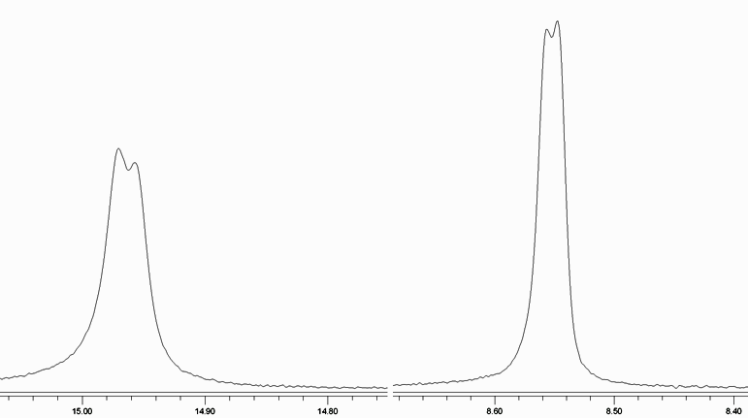

Figure 4.5 Formerly aldehydic and enol hydroxy proton splitting in ¹H NMR spectrum of 11c

Irradiation of 8d furnished four isolatable compounds. We were able to identify the expected indanone 9d by ¹H NMR spectroscopy but the yield was very low (see Table 4.1). We must admit we are not able to assign the other structures from Scheme 4.2 to the ¹H NMR spectra we measured for every single compound. We were able to identify the two unique doublets at 8.85 and 15.85 ppm corresponding probably to 11d in one spectrum as a minor impurity (< 3 %).

Table 4.1 Reported yields of isolated compounds after irradiation of 8a-d
Epoxide | Yield of 9 (%) | Yield of 10 (%) | Yield of 11 (%) | Conversion (%) | Note
8a | 67 | –ª | –^{b} | > 95 | ~ 1:1 ratio of diastereomers of 9
8b | 64 | 12 | 7 | > 95 | ~ 1:1 ratio of diastereomers of 9
8c | 66 | 15 | 8 | > 95 | –
8d | 7^{c} | –ª | –ª | > 95 | –
ª Not identified
^{b} Not formed according to comparison with authentic sample
^{c} The yield is reported from only one successfull attempt

The spectra are more complicated compared to all other epoxy ketones products and they suggest that different products are obtained after irradiation of 8d. This could be caused by the presence of the relatively large phenyl ring in the α-position to the carbonyl group. Significant distorsions could be introduced to the structure when ideal hydrogen atom transfer geometry must be attained. This can lead to new reaction pathways. Nevertheless, 2D NMR spectroscopy which will be done in near future will help us to decipher the isolated product structures.

4.3. Mechanistic and Computational Studies
We have characterized most of the compounds produced by irradiation of model epoxy ketones. Although the formation of the desired indanone products 9a-d occurs presumably through photoenolization, the mechanisms leading to observed side-products are complex. We have found previously that the reaction leading to indanones 9a-b proceeds exclusively through triplet state and the sensitization with acetone is possible.¹¹² Here we tried to irradiate the epoxides in acetone to see whether the HPLC chromatograms would change. We detected the same peaks suggesting all the processes are triplet derived. This is in agreement with Park et al.¹¹⁷ who studied the photochemistry of 2-(o-tolyl)-2-benzoyloxirane (12), an isomer of 8d, which is fundamentally the same chromophore (Scheme 4.3).

Scheme 4.3 2-(o-tolyl)-2-benzoyloxirane (12) photolysis mechanism proposal. Deuterated 12, the 12-d₂, is used to depict the deuterium isotope scrambling observed. Adapted from Park et al.¹¹⁷

Based on the laser flash photolysis experiments the fluorescence lifetime of 25 ps was found and the photochemistry occured exclusively from the triplet state because of rapid ISC from S₁(n,π*) state to T₂(π,π*) state which happened to lie near in energy. However, there is no o-methyl substituent near the keto group thus the photoenolization process can not occur. Two HAT are suggested. The δ-hydrogen atom abstraction competes with the β-hydrogen atom abstraction from the oxiranyl ring. After several rearrangements the same product, a β-ketoaldehyde analogous to 11d, was observed for both processes. These were distinguished by biexponential decay of the triplet from LFP experiments and deuterium isotope scrambling.
We repeated the deuterium incorporation experiments for 8a in a modified manner. Instead of irradiation in deuterated benzene or acetonitrile with addition of deuteromethanol we decided to sensitize the reaction with acetone-d₆ with small addition of deuterium oxide.¹¹⁸ After prolonged irradiation we observed diminishing of one of the methyl protons peak integral with respect to oxiranyl ring proton signals in the ¹H NMR spectra. This experiment is one of three widely used methods for proving the photoenolization mechanism. Hence we conclude the photoenolization is operative in our case and presumably leads to the observed indanone products. However, there are two more primary products forming. As shown above in the case of 12, a β-ketoaldehyde can be formed by β-hydrogen atom abstraction from oxiranyl ring. The same process can also occur for the epoxides under investigation. In addition, we have performed quantum chemical calculations to map the triplet state potential energy surface of a model epoxide 8 (Figure 4.6) to outline possible pathways leading to 10 and 11 and compare the activation barriers of these processes with that for photoenolization.

Figure 4.6 The model epoxide used in quantum chemical calculations of triplet potential surface

Since we have not done LFP studies of model epoxides yet, we followed that of Park et al.¹¹⁷ as an inspiration. Scheme 4.4 provides a complete overview of possible reaction pathways on triplet surface which can lead to the experimentally observed products. Several comments on Scheme 4.4 are necessary. We have explored only triplet biradical intermediates with no charge present. It has been shown by Hasegawa et al.¹¹⁹ that carbonyl radical anions (ketyl radicals) of epoxy ketones, in which the negative charge builds up at the position adjacent to the oxiranyl ring, can cleave the C_{α}–O bond selectively. We performed the quantum chemical calculations with no solvation model. The computational modelling of reactions involving a charge would result into huge activation barriers. We suppose the results we present here can explain the complexity of products obtained experimentally. However, it should be kept in mind that a sequence of reactions yielding the experimentally observed products involving radical anions could be operative. The excited singlet state reaction pathway to Z-enol has been exluded. It stems from the sensitization experiments. Intersystem crossings have not been treated as well. Scheme 4.4 does not show the cyclization of respective ground state xylyl enols (Z-enol, E-enol) to the indanone product 9, nor the reketonization of Z-enol to the starting epoxy ketone 8 by intramolecular proton transfer.
Scheme 4.4 An overview of possible reaction mechanisms on triplet surface leading to observed products in this work. There are only tripet biradicals involved in the Scheme. Reactions involving a charge were not considered. The ground state surface processes are omitted too.

We found the lowest triplet of 8 is (n,π*) in agreement with the results of Park et al..¹¹⁷ The nearest triplet state lies > 15 kcal mol^{–1} above according to B3LYP/6-31G* time-dependent formalism and has a π,n character. It corresponds to an electron transfer from a π orbital on the benzene ring to the singly occupied n orbital on the carbonyl oxygen. The carbonyl group is twisted with respect to the benzene ring by 8.2˚. There are three reactions feasible from the triplet 8. One can imagine the C_{α}–O bond opens homolytically or hydrogen atom abstraction occurs. The latter process can occur regioselectively by abstracting either one of the o-methyl hydrogens or a β-hydrogen atom (not shown in Scheme 4.4). We discussed that the transition state for 1,5-HAT is favoured in energy (Section 2.2.1.). The oxiranyl group in triplet 8 is rotated to minimize the oxiranyl oxygen – carbonyl oxygen repulsion and the resulting conformation brings one of the β-hydrogens close to the carbonyl oxygen (Figure 4.7). Inspection of the C=O···H distances suggests both processes could compete. The values of 2.490 Å and 2.449 Å have been found for β- and γ-hydrogen respectively. Both are little longer than the sum of the van der Waals radii of oxygen and hydrogen (2.72 Å).⁵⁰ We explored all three possibilities.

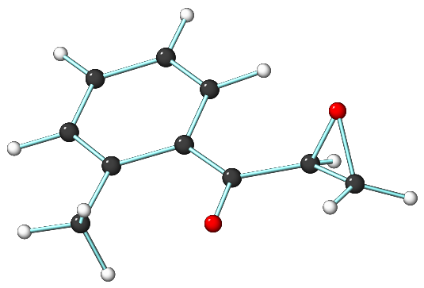
Figure 4.7 The lowest local minimum of triplet 8. Note the proximity of both the β- and γ-hydrogens and the carbonyl oxygen

Both, the C_{α}–O homolytic cleavage and γ-hydrogen atom abstraction leading to the triplet enol ³E-8, are exothermic. The reaction free energy of –24.5 kcal mol^{–1} for the former and –12.4 kcal mol^{–1} for the latter were obtained at B3LYP level of theory. The BMK functional results are almost identical. We successfully located the transition state structure of C_{α}–O bond cleavage. The barrier height of 1.2 and 3.9 kcal mol^{–1} were determined with B3LYP and BMK functional, respectively. It appears the activation free energy of γ-hydrogen atom abstraction is lower. The values of – 0.3 and 1.9 kcal mol^{–1} have been found with B3LYP and BMK functional, respectively. The negative value indicates very low or no barrier on the B3LYP potential energy surface. It is appropriate here to note the B3LYP functional often underestimates the energies of transition state structures.^{88,107} The values found for HAT are lower than the experimental activation barrier for a typical HAT in Norrish type II process.¹⁵ Nevertheless, the energy difference for these two processes signifies that the rate constant for HAT leading the triplet enol, ³E-8, is approximately an order of magnitude higher than the rate constant of homolytic cleavage to 13, a triplet precursor of the diketone product 11. This is in agreement with our observations if we assume that the quantum efficiencies of all the subsequent processes leading to products equal unity. We could not locate any TS for β-hydrogen atom transfer on the B3LYP surface from triplet 8. The C_{α}–Ο bond cleaved spontaneously during the optimization process. We tried to freeze C_{α}–Ο coordinate during the optimization process to find the TS of the HAT and activate it afterwards. This approach has not appeared to be operative. We were able to find the TS employing the AM1 method.¹²⁰ The single point calculation done at this geometry lead to an energy barrier of ~ 40 kcal mol^{–1}. It is clear that the sense of the results obtained at the AM1 geometries is, however, questionable due to used parametrization of this particular semiempirical method (recall we model the triplet states). Hence it seems reasonable to consider that the β-hydrogen atom is transfered to the carbonyl oxygen only after the C_{α}–Ο bond was cleaved. We located the TS of β-hydrogen atom abstraction from 13. The calculated activation free energies are 14.0 and 19.0 kcal mol^{–1} at the B3LYP and BMK level of theory, respectively. The energies indicate that the β-hydrogen atom transfer in 13 is the rate limiting step leading to derivatives of 11. The transition states on the B3LYP surface discussed above are shown in Figure 4.8.

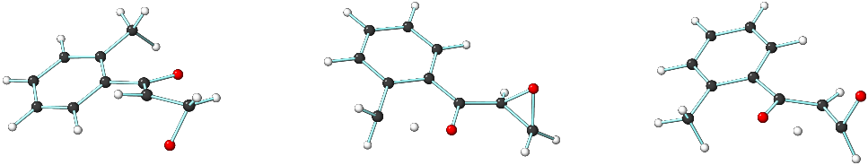

Figure 4.8 The transition states located at B3LYP/6-31G* level of theory leading to observed products. The C_{α}–Ο bond cleavage (the left structure), the γ-hydrogen atom abstraction (middle) and the β-hydrogen atom transfer from 13 are depicted.

Further piece of evidence supporting our conclusion can be seen in the photochemistry of (4,5-dimethoxy-2-methylphenyl)(3-phenyloxiran-2-yl)methanone (29, Figure 4.9) which we will discuss later (Section 4.4). The results obtained can be used to correct the conclusion of Park et al..¹¹⁷ They suggested the hydrogen atom is abstracted directly from the oxiranyl ring by comparison of the absorption spectra of 2-(o-tolyl)-2-benzoyloxirane and 2-phenyl-2-benzoyloxirane photoproducts.

Figure 4.9 The structure of (4,5-dimethoxy-2-methylphenyl)(3-phenyloxiran-2-yl)methanone (29)

The formation of derivatives of 10 can be addressed to the oxiranyl ring opening of the triplet enol ³E-8 followed by subsequent recombination of the produced triplet 1,7-biradical. A similar photoreactions were published by Hasegawa¹¹⁹ who discovered that oxiranyl methyl radicals that possess an electron-donating tributylstannyloxy substituent at the radical centre undergo selective C_{α}–Ο bond cleavage to give an oxy radical. They used tributylstannyl hydride to produce a ketyl radical in their studies. The ³E-8 can be considered as a ketyl radical produced by the hydrogen atom transfer reaction from the o-methyl group. We should note here that similar C_{α}–Ο bond cleavage could occur from ³E-8 anion which has not been studied computationally by us. Hence the oxiranyl ring opening can presumably compete with the ISC of the triplet enol to its ground state. The reaction free energy of –3.7 kcal mol^{–1} was obtained at the B3LYP level of theory. Interestingly, the reaction appears to be thermoneutral at the BMK level. The barrier to 15 is 3.8 and 5.2 kcal mol^{–1} at the B3LYP and BMK level, respectively. The activation free energy is relatively low and a competition with ISC could be expected. Paramagnetic species could be added to the reaction mixture to induce faster ISC to avoid the side-products formation. The TS structure is depicted in the Figure 4.10.
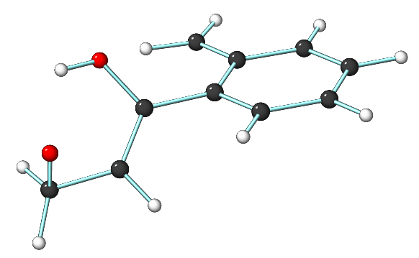

Figure 4.10 The transition state connecting the ³E-8 and 15 local minima

Another hydrogen atom transfer is possible from 15 to get 16. We found the reaction is strongly exergonic with reaction free energy equal –22.8 and –24.6 kcal mol^{–1} at the B3LYP and BMK level, respectively. The reason is that there is no longer any primary alkoxy radical present but the radical is delocalized in the π system of the molecule. The barrier computed for this transformation is 0.7 and 3.0 kcal mol^{–1} at the B3LYP and BMK level, respectively. The TS structure is shown in Figure 4.11.

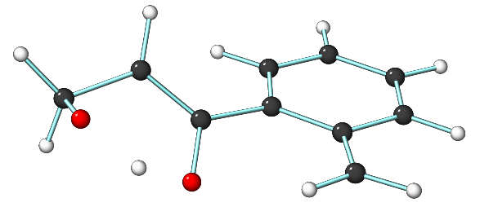
Figure 4.11 The transition state connecting 15 and 16 local minima

The activation energy suggests that the hydrogen atom transfer from 15 to 16 is very fast. The ISC followed by the coupling of a singlet biradical of 15 needs to be very efficient since we have been able to isolate 10. There are two mesomeric forms outlined in Scheme 4.4 for 16. We found more spin population on the C_{α} compared to that on former carbonyl oxygen. Hence the mesomeric form 16b is preferred and the path to indanone 9 should prevail. This is in agreement with our observations. We have not been able to identify 17 in any irradiation of our epoxides. However, we admit we have not identified one side-product formed by irradiation of 8a-c. None of the ¹H NMR spectra measured for products isolated after irradiation of 8d corresponds to respective 17 derivative. It is clear that we found another possible pathway to form 9. The deuterium incorporation experiment supports the photoenolization mechanism. It is possible that both mechanisms are operative. LFP experiments, which will be performed in near future, will resolve this puzzling question.
To conclude, we located five TS on the triplet surface of 8 which reveal possible transformations leading to observed products. We showed that the γ-hydrogen atom abstraction was faster than the homolytic C_{α}–Ο bond cleavage in n,π* lowest triplet of 8. No β-hydrogen atom transfer from the oxiranyl ring could be observed. Two competing pathways of 9 formation were displayed. We have not considered any reactions of anionic biradicals. The LFP experiments are necessary to confirm our predictions.

We also explored two important ground state reactions of the xylyl enols to gain insight into the formation of the indanone 9 (Scheme 4.5) and the intramolecular proton transfer in the Z-xylyl enol which reverts back to the starting epoxy ketone 8 (Scheme 4.6) lowering the quantum yield of the indanone formation. A heterolytic C_{α}–Ο bond cleavage could probably compete with the latter process if this was non-efficient (see Scheme 2.5 in Section 2.3.1.5).
Scheme 4.5 The cyclization of the E-enol to corresponding indanone 9 in both the protonated and deprotonated form. Only the anionic reaction was studied computationally
Scheme 4.6 Intramolecular proton transfer reketonizing the Z-enol to parent epoxy ketone 8

The cyclization reaction of the E-enol is not feasible in the gas-phase. The reason is the charge separation which appears in the TS since the C_{α}–Ο bond cleaves heterolytically forming a negative charge on the oxygen while a positive charge is formed on the carbonyl oxygen which is protonated. Thus the energy would rise as the reaction progresses. A solvation model has to be used to avoid this kind of problems. However, the condensed phase modelling is computationally very difficult. Therefore we decided to look at the cyclization of the anionic species because no charge separation described above can occur. We found an interesting result after optimization of the corresponding minima of the E-enol– and 9–. The minimum of 9– resembles a retro-aldol process of 9– product. The distance between the C_{α} and formerly the hydroxymethylene carbon equals 2.345 Å. It is significantly longer than a typical C–C bond. This indicates the retro-aldol process occurs spontaneously in anionic 19 in the gas phase supporting our observation of the same reaction for protonated species under the GC conditions. The activation barrier of 17.9 and 22.2 kcal mol^{–1} for the cyclization of the anionic species has been found. This barrier is rather high and the solvation will strongly influence this process and acid or base catalysis could be expected. The transition state structure is shown in Figure 4.12.

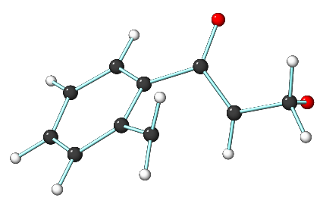

Figure 4.12 The transition state structure of indanone 9– formation

The back proton transfer in Z-enol involves two subsequent steps. Primarily the O–H must rotate into a reactive conformation prior to the proton transfer alone as the lowest conformer of Z-enol is stabilized by an intramolecular hydrogen bond between the enolic proton and the oxiranyl ring oxygen. This causes the proton to point to the opposite side relative to the benzylic position. The energy difference for these two conformers is 2.3 and 2.4 kcal mol^{–1} for the B3LYP and BMK functional, respectively. The transition state for the O–H bond rotation has been found to lie 6.6 and 6.7 kcal mol^{–1} above the lowest energy conformer of Z-enol, respectively. The activation energies of 5.5 and 6.8 kcal mol^{–1} have been computed for the proton transfer alone. Using the Eyring equation and steady-state approximation (approximate in this case) one can calculate the rate constant for the whole process and recalculate it to an apparent one step reaction activation energy. The value of the rate constant obtained this way at the BMK level of theory is ~ 1.3 × 10⁶ mol⁻¹ s⁻¹ which corresponds to ~ 9.1 kcal mol^{–1} indicating a relatively efficient process at 298 K. Both TS are depicted in Figure 4.13.
It can be concluded the cyclization of the E-enol requires acid or base catalysis at the neutral pH. The reketonization process is relatively efficient suggesting the indanone 9 is formed exclusively from the E-enol.

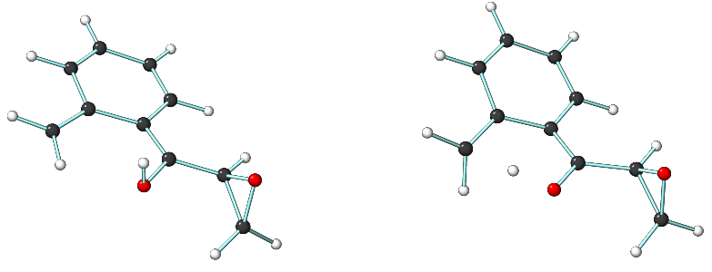

Figure 4.13 The transition state structures of the back proton transfer to 8

4.4. The Strategy of Indanocine Synthesis Using a Photochemical Key Step
Synthesis of compounds possessing a considerable biological activity is one of the main interests of the pharmaceutical industry. Since building blocks of many natural products and their various synthetic analogues based on indanone and related structures have been proved to have such an ability, methods have been searched for their synthesis.¹¹² Several pterosines (19-24 for example, Figure 4.14) have been shown to possess interesting biological activity especially due to their antibacterial and cytotoxic effects.^{121,122} The indanones presented here can be considered as analogues to Pterosines 19-21 due to its hydroxymethyl group at the α-carbon.¹²³⁻¹²⁶ The retro-aldol product of 9c is analogous to Pterosines 22-24 and it seems the complete synthesis of many Pterosines can be carried out via our methodology.
Figure 4.14 Several biologically interesting Pterosines (24-29)

However, we chose the Indanocine (25) synthesis due to its complexity (Figure 4.15). Moreover the reaction we present has been shown to be most suitable for the introduction of the benzylidene side-chain in the Indanocine synthesis.¹¹² The reason is that the hydroxymethyl group which is retained in the indanone product after the photochemical step could be dehydrated easily to get an elimination product. 25 is a compound cytotoxic to several tumour cell lines. Unlike other antimitotic agents, it induces apoptotic cell death in stationary phase multidrug-resistant (MDR) cancer cells at concentrations that do not impair viability of normal non-proliferating cells. This sensitivity to MDR cancer cells suggests Indanocine to be considered as a leader compound in the search for agents to combat the drug-resistant disease.^{113,114}

Figure 4.15 The structure of an anti-cancer drug Indanocine

There are several synthetic strategies which can be followed. The most reasonable way seems to exert the photochemistry as one of the last steps to introduce the indanone skeleton with a hydroxy substituent, dehydration of which would result into an Indanocine-like prodrug. However, the amino group constitutes a major problem for the photochemical step. It has been shown triethylamine reduces epoxy ketones upon irradiation yielding a β-hydroxy ketone.¹²⁷ The amino group interference thus seems rational. The amino group can be protected by an electron-withdrawing group reducing the electron density on the nitrogen atom hence avoiding possible complications due to electron transfer reactions. Another problem would, however, appear by such a modification of the skeleton. The o-position of the protected amino substituent could interfere with the ketone group distorting it to an inappropriate conformation which could prevent the hydrogen atom abstraction to occur. The retrosynthetic analysis would suggest a nitro group to be a better candidate since it is relatively small and will cause no intramolecular electron transfer reactions. Resonance Raman spectroscopic measurements and density functional theory studies of p-nitroacetophenone (PNAP), however, indicate that the excited states of PNAP come from π (benzene ring) → π* (NO₂) group charge-transfer band.⁷³ This indicates a similar behaviour could be seen for the triplet state. We performed quantum chemical calculations of a model epoxy ketone structurally similar to Indanocine to evaluate the role of the nitro group in the molecule in its triplet state. We found three minima by rotating the nitro group in the molecule. It appears that that with the carbonyl group in the position ideal for the hydrogen transfer reaction possesses the highest energy. We found a minimum lower in energy by ~ 3 kcal mol^{–1} with seriously distorted benzene ring and carbonyl oxygen pointing the opposite direction to the o-methyl group (an anti conformation). Unexpectedly, we found another minimum which did not resemble the starting structure any more. The single point calculation showed the energy has lowered by additional ~ 30 kcal mol^{–1}. The structure of this minima is shown in Figure 4.16. It can be concluded the nitro group strongly influences the excited state and will be responsible for triplet state chemistry of the model epoxy ketone used. The intramolecular cyclization observed in this case helped us to decide to stop any further synthetic efforts with a nitro group substituted epoxy ketones. The next disconnection leads to a molecule resembling the benzene ring substitution of 29. The nitration and subsequent reduction of identically substituted indanone skeleton was used in the existing Indanocine synthesis.¹¹³ We know from the previous discussion (Section 2.3.1.2) on benzene substituents effects on the triplet reactivity of aromatic ketones that the methoxy group inverts the energies of n,π* and π,π* states thus decreasing the reactivity in the photoinduced hydrogen atom transfer reactions. Although the overall rate constant decreases the hydrogen abstraction can still occur. We employed DFT calculations to predict the reactivity of 29a, the analogue of 29 (Figure 4.17)
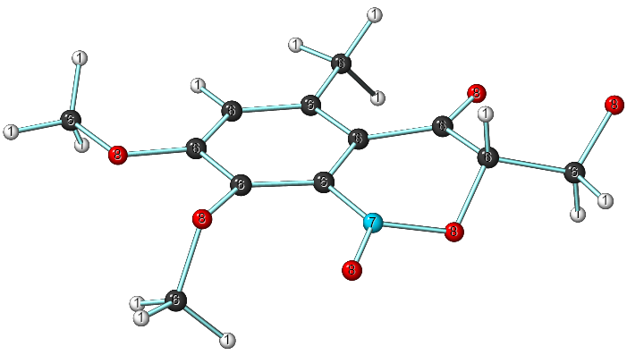
Figure 4.16 Structure of the lowest minima found for an Indanocine-like substituted model epoxy ketone on the triplet potential energy surface. Type of the atoms is denoted.

Figure 4.17 The model epoxy ketone 29a used to predict the photochemical behaviour of 29

Not surprisingly, we found that the lowest triplet state is the π,π* state indeed. The TD DFT calculation showed the nearest n,π* state to lie 14.3 kcal mol^{–1} above. The orbitals of both states are shown in Figure 4.18. The calculated energy gap is too huge for any triplet hydrogen atom transfer reaction to occur via thermal equilibration. However, the TD DFT methods do not provide exact energies. The B3LYP method employed here has been shown to perform with the absolute mean deviation in the range of 0.25–0.32 eV (5.7–7.4 kcal mol^{–1}) for various excited state chemistry calculations.¹²⁸ This hopefully allows one to carry out the desired photochemical transformation successfully.
We synthesized the epoxy ketone 29 according to Scheme 4.7 to experimentally confirm or disprove the theoretical results. We used almost the same approach as described above for all other epoxides in this work. Methylation of commercially available 2-methoxy-4-methylphenol with dimethyl sulfate gave 26 in excellent yield. Simple Friedel-Crafts acylation of 26 furnished 27 very high yield. We continued by aldol condensation to prepare the respective enone in high yield which was subsequently oxidized by alkalic hydrogen peroxide solution to get the desired epoxy ketone 29 in high yield.

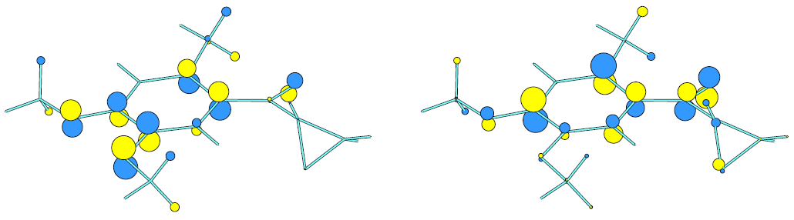
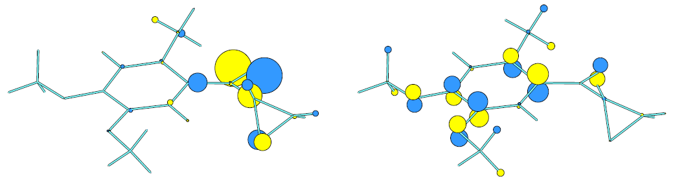
Figure 4.18 The simplified view of orbitals of the lowest π,π* (up) and the nearest n,π* triplet state (bottom)

Scheme 4.7 The synthesis of the model epoxy ketone 29

Irradiation of 29 in acetonitrile to ~ 70-75 % conversion furnished only one isolable product. The GC-MS analysis provided the molecular peak at 298 m/z suggesting an isomeric compound to 29 formation. It indicated the expected indanone did not form since no peaks corresponding to a retro-aldol product had been observed. After COSY, HMQC and HMBC experiments we identified 30 to be the isolated product (Scheme 4.8).

Scheme 4.8 Irradiation of 29 in various solvents resulted in 30 as a major product

This is rather a disappointing result since we could not prepare the expected indanone. On the other hand it provides additional support for our proposed mechanism depicted in Scheme 4.4. Since the HAT is suppressed only the oxiranyl ring can open leading to 30. The π,π* character of the lowest triplet state prevents any γ-hydrogen abstraction and excludes the β-hydrogen atom transfer from the oxiranyl ring to occur, too. Additionally, we did not observe any product resembling 10. It could stem from the fact the reaction to 10 must proceed through the triplet enol intermediate. However, care must be taken to make any final conclusions. LFP experiments are expected to establish the mechanism of these transformations.
We have not gave up the Indanocine synthesis completely yet. We know from our previous discussion that the environment can have a dramatic impact on the triplet state levels. We tried to irradiate 29 in various solvents with low relative permitivity to destabilize the non-bonding n orbital on the carbonyl oxygen atom. This should decrease the energy of the n,π* state. But 30 was formed as a major product when t-BuOH, acetone, benzene, or hexane were used. It has been shown that the quantum chemical calculations can predict the energy order of the two lowest triplet states and estimate the relative energy gap between these. We have proposed synthetically feasible modifications of the benzene ring substituents in the positions 4 and 5 to bring the energies of the π,π* and the n,π* states to proximity and computed the character of the lowest triplet state and the energy difference to its nearest counterpart. The results are summarized in Table 4.4.
It is obvious that most of the proposed substituents preserve the π,π∗ state as the lowest in energy. Introduction of fluorines decreases the energy gap which is, however, still too high. Substitution of the 5-OCH₃ group for 5-OCF₃ inverted the triplet states making the n,π* state lower in energy than the π,π∗. This is rather surprising since the same substitution in position 4 did not show such an effect. A closer inspection of the geometry provides us with a possible explanation. The 5-OCF₃ is rotated with respect to the benzene ring by ~ 84˚ while the other examples are in its plane. The oxygen lone pairs thus cannot join the conjugation to stabilize the nonbonding n orbital on carbonyl oxygen. However, the rotation of the 5-OCF₃ group would presumably result into connection of the lone pair to the conjugation thus inverting the electronic states. Inspection of the computed vibrational spectrum revealed that the lowest energy mode corresponds to the rotation of the 5-OCF₃ indeed.

Table 4.4 The summary of the lowest two triplet states of structurally modified model epoxy ketones in the positions 4 and 5. The nearest triplet state denotes the energetically nearest triplet state to the lowest one.
Substituents | The character of the triplet states |  | Energy gap (kcal mol^{–1})
Substituents | The lowest | The nearest | Energy gap (kcal mol^{–1})
–OCF₂O– | π,π* | n,π* | 11.7
4-OCF₃, 5-OCF₃ | π,π* | n,π* | 11.6
–OSi(Me)₂O– | π,π* | n,π* | 14.8
4-OCH₃, 5-OC(=O)CH₃ | π,π* | n,π* | 13.3
–OCH₂O– | π,π* | n,π* | 15.6
4-OCH₃, 5-OCF₃ª | n,π* | π,n^{b} | 9.8
4-OCF₃, 5-OCH₃ | π,π* | n,π* | 13.1
–OC(=O)O– | n,π* | π,n^{b} | 11.8
ª The n,π* character could be caused by the conformation found as the minimum, where the 5-OCF₃ group is not coplanar with the benzene ring
^{b} Corresponds to an electron transfer from a π orbital on benzene ring to the singly occupied n orbital on carbonyl oxygen

The last row in Table 4.4 shows another substituent with the n,π* lowest triplet state. The carbonate substituent is in the plane of the benzene ring. We found out the orbitals look alike the orbitals of triplet 18. Hence this compound can be suggested as an evident choice on the way to the Indanocine photochemical synthesis. These experiments are underway.

4.5 Conclusion I
Four model epoxy ketones were successfully synthesized in high yields. Their irradiation lead to three compounds in general. The anticipated indanone class product was obtained in very good yields for all the model compounds (9d is not considered). The side-products were identified for compounds 8b and 8c only.
Senzitization experiments suggested that all the products were formed through the triplet state pathway. Deuteration experiments provided strong evidence that the photoenolization mechanism leading to observed indanones was operative.
Quantum chemical calculations were employed to explore the triplet potential energy surface of model epoxy ketones. We were able to confirm and correct the mechanism proposal previously published in the literature for a similar chromophore. Five distinct transition states were located on the triplet surface. Their relative energies provided relatively strong evidence for the mechanisms by which the side-products were formed. Computed molecular orbitals indicated the scope of the reaction which could be used for synthesis of biologically interesting compounds.
The photochemical synthesis of indanone skeleton was simple which suggests that the synthesis of various Pterosines can be straightforward. Synthetic strategy for Indanocine was proposed and a structurally analogous epoxy ketone 29 was synthesized. No expected indanone product was observed upon irradiation in various solvents. Quantum chemical calculations explained this apparent failure and suggested a new promising starting compound to prepare Indanocine.

Part II: A Contribution to the o-Nitrobenzyl Photochemistry
We have devoted the discussion in the previous chapter to the synthetic application of the photoenolization process in dimethylphenacyl epoxides to produce synthetically interesting indanones. We have also tried to confirm that the mechanism of the observed transformation is truly the photoenolization and to rationalize the mechanisms by which isolated side-products are formed.
Now we will turn to a different chromophore but the very same fundamental type of process which is the photoinduced hydrogen atom transfer. This part of the work will discuss the influence of various substituents at the benzylic position of the o-nitrobenzyl (we will use o-nitrobenzyl and nitrobenzyl interchangeably in the text) chromophore on the height of the barrier for HAT in the triplet state and possibly on the observed quantum yields. We hope the results presented here will shed light to the triplet state reactivity of the o-nitrobenzyl moiety and related compounds, will help to design future experiments in this field and suggest the scope of this type of chromophore as a photoremovable protecting group.

5.1. Introduction
The effect of substituents on the thermodynamic stability and kinetic parameters of reactions is of widespread chemical interest. There have been numerous attempts to understand how the kinetic barriers change with the structure. Recall the Bell-Evans-Polanyi principle, Hammond postulate or Hammet relation.¹²⁹ All of these are now broadly used in the physical or physical organic chemistry. Although such attempts have been tried in photochemistry, it has appeared that these are not often completely applicable. Remember our discussion on Hammet constants and the photochemical reactivity of triplet ketones. In the next sections we will discuss the results obtained for hydrogen atom abstraction in the triplet o-nitrobenzyl moiety in connection with its reactivity. Since 1,4-biradical intermediate is believed to form^{82,91-93}, it is reasonable to believe that comparison of the C-H bond strength of o-nitrobenzyl with that of triplet ketones can be observed. We have started to study such trends looking at correlations between radical stability, kinetic parameters of the HAT and thermochemical data in the triplet and the ground states. Since the necessary data are difficult to obtain by experiments we employed quantum chemical calculations to sort such relationships out. Besides, valuable information on geometry of hydrogen atom transfer in the triplet state are obtained.

5.2. Comments on the Methods Used
The homolytic bond dissociation energy (BDE) is an important thermodynamic quantity that provides a measure of radical stability. For a CH₃X molecule, the C–H BDE is defined as an enthalpy change for the reaction
A related convenient measure of the effect of a substituent on the radical stability, relative to its effect in the parent closed-shell molecule, is the radical stabilization energy (RSE). For monosubstituted methyl radical, the RSE is commonly defined as the energy change in the isodesmic reaction
Defined this way, a positive value represents a net stabilization of the substituted radical while a negative value implies a net destabilization. Since the errors found for any particular theoretical method in the calculation of BDE are generally systematic, cancellation of errors might be expected for the results of RSE.¹³⁰ Hence cheaper methods may lead to relatively accurate description of a substituent effect on the radical stability. In this work we use the RSE with respect to 2-nitrotoluene and 2-nitrobenzyl radical as a reference computed by relatively inexpensive DFT methods based on double-hybrid functionals recently introduced by Grimme^{110,111} because the molecules under investigation contain more than 10 heavy atoms and high-level methods are not applicable in this case. These functionals (B2-PLYPand MPW2-PLYP) are related to B-LYP and MPW-LYP functionals and besides including a portion of exact HF exchange, they also include a perturbative second-order correlation contribution and showed promising performance in the RSE values calculation.¹³⁰
We followed the protocol to obtain the RSE used by Radom et al.¹³⁰ in a modified manner. We have looked at the basis sets dependence of the RSE values for the allyl radical as a good representative for the 2-nitrobenzyl radical to find even less expensive way of RSE values computation with reasonable accuracy. The results obtained are summarized in the following table (Table 5.1).

Table 5.1 The basis sets dependence of the allyl radical RSE with the used DFT methods relative to the 6-311+G(3df,2p) basis set (in kcal mol^{–1})
 | UB2-PLYP | B2-PLYP | UMPW2-PLYP | RMPW2-PLYP
6-311+G(2df,2p) | -0.06 | -0.06 | -0.05 | -0.06
6-311+G(2df,p) | -0.10 | -0.11 | -0.10 | -0.11
6-311+G(3df,p) | -0.04 | -0.04 | -0.04 | -0.04
6-311+G(2d,p) | -0.34 | -0.39 | -0.32 | -0.37
6-311+G(d,p) | -0.48 | -0.61 | -0.45 | -0.58
6-311G(3df,2p) | 0.29 | 0.27 | 0.31 | 0.27
6-31+G(d,p) | -0.24 | -0.45 | -0.22 | -0.43
6-31+G(2d,p) | -0.14 | -0.23 | -0.14 | -0.23
6-31+G(3d,2p) | -0.15 | -0.20 | -0.14 | -0.20

The RSE value of ~17 kcal mol^{–1} with the 6-311+G(3df,2p) basis set was found for the allyl radical. Hence one can conclude the RSE values are not significantly dependent on the basis set used and even such small double-ζ basis set like 6-31+G(d,p) gives reasonable results. This can be probably ascribed to the cancellation of the errors in the isodesmic reaction approach used. Several trends can be observed from Table 5.1. The variation in the RSE is more pronounced for restricted formalism of the DFT methods used. Omitting the diffuse functions for heavy atoms increased the RSE values and double-ζ basis sets seem to perform better for the allyl radical than the triple-ζ basis sets do. However, more molecules should be included to generalize such trends. Based upon these results we decided to use the 6-31+G(2d,p) basis set in our calculations of RSE.
The correlations we have tested are based on the Bell-Evans-Polanyi principle which can be considered as a consequence of the Hammond postulate (both included in the Marcus theory).¹²⁹ This principle is defined for a series of analogous (or similar) reactions and states that more exothermic (endothermic) process has lower (higher) activation energy. Such a relationship is assumed to be linear, i.e., the activation energy varies linearly with the energy of the reaction as depicted in the following equation
The substituents which can be cleaved from the nitrobenzyl moiety as a leaving group, and for which the nitrobenzyl is commonly used as a photoremovable protecting group^{5,6,8}, stabilize the radicals by conjugation. Substituents that show only the induction effect were and a molecule with double substitution at the benzylic position were investigated too. The whole set of all the model compounds is shown in Figure 5.1.

Figure 5.1 The model compounds considered in the present study

The quantum yields we used in the present study were measured by Bochet et al.¹³¹ for the nitroveratryl group^{6,94} which contains two methoxy groups on the benzene ring and are summarized in Table 5.2. We know that such substitution completely suppresses the triplet reactivity of ketones due to huge gap between the lowest π,π* and the reactive n,π∗ state. However, the character of the excitation is not inverted for the nitroveratryl group and the lowest triplet is n,π* in origin as for the parent non-substituted nitrobenzyl. We have proved this computationally by optimizing both molecules. The simplified orbitals (from MOPLOT) are shown in Figure 5.2.

Table 5.2 Quantum yields of cleavage of a leaving group for a series of nitroveratryl protected compounds at two different wavelengths
Substituent | Φ₂₅₄ | Φ₃₆₀
Me(CH₂)₇O | 0.16 | 0.22
Me(CH₂)₉OC(=O)O | 0.011 | 0.009
Me(CH₂)₁₁NHC(=O)O | 0.012 | 0.019
Me(CH₂)₁₁C(=O)O | 0.007 | 0.008
Me(CH₂)₁₀C(=O)NH | 0.054 | 0.072
Me(CH₂)₁₁NH | 0.16 | 0.14
Me(CH₂)₈OC(=O)NH | 0.076 | 0.088

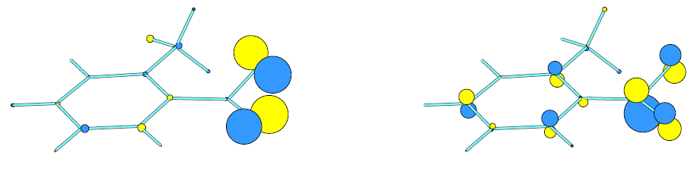
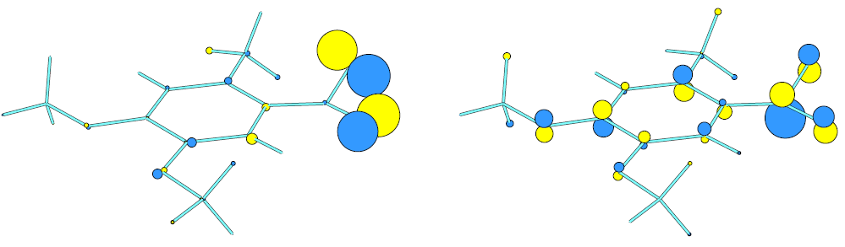

Figure 5.2 Simplified view of MO of triplet 31 (up) and triplet of nitroveratryl group (bottom)

5.3. Structure of Triplet o-Nitrotoluene
Figure 5.3 shows the atom numbering for 31. Its molecular structure has been already determined from electron diffraction data and ab initio calculations based on perturbation theory (MP2(fc)/6-31G*).¹³² Il’ichev and Wirz⁸⁸ tested several hybrid DFT methods with different basis sets for optimizing the geometry of 31. All the methods predicted a minimum-energy structure of 31 with nitro group twisted relatively to the benzene ring. The BHLYP method yielded substantially shorter values for bond lengths with differences larger than could be accounted for vibrational effects. All other methods gave satisfactory results and the B3LYP functional with moderate 6-31G* basis set has been shown to perform very well for geometry parameters, harmonic vibrational frequencies and the dipole moment of 31.

Figure 5.3 Atom numbering for 2-nitrotoluene (31) and cis and trans aci-nitro intermediates

Table 5.3 Selected experimental values and computed bond lengths (in Å), angles and dihedral angles (in degrees) of 31 ground, triplet state and TS of HAT obtained at the B3LYP/6-31G* (A) level of theory or B3LYP/6-311+G(2d,p) (B)
 |  | Ground state^{b} |  | Triplet state | TS
Parameter | Exptl.ª | A | B | A | A
C₁–C₂ | 1.405 | 1.410 | 1.403 | 1.415 | 1.413
C₁–C₇ | 1.508 | 1.510 | 1.506 | 1.510 | 1.495
C₇–H₈ | 1.103 | 1.093 | 1.090 | 1.095 | 1.307
C₂–N₁₁ | 1.490 | 1.475 | 1.475 | 1.403 | 1.397
N₁₁–O₁₂ | 1.231 | 1.232 | 1.226 | 1.309 | 1.395
N₁₁–O₁₃ | 1.231 | 1.232 | 1.226 | 1.309 | 1.252
O₁₂–H₈ | 2.56 | 2.486 | 2.525 | 2.603 | 1.212
C₂–N₁₁–O₁₂ |  | 118.4 | 118.1 | 125.9 | 120.1
C₂–N₁₁–O₁₃ |  | 117.7 | 117.6 | 123.7 | 125.8
O₁₂–N₁₁–O₁₃ | 124.9 | 123.8 | 124.3 | 104.6 | 114.0
C₇–H₈–O₁₂ |  | 89.9 | 90.1 | 88.9 | 155.0
C₁–C₂– N₁₁–O₁₂ | -38 | -13.7 | -24.8 | -28.8 | -0.0
C₁–C₂– N₁₁–O₁₃ |  | 166.8 | 155.9 | 177.7 | 0.0
C₂–N₁₁–O₁₂–H₈ |  | 36.4 | 46.9 | 9.2 | 0.0
C₂–C₁–C₇–H₈ |  | -51.8 | -46.9 | -69.8 | -0.1
ª Gas-phase diffraction electron data¹³²
^{b} From Il’ichev and Wirz⁸⁸ and the present work

We employed the same level of theory to compare the experimental geometry of 31 from diffraction data¹³² and those obtained computationally for the ground, triplet and the triplet transition states of HAT. We were able to reproduce the values of Il’ichev and Wirz⁸⁸ for ground state structure of 31. The results for the selected part of the molecule are given in Table 5.3.
It is clear that the geometry of triplet 31 differs compared to its ground state. There is only little influence on the benzene ring and the methyl group, however, the nitro group undergoes significant changes. The N–O bond length is the same for both nitro group oxygens but is elongated by approximately 0.08 Å. On the other hand, the C₂–N₁₁ bond length is shortened by ~ 0.07 Å. Both the C₂–N₁₁–O₁₂ and C₂–N₁₁–O₁₃ angles increased, while that of O₁₂–N₁₁–O₁₃ decreased. The N₁₁–O₁₃ bond is no longer twisted from the benzene ring plane, while N₁₁–O₁₂ is above and the nitro groups is bend. The distance of the hydrogen H₈ and the oxygen O₁₂ increased by ~ 0.08 Å to 2.603 Å. The optimum value should equal the sum of van der Waals radii of oxygen and hydrogen which is 2.72 Å.⁵⁰ Considerable changes in the nitro group geometry occur in the transition state. The C₂–N₁₁ bond length further decreased and the two N–O bond lengths are no longer equal. The N₁₁–O₁₂ bond elongates towards the abstracted hydrogen atom, while the other shortens. The C₇–H₈ and the O₁₂–H₈ distances of 1.307 Å and 1.212 Å, respectively, have been found in the TS. All the dihedral angles listed above are almost 0˚ indicating an in-plane arrangement of the nitro group, benzene ring and the C₇–H₈ bond. This suggests that significant changes occur upon excitation of the molecule leading to aci-nitro products. Figure 5.4 shows the minima and TS found.
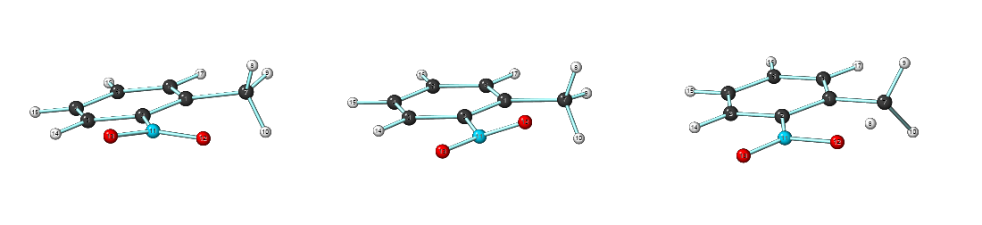
Figure 5.4 Structures of 31 ground state (left), lowest triplet state (middle) and the TS of hydrogen atom abstraction (right)

The dipole moment of 4.33 D has been reported for 31 at B3LYP/6-31G*.⁸⁸ The experimental values are in the range of 3.8–4.0 D.¹³³ We obtained 3.62 D for triplet 31 and 4.61 D for the TS. It can be concluded the triplet is less polar than the ground state and the TS structure of triplet HAT slightly resembles the ground state 31.

5.4. Differences of Aci-nitro Intermediate and its Triplet State
It is well known after the hydrogen atom is abstracted an intermediate is formed. This intermediate is referred to as aci-nitro intermediate (Figure 5.3, 31b). Its structure and reactivity is well understood^{86,88,89}, but its triplet state which is equivalent to 1,4-biradical in triplet ketones has not yet been investigated properly.⁸⁸ Benzylic substitution of 31 may lead to four different diastereomers of 31b depending on the configuration on both double bonds, C₁=C₇ and C₂=N₁₁, respectively. It is known from either matrix isolation experiments⁸⁶ or quantum chemical calculations⁸⁸ that the most stable diastereomer has the E configuration on both double bonds. Moreover, there can be two conformations for the O₁₂–H₈ (O₁₃–H₈) relative to N₁₁–O₁₂ (N₁₁–O₁₃) bond. The syn conformer has been found to be more stable than the anti according to our and Il’ichev⁸⁸ calculations. Turning to the triplet state, the E configuration on C₁=C₇ double bond remains as the more stable one but that on C₂=N₁₁ bond is inverted. The energy difference in the ground state prefers the trans-31b by ~ 4 kcal mol^{–1}. It is interesting that the difference (but for reversed configuration, Z) is only ~ 0.5 kcal mol^{–1} for 31b in the triplet state. The 31b structure has C_{s} symmetry. The substitution at the benzylic position does not change the stable planar structure. The triplet state differs significantly. The arrangement of the formerly nitro group is twisted relative to the benzene ring and bend as described for triplet 31. The geometry of triplet 31b is depicted in the following figure (Figure 5.5).

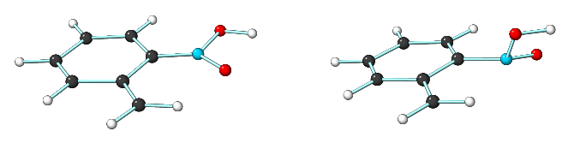
Figure 5.5 The most stable aci-nitro intermediates of 31. The ground state (left structure) and the triplet state depicted

We calculated the gas-phase acidities for triplet 31b. The acidities were obtained as a difference between thermal enthalpies (no scaling for frequencies was used) of the anion (having the C_{s} symmetry) and the conjugated acid plus the translational enthalpy of a free proton (3RT/2 = 0.889 kcal mol^{–1}). We found the enthalpies equaled 334.05 kcal mol^{–1} and 334.60 kcal mol^{–1} for trans-31b triplet and cis-31b triplet, respectively. The comparison with the gas-phase acidities calculated by Il’ichev⁸⁸ suggests that the triplet aci-nitro is a weaker acid than its ground state. The dipole moment of 5.7 D has been found for triplet 31b, while that of ground state is 1.3 D making the triplet state considerably more polar.

5.5. The Impact of the Benzylic Substitution on the Geometries
Analysis of the geometries of triplet 32 – 46 did not shown any substantial difference from the geometry described for 31. The nitro group is twisted for all the model compounds with the benzylic substituent pointing outwards the molecule. We found two compounds (36 and 38) which differ slightly due to intramolecular seven-membered hydrogen bond. This has caused that the C₁–C₇ bond is rotated by ~ 120˚. This minimum appears to be stabilized by > 1.3 kcal mol^{–1} compared to non-hydrogen bonded structure for both instances. Figure 5.6 highlights this feature. A similar geometry modification is found for 46. The reason is that the positive charge on ammonium nitrogen is attracted by the negatively polarized nitro group oxygen. The positive charge for the molecule suggests the solvation to be important for this particular case and it appears that the HAT for 46 cannot be considered completely analogous with other molecules in our set. However, we do not exclude 46 from further study. Although it is disqualified for correlations discussed below, interesting results have been obtained indeed.

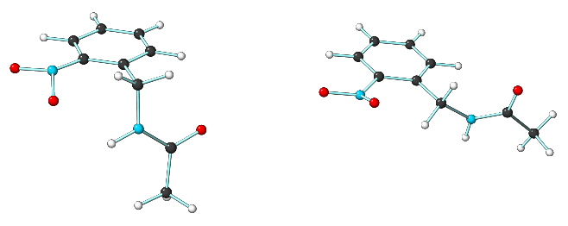

Figure 5.6 Two minima of 36. The left structure with intramolecular hydrogen bond is stabilized by
~ 1.9 kcal mol^{–1}

The influence of substitution on HAT was analysed in terms of the C₇–H₈ and O₁₂–H₈ distances, the C₂–N₁₁–O₁₂–H₈ dihedral angle in the TS, and the RSE of a substituted benzylic radical. Table 5.4 summarizes the values.

Table 5.4 C₇–H₈ and O₁₂–H₈ distances (in Å) and the C₂–N₁₁–O₁₂–H₈ dihedral angle (in degrees) in triplet TS of HAT for substituted o-nitrobenzyl compounds. RB2-PLYP RSE relative to the radical of 31 are included (in kcal mol^{–1})
Molecule | C₇–H₈ | O₁₂–H₈ | C₂–N₁₁–O₁₂–H₈ | RSE
31 | 1.307 | 1.212 | 0.0 | 0.0
32 | 1.235 | 1.349 | 9.5 | 10.61
33 | 1.260 | 1.290 | 8.9 | 5.73
35 | 1.258 | 1.293 | 8.6 | 6.17
37ª | N/A | N/A | N/A | 16.22
41 | 1.271 | 1.259 | 11.3 | 4.49
42 | 1.264 | 1.286 | 8.5 | 7.69
43 | 1.230 | 1.342 | 8.3 | 11.90
44 | 1.277 | 1.271 | 11.5 | 2.96
45 | 1.309 | 1.207 | 8.6 | -0.16
46 | 1.354 | 1.203 | 26.1 | -1.97
ª No TS of HAT for 37 can be found on B3LYP/6-31G* triplet PES

The strong inductively electron-withdrawing groups (see 45, 46) have increased the C₇–H₈ distance compared to parent 31, while that of O₁₂–H₈ has decreased. The opposite effect is observed for inductively electron-withdrawing but by resonance electron-releasing groups. A trend can be observed. The better the resonance and the weaker the inductive effect, the higher the radical stabilization energy and the shorter and longer the C₇–H₈ and O₁₂–H₈ distances are, respectively. This can be probably ascribed to the extent of the biradical formation. The more “naked” radical at the benzylic position is being formed, the longer the C₇–H₈ bond resembling the structure of the 1,4-biradical product with planar benzylic position relative to benzene ring is. This is in agreement with the Hammond postulate. The MeS and MeO groups have earlier TS since the HAT in triplet state is exothermic. However, there are more structural features changing and all of them should be considered altogether. For example, the C₂–N₁₁–O₁₂–H₈ dihedral angle varies from complete planar arrangement for 31 to 26.1˚ for 46 but no correlation with RSE is evident. That is why any structural trends are very difficult to elucidate. Moreover, steric hindrance may start to play a significant role for larger substituents which makes the pure electronic analysis difficult. For example, the MeS group stabilizes the radical better than the MeO group does, and although the C₇–H₈ distance is shorter for the former as expected from the trend described above, that of O₁₂–H₈ expected from the trend is reversed, i.e., it is longer for MeO group.
We have tried to find further evidence to support the assumption that the stability of the forming radical influences the reaction. We compared the C–X (X being the benzylic substituent) bond lengths and their changes in the triplet state, TS, the 1,4-biradical (triplet aci-nitro), and the respective benzyl radical. The results are lucidly arranged in Table 5.5.

Table 5.5 Bond lengths of C–X bond (benzylic carbon – substituent) length (in Å) in the triplet state, the TS, the triplet biradical intermediate and the substituted benzyl radical and their relative changes during the progress of the reaction; the RSE are included (in kcal mol^{–1})
 | C–X bond length |  |  |  | ∆R(C–X)ª |  | Rel. bond^{b} shortening(%) | RSE
Molecule | Triplet | TS | Aci | radical | TS | Aci | Rel. bond^{b} shortening(%) | RSE
31 | 1.094 | 1.093 | 1.085 | 1.086 | -0.001 | -0.009 | 11.1 | 0.0
32 | 1.412 | 1.375 | 1.353 | 1.344 | -0.037 | -0.059 | 62.7 | 10.61
33 | 1.438 | 1.398 | 1.374 | 1.367 | -0.040 | -0.064 | 62.5 | 5.73
35 | 1.439 | 1.397 | 1.370 | 1.364 | -0.042 | -0.069 | 60.9 | 6.17
41 | 1.818 | 1.773 | 1.729 | 1.728 | -0.045 | -0.089 | 50.6 | 4.49
42 | 1.466 | 1.434 | 1.400 | 1.404 | -0.032 | -0.066 | 48.5 | 7.69
43 | 1.843 | 1.777 | 1.741 | 1.735 | -0.066 | -0.102 | 64.7 | 11.90
44 | 1.389 | 1.361 | 1.344 | 1.341 | -0.027 | -0.045 | 60.0 | 2.96
45 | 1.518 | 1.509 | 1.490 | 1.493 | -0.009 | -0.028 | 32.1 | -0.16
46 | 1.532 | 1.531 | 1.482 | 1.487 | -0.001 | -0.050 | 2.0 | -1.97
ª obtained as R_{TS}(C–X) – R_{triplet}(C–X) or R_{aci}(C–X) – R_{triplet}(C–X)
^{b} obtained as ∆R_{TS}(C–X)/ ∆R_{aci}(C–X) ratio

It can be nicely seen in Table 5.5, that the C–X bond indeed shortens in the progress of the reaction. Comparing the C–X bond lengths between the benzyl radical and the relevant triplet aci-nitro intermediate, one can conclude, that the radical is fully developed in the latter making our assumption valid. The same conclusion can be made by inspecting the spin populations. It is impossible to relate the percentage of bond shortening in the TS relative to the biradical product to the RSE or the position of the TS along the reaction coordinate unfortunately. The problem probably stems from different heteroatoms involved as substituents, hence making such comparison improper.

5.6. Thermodynamic and Kinetic Parameters and Their Correlations
We have showed some evidence that a radical is formed at the benzylic position, although we were unable to clearly distinguish any correlation of RSE or the extent of radical formed with the position of the TS along the reaction coordinate. Nevertheless we will show that various thermodynamic parameters indeed correlate among themselves according to Bell–Evans–Polanyi principle. The general reaction scheme is shown in Figure 5.7. The thermodynamic parameters for the reaction scheme shown in Figure 5.7 for all model molecules are summarized in Table 5.6.

Figure 5.7 Overview of reactants, products and triplet intermediates and associated thermodynamic quantities. S₀ is the ground state of parent compound, T₁ is its triplet state, TS stands for the TS of HAT in triplet, ³BR is the triplet state of aci-nitro intermediate which is denoted as o-Q here.

Several conclusions can be made immediately from Table 5.6. The reaction from substituted o-nitrobenzyl compound to the aci-nitro intermediate is endothermic, while the same process in the triplet state is exothermic. The pK_{T} value for different substituents for both processes varies by more than 10 orders of magnitude (equilibrium constant taken at 298 K).
Table 5.6 Summary of all computed thermodynamic quantities (in kcal mol^{–1}, at 0 K). ΔH_{GS} denotes the enthalpy change for the ground state and ³T ΔH is the enthalpy change for the triplet state HAT, ³T ΔH‡ represents the activation energy for triplet HAT, E_{T1} and E_{T2} are the triplet energies of reactant and product, respectively. RSE is the radical stabilization energy computed with RB2-PLYP functional
Molecule | ΔH_{GS} | RSE | ³T ΔH | ³T ΔH‡ | E_{T1} | E_{T2}
31 | 27.3 | 0.00 | -11.2 | 7.5 | 54.2 | 12.2
32 | 17.9 | 10.61 | -20.7 | -0.5 | 55.1 | 11.5
33 | 21.7 | 5.73 | -17.7 | 3.3 | 55.1 | 11.8
34 | 20.9 | 6.39 | -18.6 | - | 55.0 | 11.8
35 | 21.3 | 6.17 | -18.2 | 2.8 | 55.0 | 11.6
36 | 19.8 | 7.40 | -19.7 | - | 54.9 | 10.7
37 | 12.1 | 16.22 | -28.6 | N/Aª | 57.6^{b} | 11.5
38 | 19.3 | 7.54 | -20.5 | - | 54.8 | 11.0
39 | 21.6 | 5.77 | - | - | - | -
40 | 24.7 | 4.66 | - | - | - | -
41 | 22.7 | 4.49 | -17.0 | 3.1 | 54.8 | 10.7
42 | 19.2 | 7.69 | -21.4 | 6.1 | 54.7 | 10.3
43 | 17.4 | 11.90 | -20.8 | -2.9 | 52.7 | 9.7
44 | 23.8 | 2.96 | -15.2 | 5.4 | 55.7 | 12.3
45 | 25.8 | -0.16 | -13.4 | 7.1 | 54.4 | 11.4
46 | 29.4 | -1.97 | -4.8 | 19.9 | 55.6 | 16.0
ª No TS state can be located for 37 at B3LYP/6-31G* PES
^{b} The higher value for triplet 37 is caused by the absence of the lowest conformer found for all other model molecules

A closer look at both reaction enthalpies and RSE reveals that these quantities correlate linearly i.e. the higher the RSE the more exothermic the HAT is in the triplet state. The opposite effect is observed for the reaction enthalpy in the ground state. The first trend could be expected since we have seen that the benzylic radical site is fully developed in the triplet biradical but the reason why the same trend, although reversed, is observed in the ground state is surprising at first glance because this suggests the aci-nitro intermediate has, at least partially, a biradical character. We must note here we have completely omitted 40 from any further study. The reason can be seen from the structure of the most stable diastereomer of its aci-nitro form. We found the double substitution prevented the benzene ring from planarity, causing serious distortions of the molecule. Therefore, we concluded that the HAT for this compound could not be considered as a similar reaction compared to other molecules in the set. Besides, it appears all quantities considered for 42 deviate significantly from the linear trends observed for the set of molecules under investigation. We have entirely excluded 42 from any further study, although we admit we cannot explain this by any definite piece of evidence. Figure 5.8 and 5.9 demonstrate the trends described above.
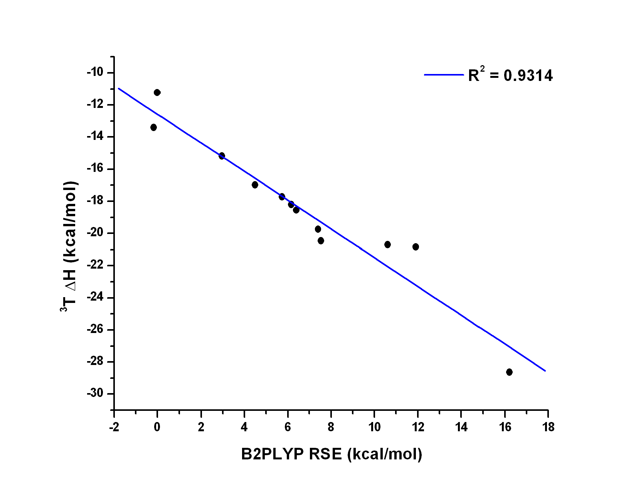

Figure 5.8 The RSE (kcal mol^{–1}) with ³T ΔH (kcal mol^{–1}) correlation
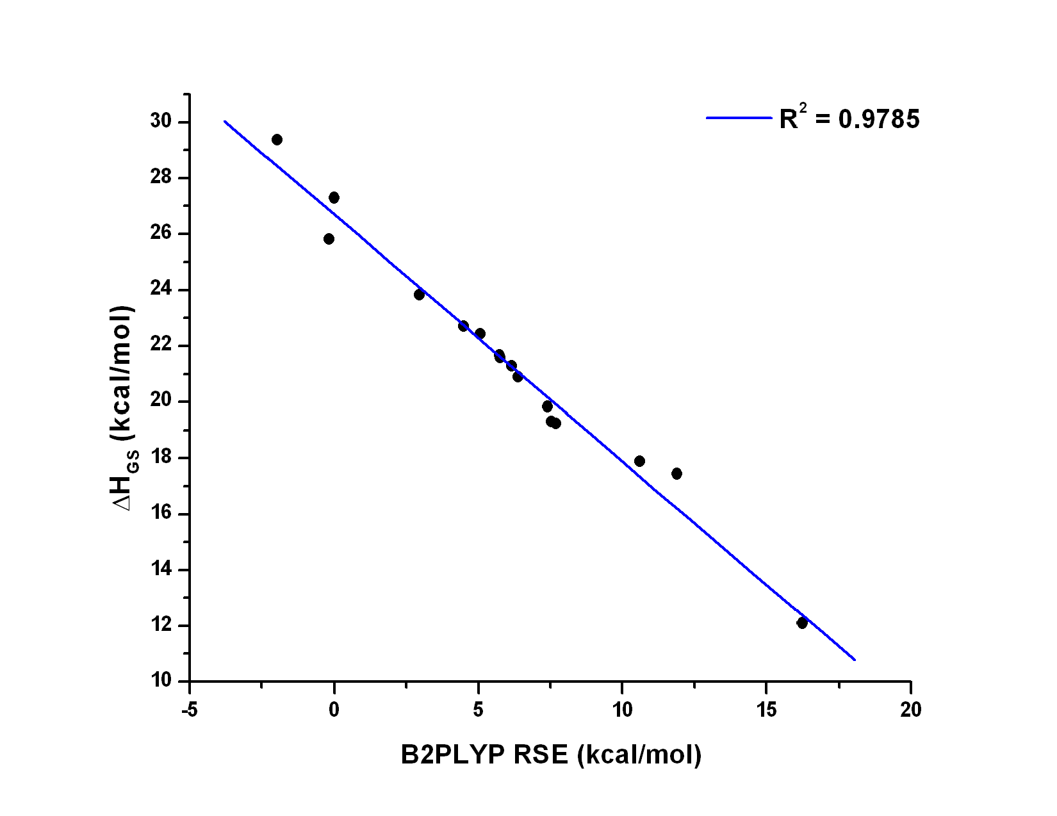

Figure 5.9 The RSE (kcal mol^{–1}) with ΔH_{GS} (kcal mol^{–1}) correlation (with 42)

Let us turn to more interesting parameter which is the activation barrier for the HAT in the triplet state. We were able to locate transition state structures for most of the model compounds. We have not searched for the TS of molecules with very similar RSE values (34, 36, 38 and 39). No TS structure could be obtained for 37. In the optimization process for the triplet 37, starting at the geometry similar to that we have described for triplet 31, the hydrogen atom was spontaneously abstracted from the benzylic position. The resulting structure could be described as the anti conformer of the lowest energy diastereomer of the triplet biradical (Z,E configuration on double bonds). Thus no barrier exists at the B3LYP/6-31G* potential energy surface (PES). The nitro group in the triplet 37 had to be rotated almost perpendicular with respect to the benzene ring to find any local minimum on triplet PES. For that reason the triplet energy (E_{T1}) of 37 is more than 2 kcal mol^{–1} higher compared to the average value for all other compounds studied. It is suitable to note that the RSE of 16.22 kcal mol^{–1} for 37 radical has been found with RB2-PLYP functional (other methods tested performed within 1 kcal mol^{–1} from this value) and it is the highest RSE found among all. Additionally, it appears that the activation barriers for molecules with the highest RSE (32, 43) are negative. The negative activation energy means that the energy maximum on the B3LYP/6-31G* surface may not exist at more accurate B3LYP/6-311+G(3df,2p) level. It is likely that the barrier is either zero or very small, and the transition state structure has a geometry very similar to that of the reactant structures, i.e., of very early transition state. This is in agreement with the values for the C₇–H₈ and O₁₂–H₈ distances we discussed previously. Moreover, it is expected that only little or no kinetic isotope effect would be found for these compounds if the reaction was truly triplet derived. If we omit compound 37, a correlation plot for RSE and the activation energies could be constructed. Since we have found a correlation of RSE and the reaction enthalpy of the triplet state reaction, a correlation of the reaction enthalpy and the activation energy should exist and it should be linear in accord to the Bell-Evans-Polanyi principle. Both are depicted in the following figures (Figure 5.10 and 5.11).
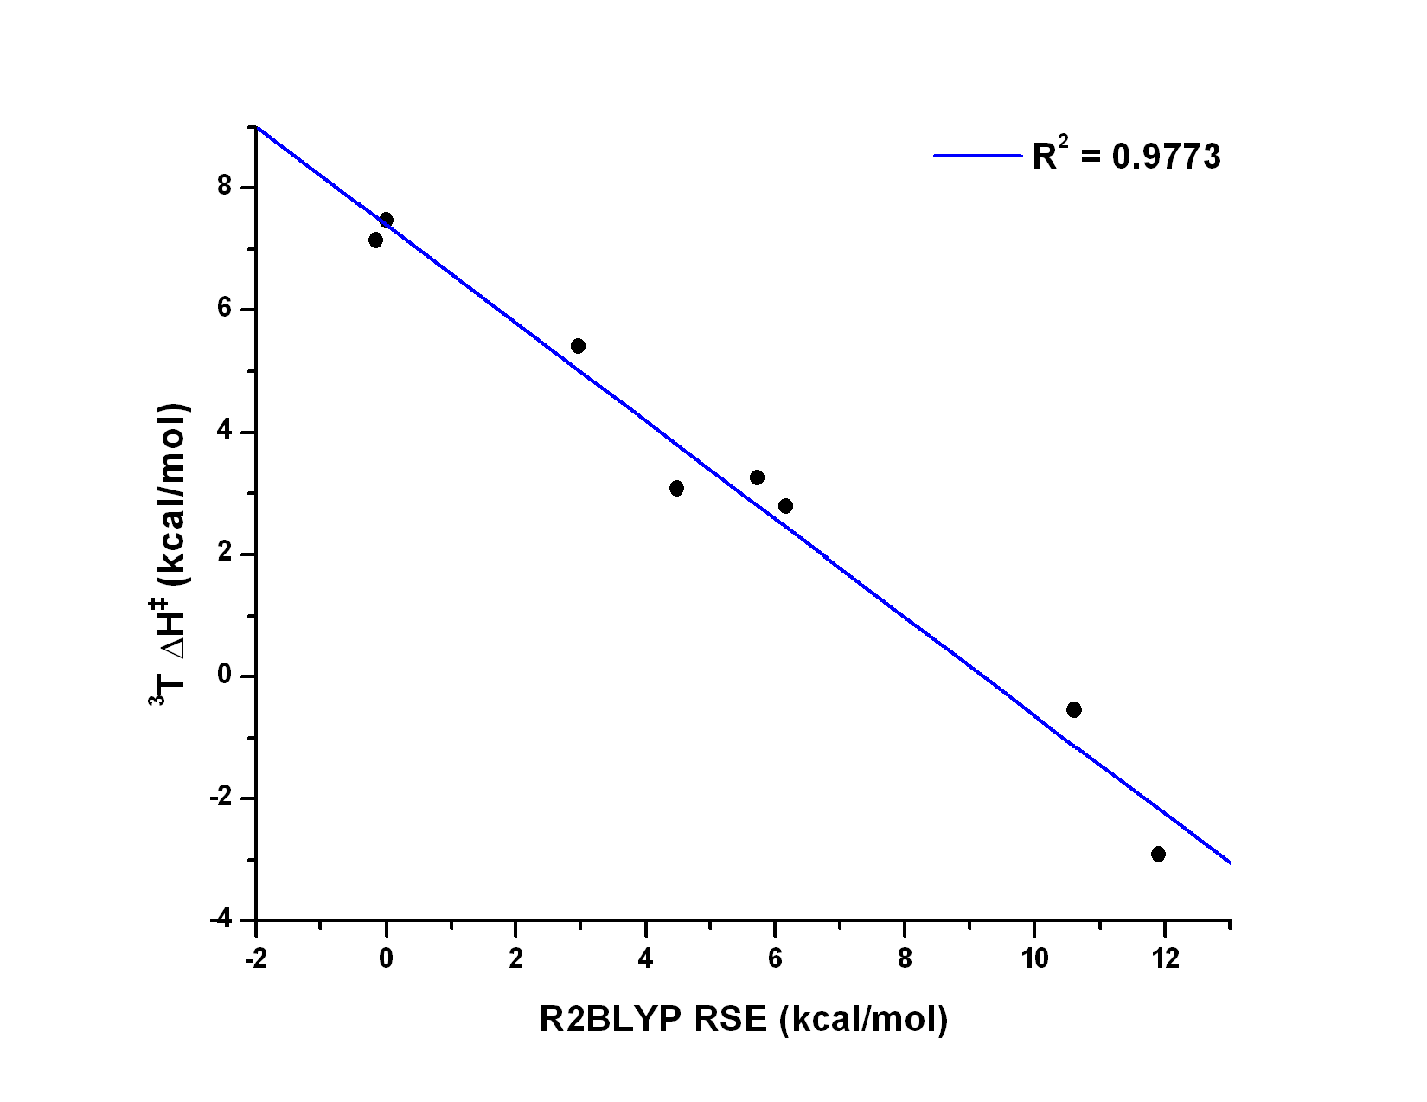

Figure 5.10 The RSE (kcal mol^{–1}) with ³T ΔH‡ (kcal mol^{–1}) correlation
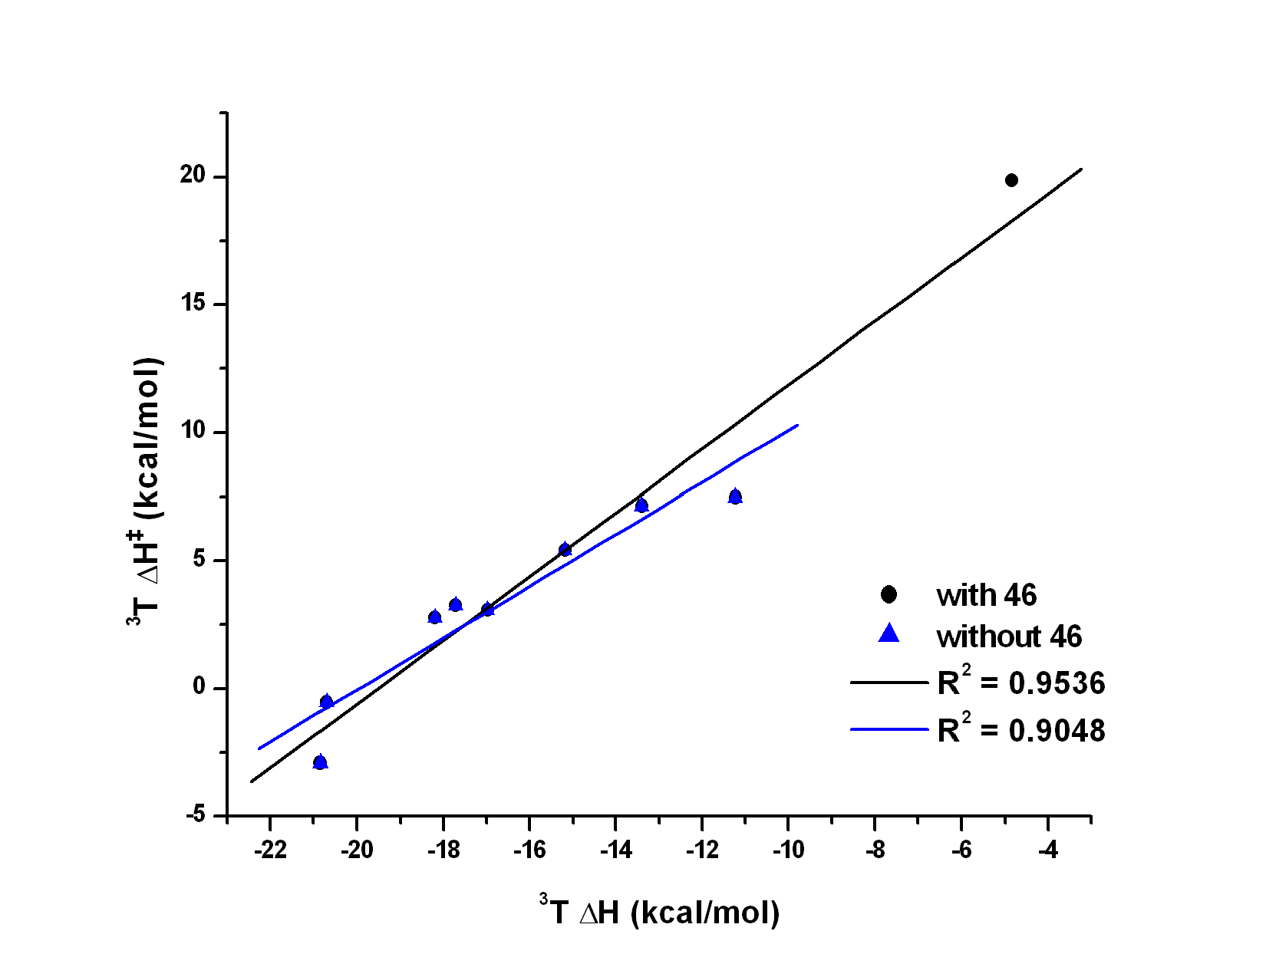
Figure 5.11 The ³T ΔH (kcal mol^{–1}) with ³T ΔH‡ (kcal mol^{–1}) correlation. The plots including 46 (in black) and that without 46 (in blue) are depicted

Some discrepancies from perfect linearity can be recognized. For example, the RSE for the radical of 45 is slightly more negative corresponding to a higher ΔH_{GS}, less negative ³T ΔH, and higher ³T ΔH‡ for triplet HAT than those of 31. But an opposite effect was observed suggesting that other features for the hydrogen atom abstraction must be considered. We must humbly admit we do not still completely understand why this is so. A leveling from linearity for 36 and 38 can be attributed to the existence of the intramolecular hydrogen bond making a different conformer the lowest one. On that account, all the reactions under investigation are not entirely analogous.
To our surprise we are able to correlate the ΔH_{GS} and the ³T ΔH‡ for triplet HAT, too (Figure 5.12). This is little an astonishing finding because we are not aware of any system with similar behaviour. This provides a relatively powerful way to estimate which of two reactions can be faster in the excited state only by considering the ground state reaction enthalpies. The reason for this behaviour stems from two facts. The first one comes out from the validity of Bell-Evans-Polanyi principle for HAT in the triplet state (the reactions are more or less analogous). Besides, the benzylic substituents influence the chromophore absorption properties only little. It can be seen from the triplet energies for both the reactants and products (see E_{T1} and E_{T2} in Table 5.6). For all the compounds (37 is not considered), the former is 54.8 ± 0.7 kcal mol^{–1}, while the latter (with 37, but not 46) 11.3 ± 0.7 kcal mol^{–1}. A correlation of ³T ΔH with ΔH_{GS} shows the extent of benzylic substitution influence on the chromophore properties. If the chromophore was not affected at all, the R² value would equal 1.0 (Figure 5.13). It is clear that the value for 46 deviates significantly from other molecules in the set. It can be concluded the chromophore is affected markedly in this particular case. The reason can be presumably the lack of solvation and the positive charge of 46. Employing the simple Förster cycle, it is immediately clear that our two surprising correlations (RSE vs. ΔH_{GS} and ΔH_{GS} vs. ³T ΔH‡) are just simple consequences of the laws of thermodynamics. A nice correlation of RSE with ΔH_{GS} can be deduced from the fact that the substituents we employed could also stabilize a cation similarly than they stabilized a radical. Considering a mesomeric structure of the aci-nitro intermediate with a carbenium ion in the benzylic position to prevail makes our observations apparent.
We believe the behaviour of our molecules set can be observed in similarly arranged systems in both triplets and singlet states where probably no vibronic mixing is present. Since the substituents in the present study can stabilize the cations alike, appropriate systems with electron transfer reactions could demonstrate a similar effect as well.
Unfortunately, absolutely no correlation can be found for the quantum yields of Bochet et al. and any thermodynamic quantity computed in this work. The quantum yield involves all the possible processes which occur during the progress of the reaction. There are many decay processes possible (phosphorescence, fluorescence, IC from S₁ to ground state or slow ISC to triplet state). Neglecting all of these, there is also excited singlet state derived pathway to products. In addition, we have not considered the disproportionation of the triplet biradical intermediate back to the starting material or the proton transfer from the aci-nitro intermediate back to the methylene group. The last process mentioned could play a major role in the value of the quantum yield. In order to correlate our results, the quantum efficiencies of triplet derived aci-nitro intermediates formation would have to be measured by fast spectroscopic techniques.
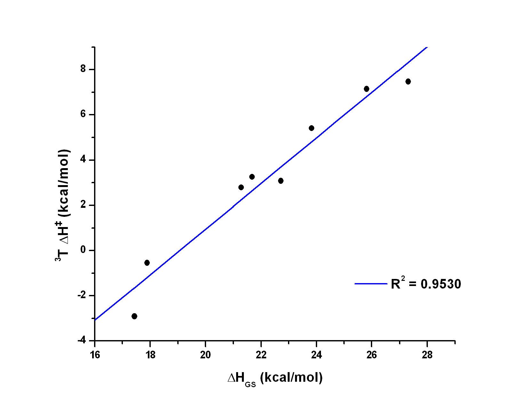
Figure 5.12 The ΔH_{GS} (kcal mol^{–1}) with ³T ΔH‡ (kcal mol^{–1}) correlation. 46 is not included.
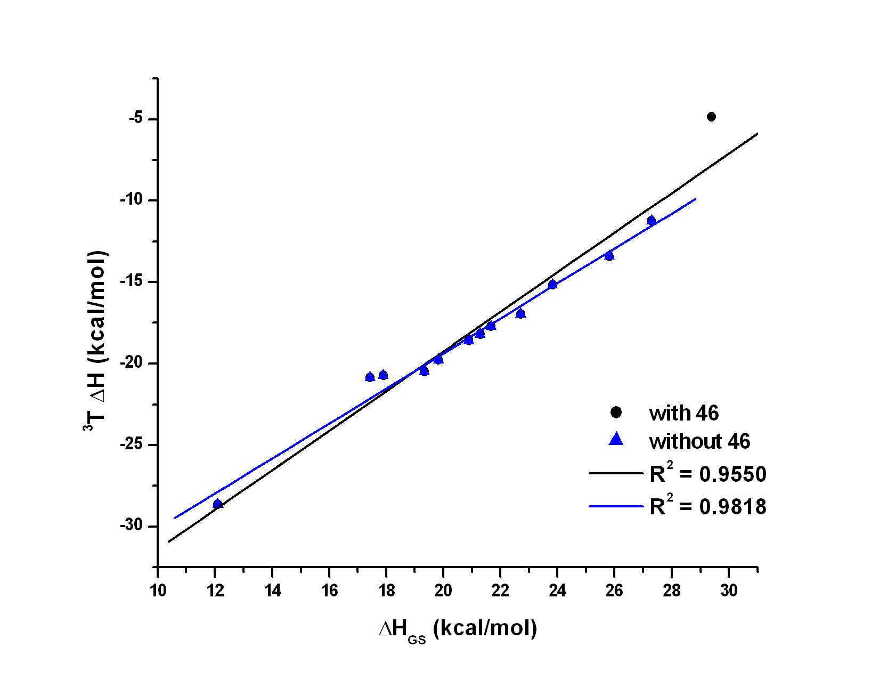
Figure 5.13 The ΔH_{GS} (kcal mol^{–1}) with ³T ΔH (kcal mol^{–1}) correlation. The plots including 46 (in black) and that without 46 (in blue) are depicted

5.7. Conclusion II
A new protocol for computation of the radical stabilization energies has been proposed and successfully applied in exploring the triplet state reactivity of the substituted o-nitrobenzyl chomophore.
The quantum chemical calculations based on density functional theory provided valuable information of the o-nitrotoluene lowest triplet state geometry and attributes which were compared to that of its ground state. Transition state of the hydrogen atom abstraction and the resulting 1,4-biradical product were located on the triplet surface.
Benzylic substitution was investigated in regard to the triplet state reactivity. 16 compounds were studied and 10 transition states were located. It was found that a radical site was fully developed in the progress of the hydrogen atom transfer reaction. We showed the thermodynamic and kinetic parameters were strongly influenced by the benzylic substituent and correlated linearly with the computed radical stabilization energies according to the Bell-Evans-Polanyi principle. A correlation of the ground state reaction enthalpy and the triplet activation barrier of hydrogen atom transfer reaction was demonstrated. It provides a relatively powerful way for estimation of the triplet kinetic behaviour. It is believed that similarly arranged systems could display this effect in photoinduced electron transfer reactions.
Our results confirmed the hydrogen atom transfer as a possible slow step in the photoinduced release of a protected species and suggested that no or negligible kinetic isotope effect should be observed for some model compounds.
Compound 44 demonstrated a huge increase in the reaction barrier for triplet hydrogen atom transfer and is believed to stimulate the experimental work in the search for a quantum mechanical tunnelling mechanism involvement. Moreover, it represents a promising candidate for studies of the ratio of the excited singlet or triplet states involvement in the hydrogen atom transfer reactions in the o-nitrobenzyl moiety.
No correlation of computed physical quantities and the experimental quantum yields has been found.

List of Abbreviations

AcOH acetic acid
BDE bond dissociation energy
COSY Correlation Spectroscopy
DCM dichloromethane
DFT density functional theory
DMS dimethyl sulfate
HAT hydrogen atom transfer
HF Hartree-Fock
HMBC Heteronuclear Multiple Bond Coherence
HMQC Heteronuclear Multiple Quantum Coherence
IC internal conversion
ISC intersystem crossing
KIE kinetic isotope effect
LDA lithium diisopropyl amide
LFP laser flash photolysis
MCPBA m-chloroperoxybenzoic acid
MeOH methanol
MO molecular orbital
PES potential energy surface
PNAP p-nitroacetophenone
RSE radical stabilization energy
S₁ lowest excited singlet electronic state
T₁ lowest triplet electronic state
t-BuOH t-butanol
TD DFT time-dependent density functional theory
THF tetrahydrofurane
TLC thin layer chromatography
TMS tetramethylsilane
TS transition state
ZPVE zero-point vibrational energy

References
(1) Hayes, C. J.; Burgess, D. R. J. Phys. Chem. A 2009, 113, 2473-2482.
(2) Kuwata, K. T.; Dibble, T. S.; Sliz, E.; Petersen, E. B. J. Phys. Chem. A 2007, 111, 5032-5042.
(3) Corrie, J. E. T.; Barth, A.; Munasinghe, V. R. N.; Trentham, D. R.; Hutter, M. C. J. Am. Chem. Soc. 2003, 125, 8546-8554.
(4) Il'ichev, Y. V.; Schwörer, M. A.; Wirz, J. J. Am. Chem. Soc. 2004, 126, 4581-4595.
(5) Kessler, M.; Glatthar, R.; Giese, B.; Bochet, C. G. Organic Letters 2003, 5, 1179-1181.
(6) Robles, J. L.; Bochet, C. G. Organic Letters 2005, 7, 3545-3547.
(7) Riguet, E.; Bochet, C. G. Organic Letters 2007, 9, 5453-5456.
(8) Bochet, C. G. Tetrahedron Letters 2000, 41, 6341-6346.
(9) Klán, P.; Zabadal, M.; Heger, D. Organic Letters 2000, 2, 1569-1571.
(10) Zabadal, M.; Klán, P. Chemické Listy 2001, 95, 694-699.
(11) Klán, P.; Pelliccioli, A. P.; Pospíšil, T.; Wirz, J. Photochemical & Photobiological Sciences 2002, 1, 920-923.
(12) Literák, J.; Wirz, J.; Klán, P. Photochemical & Photobiological Sciences 2005, 4, 43-46.
(13) Kammari, L.; Plíštil, L.; Wirz, J.; Klán, P. Photochemical & Photobiological Sciences 2007, 6, 50-56.
(14) Barton, D. H. R.; Beaton, J. M.; Geller, L. E.; Pechet, M. M. J. Am. Chem. Soc. 1960, 82, 2640-2641.
(15) Wagner, P. J. Accounts of Chemical Research 1971, 4, 168.
(16) McLafferty, F. W. Analytical Chemistry 1959, 31, 82-87.
(17) Kingston, D. G.; Bursey, J. T.; Bursey, M. M. Chemical Reviews 1974, 74, 215-242.
(18) Loncharich, R. J.; Houk, K. N. J. Am. Chem. Soc. 1987, 109, 6947-6952.
(19) Dorigo, A. E.; McCarrick, M. A.; Loncharich, R. J.; Houk, K. N. J. Am. Chem. Soc. 1990, 112, 7508-7514.
(20) Wagner, P. J.; Zepp, R. G.; Kelso, P. A.; Kemppain.Ae J. Am. Chem. Soc. 1972, 94, 7500.
(21) Lin, C. T.; Moule, D. C. Journal of Molecular Spectroscopy 1971, 37, 280.
(22) Hochstra.Rm; Lin, T. S. Journal of Chemical Physics 1968, 49, 4929.
(23) Dorigo, A. E.; Houk, K. N. J. Am. Chem. Soc. 1987, 109, 2195-2197.
(24) Wagner, P. J.; Klan, P. In CRC Handbook of Photochemistry and Photobiology; 2nd ed.; Horspool, W. L., F.;, Ed.; CRC Press: New York, 2004.
(25) Wirz, J.; Klán, P. Photochemistry of Organic Compounds: From Concepts to Practice; 1st ed.; Wiley-Blackwell, 2009.
(26) Yang, N. C.; Yang, D. D. H. J. Am. Chem. Soc. 1958, 80, 2913-2914.
(27) Wagner, P. J.; Zepp, R. G.; Kelso, P. A. J. Am. Chem. Soc. 1972, 94, 7480.
(28) Wagner, P. J.; Zepp, R. G. J. Am. Chem. Soc. 1972, 94, 287.
(29) Small, R. D.; Scaiano, J. C. Chem. Phys. Lett. 1977, 50, 431-434.
(30) Small, R. D.; Scaiano, J. C. Journal of Photochemistry 1977, 6, 453-456.
(31) Small, R. D.; Scaiano, J. C. Chem. Phys. Lett. 1978, 59, 246-248.
(32) Small, R. D.; Scaiano, J. C. J. Phys. Chem. 1977, 81, 2126-2131.
(33) Turro, N. J.; Ramamurthy, V.; Scaiano, J. C. Principles of Molecular Photochemistry: An Introduction; 1st ed.; University Science Books, 2009.
(34) De Feyter, S.; Diau, E. W. G.; Zewail, A. H. Angew. Chem.-Int. Ed. 2000, 39, 260.
(35) Wagner, P. J.; Hammond, G. S. J. Am. Chem. Soc. 1966, 88, 1245.
(36) Wagner, P. J.; Jellinek, T. J. Am. Chem. Soc. 1971, 93, 7328.
(37) Hammond, G. S.; Leermakers, P. A. J. Am. Chem. Soc. 1962, 84, 207.
(38) Deboer, C. D.; Herkstro.Wg; Marchett.Ap; Schultz, A. G.; Schlessi.Rh J. Am. Chem. Soc. 1973, 95, 3963-3969.
(39) Encina, M. V.; Lissi, E. A.; Lemp, E.; Zanocco, A.; Scaiano, J. C. J. Am. Chem. Soc. 1983, 105, 1856-1860.
(40) Wagner, P. J.; Park, B. S. Org. Photochemistry 1991, 11, 227.
(41) Wagner, P. J.; Kemppain.Ae; Schott, H. N. J. Am. Chem. Soc. 1973, 95, 5604-5614.
(42) Wagner, P. J.; Siebert, E. J. J. Am. Chem. Soc. 1981, 103, 7329-7335.
(43) Loutfy, R. O. Tetrahedron 1973, 29, 2251-2252.
(44) Rauh, R. D.; Leermake.Pa J. Am. Chem. Soc. 1968, 90, 2246.
(45) Li, Y. H.; Lim, E. C. Chem. Phys. Lett. 1970, 7, 15-18.
(46) Hasegawa, T.; Kajiyama, M.; Yamazaki, Y. J. Phys. Org. Chem. 2000, 13, 437-442.
(47) Wagner, P. J.; Kemppain.Ae; Kochevar, I. E. J. Am. Chem. Soc. 1972, 94, 7489-&.
(48) Wagner, P. J. J. Am. Chem. Soc. 1967, 89, 5898.
(49) Paquette, L. A.; Balogh, D. W. J. Am. Chem. Soc. 1982, 104, 774-783.
(50) Bondi, A. J. Phys. Chem. 1964, 68, 441.
(51) Scheffer, J. R.; Scott, C. In CRC Handbook of Photochemistry and Photobiology; Horspool, W., Lenci, F., Eds.; CRC Press: New York, 2004.
(52) Wagner, P. J.; Zhou, B. L. Tetrahedron Letters 1989, 30, 5389-5392.
(53) Zwicker, E. F.; Yang, N. C.; Grossweiner, L. I. J. Am. Chem. Soc. 1963, 85, 2671.
(54) Huffman, K. R.; Loy, M.; Ullman, E. F. J. Am. Chem. Soc. 1965, 87, 5417.
(55) Small, R. D.; Scaiano, J. C. J. Am. Chem. Soc. 1977, 99, 7713-7714.
(56) Das, P. K.; Encinas, M. V.; Small, R. D.; Scaiano, J. C. J. Am. Chem. Soc. 1979, 101, 6965-6970.
(57) Kumar, C. V.; Chattopadhyay, S. K.; Das, P. K. J. Am. Chem. Soc. 1983, 105, 5143-5144.
(58) Pelliccioli, A. P.; Klán, P.; Zabadal, M.; Wirz, J. J. Am. Chem. Soc. 2001, 123, 7931-7932.
(59) Wagner, P. J.; Chen, C. P. J. Am. Chem. Soc. 1976, 98, 239-240.
(60) Garciagaribay, M. A.; Gamarnik, A.; Pang, L.; Jenks, W. S. J. Am. Chem. Soc.1994, 116, 12095-12096.
(61) Garciagaribay, M. A.; Gamarnik, A.; Bise, R.; Pang, L.; Jenks, W. S. J. Am. Chem. Soc. 1995, 117, 10264-10275.
(62) Johnson, B. A.; Gamarnik, A.; GarciaGaribay, M. A. J. Phys. Chem. 1996, 100, 4697-4700.
(63) Johnson, B. A.; Garcia-Garibay, M. A. J. Am. Chem. Soc. 1999, 121, 8114-8115.
(64) Johnson, B. A.; Hu, Y. F.; Houk, K. N.; Garcia-Garibay, M. A. J. Am. Chem. Soc. 2001, 123, 6941-6942.
(65) Campos, L. M.; Warrier, M. V.; Peterfy, K.; Houk, K. N.; Garcia-Garibay, M. A. J. Am. Chem. Soc. 2005, 127, 10178-10179.
(66) Wagner, P. J.; Zepp, R. G. J. Am. Chem. Soc. 1971, 93, 4958.
(67) Breslow, R. Acc. Chem. Res. 1980, 13, 170-177.
(68) Winnik, M. A.; Lee, C. K.; Basu, S.; Saunders, D. S. J. Am. Chem. Soc. 1974, 96, 6182-6184.
(69) Wagner, P. J.; Meador, M. A.; Park, B. S. J. Am. Chem. Soc. 1990, 112, 5199-5211.
(70) Zhou, B.; Wagner, P. J. J. Am. Chem. Soc. 1989, 111, 6796-6799.
(71) Slavíček, P.; Ončák, M. unpublished results
(72) Laimgruber, S.; Schmierer, T.; Gilch, P.; Kiewisch, K.; Neugebauer, J. Phys. Chem. Chem. Phys. 2008, 10, 3872-3882.
(73) Pei, K. M.; Ma, Y. F.; Zheng, X. M.; Li, H. Y. Chem. Phys. Lett. 2007, 437, 153-158.
(74) Mohammed, O. F.; Vauthey, E. J. Phys. Chem. A 2008, 112, 3823-3830.
(75) Zugazagoitia, J. S.; Almora-Diaz, C. X.; Peon, J. J. Phys. Chem. A 2008, 112, 358-365.
(76) Gorner, H. J. Photochem. and Photobiol A-Chem. 1998, 112, 155-158.
(77) Gorner, H.; Currell, L. J.; Kuhn, H. J. J. Phys. Chem. 1991, 95, 5518-5523.
(78) Wan, P.; Yates, K. J. Org. Chem. 1983, 48, 136-138.
(79) Wan, P.; Yates, K. Can. J. Chem. 1986, 64, 2076.
(80) Schwörer, M.; Wirz, J. Helvetica Chimica Acta 2001, 84, 1441-1458.
(81) George, M. V.; Scaiano, J. C. J. Phys. Chem. 1980, 84, 492-495.
(82) Yip, R. W.; Sharma, D. K. Res. Chem. Inter. 1989, 11, 109-116.
(83) Laimgruber, S.; Schreier, W. J.; Schrader, T.; Koller, F.; Zinth, W.; Gilch, P. Angew. Chem. Int. Ed. 2005, 44, 7901-7904.
(84) Leyva, V.; Corral, I.; Schmierer, T.; Heinz, B.; Feixas, F.; Migani, A.; Blancafort, L.; Gilch, P.; Gonzalez, L. J. Phys. Chem. A 2008, 112, 5046-5053.
(85) Heinz, B.; Schmierer, T.; Laimgruber, S.; Gilch, P. J. Photochem. and Photobiol A-Chem. 2008, 199, 274-281.
(86) Dunkin, I. R.; Gebicki, J.; Kiszka, M.; Sanin-Leira, D. J. Chem. Soc.-Perkin Trans. 2 2001, 1414-1425.
(87) Kuberski, S.; Gebicki, J. J. Mol. Struc. 1992, 275, 105-110.
(88) Il'ichev, Y. V.; Wirz, J. J. Phys. Chem. A 2000, 104, 7856-7870.
(89) Gaplovsky, M.; Il'ichev, Y. V.; Kamdzhilov, Y.; Kombarova, S. V.; Mac, M.; Schworer, M. A.; Wirz, J. Photochemical & Photobiological Sciences 2005, 4, 33-42.
(90) Gorner, H. Photochemical & Photobiological Sciences 2005, 4, 822-828.
(91) Yip, R. W.; Sharma, D. K.; Giasson, R.; Gravel, D. J. Phys. Chem. 1984, 88, 5770-5772.
(92) Yip, R. W.; Sharma, D. K.; Giasson, R.; Gravel, D. J. Phys. Chem. 1985, 89, 5328-5330.
(93) Yip, R. W.; Sharma, D. K.; Blanchet, D.; Giasson, R.; Gravel, D. Can. J. Chem. 1991, 69, 1193-1200.
(94) Blanc, A.; Bochet, C. G. J. Am. Chem. Soc. 2004, 126, 7174-7175.
(95) Bejan, I.; Abd El Aal, Y.; Barnes, I.; Benter, T.; Bohn, B.; Wiesen, P.; Kleffmann, J. Phys. Chem. Chem. Phys. 2006, 8, 2028-2035.
(96) Nagaya, M.; Kudoh, S.; Nakata, M. Chem. Phys. Lett. 2006, 427, 67-71.
(97) Catalan, J.; Palomar, J.; dePaz, J. L. G. J. Phys. Chem. A 1997, 101, 7914-7921.
(98) Yi, P. G.; Liang, Y. H.; Cao, C. Z. Chem. Phys. 2005, 315, 297-302.
(99) Kitaura, Y.; Matsuura, T. Tetrahedron 1971, 27, 1583.
(100) Nakagaki, R.; Hiramatsu, M.; Mutai, K.; Nagakura, S. Chem. Phys. Lett. 1985, 121, 262-266.
(101) Nakagaki, R.; Hiramatsu, M.; Mutai, K.; Tanimoto, Y.; Nagakura, S. Chem. Phys. Lett. 1987, 134, 171-176.
(102) Nakagaki, R.; Mutai, K.; Hiramatsu, M.; Tukada, H.; Nagakura, S. Can. J. Chem. 1988, 66, 1989.
(103) Frisch, M. J. T. et al.; Gaussian, Inc.,: Wallingford CT, 2004.
(104) Becke, A. D. J. Chem. Phys. 1993, 98, 5648.
(105) Scott, A. P.; Radom, L. J. J. Phys. Chem. 1996, 100, 16502.
(106) Merrick, J. P.; Moran, D.; Radom, L. J. Phys. Chem. A 2007, 111, 11683-11700.
(107) Boese, A. D.; Martin, J. M. L. J. Chem. Phys. 2004, 121, 3405.
(108) Peng, C.; Ayala, P. Y.; Schlegel, H. B.; Frisch, M. J. J. Comp. Chem. 1996, 17, 49.
(109) Gonzales, C.; Schlegel, H. B. J. Chem. Phys. 1989, 90, 2154.
(110) Grimme, S. J. Chem. Phys. 2006, 124, 034108.
(111) Schwabe, T.; Grimme, S. Phys. Chem. Chem. Phys. 2006, 8, 4398.
(112) Šolomek, T. In Bachelor work; Masaryk University: Brno, 2007, p 58.
(113) Shih, H. C. D., L.; Carrera, C. J.; Adachi, S.; Cottam, H. B.; Carson, D. A. Bioorg. Med. Chem. Lett. 2000, 10, 487-490.
(114) Hadfield, J. A. D., S.; Hirst, N.; McGown, A. T. Prog. Cell Cyc. Res. 2003, 5, 309-325.
(115) Katritzky, A. R.; Pastor, A. J. Org. Chem. 2000, 65, 3679–3682.
(116) Miura, K.; Tojino, M.; Fujisawa, N.; Hosomi, A.; Ryu, I. Angew. Chem. Int. Ed. 2004, 43, 2423-2425.
(117) Kim, H.; Kim, T. G.; Hahn, J.; Jang, D. J.; Chang, D. J.; Park, B. S. J. Phys. Chem. A 2001, 105, 3555-3563.
(118) Haag, R. W., J. Helv. Chim. Acta 1977, 60, 2595-2607.
(119) Hasegawa, E.; Ishiyama, K.; Kato, T.; Horaguchi, T.; Shimizu, T.; Tanaka, S.; Yamashita, Y. J. Org. Chem. 1992, 57, 5352-5359.
(120) Dewar, M. J. S.; Zoebisch, E. G.; Healy, E. F.; Stewart, J. J. P. J. Am. Chem. Soc. 1985, 107, 3902-3909.
(121) Kobayashi, A. E., H.; Koshimizu, K.; Mitsui, T. Biol. chem. 1975, 39, 1851.
(122) Kobayashi, A. K., K. Agric. biol. chem 1980, 44, 393.
(123) McCaskill, R. H.; Ayer, W. A. Can. J. Chem. 1981, 59, 2150.
(124) McMorris, T. C.; Ng, K. E. Can. J. Chem. 1984, 62, 1945.
(125) Chen, Y. H.; Chang, F. R.; Lu, M. C.; Hsieh, P. W.; Wu, M. J.; Du, Y. C.; Wu, Y. C. Molecules 2008, 13, 255-266.
(126) Wessig, P.; Teubner, J. Synlett 2006, 1543-1546.
(127) Hasegawa, E.; Ishiyama, K.; Horaguchi, T.; Shimizu, T. J. Org. Chem. 1991, 56, 1631-1635.
(128) Grimme, S.; Neese, F. Journal of Chemical Physics 2007, 127.
(129) Jensen, F. Introduction to Computational Chemistry; 2nd ed.; Wiley, 2006.
(130) Menon, A. S.; Wood, G. P. F.; Moran, D.; Radom, L. J. Phys. Chem. A 2008, 112, 5554-5554.
(131) Bochet, C. G.; Blanc, A., unpublished results
(132) Shishkov, I. F.; Vilkov, L. V.; Kovacs, A.; Hargittai, I. J. Mol. Struc. 1998, 445, 259-268.
(133) Cheng, L. T.; Tam, W.; Stevenson, S. H.; Meredith, G. R.; Rikken, G.; Marder, S. R. J. Phys. Chem. 1991, 95, 10631-10643.

